Name: ____________________________________________________________ Class: __________________

**Math 2 Unit 7 – Vocabulary and Angle Pair Relationships**

**Day 1: Basics of Geometry**

|  |  |  |  |
| --- | --- | --- | --- |
| **Congruent Angles** | **Angle Bisector** | | **Complementary Angles** |
| **Supplementary Angles** | **Linear Pair** | | **Vertical Angles** |
| **Right Angles** | **Right Triangle** | | **Angle Bisector** |
| **Reflexive Property of Congruence** | | **Transitive Property of Congruence** | |
| **Parallel Lines** | **Transversal** | | **Alternate Interior Angles** |
| **Alternate Exterior Angles** | **Corresponding Angles** | | **Consecutive Interior Angles** |
| **Triangle Sum Theorem** | | **Exterior Angle Theorem** | |

Draw the given pictures. Label all points.

|  |  |  |
| --- | --- | --- |
| 1.  is the midpoint of . | 2. Lines $\overset{⃡}{AB}$ and $\overset{⃡}{CD}$ intersect at point . | 3. $\overline{WZ}$ bisects $∠FWX$. |
| 4. One angle has a measure of 50o and another has a measure of xo. The two form a linear pair | 5. Line is perpendicular to , and they intersect at point . Line is also perpendicular to , intersecting at point | 6.  and are complementary. |
| 7. $\overset{⃡}{ST}$ bisects $\overline{XY}$ | 8. $∆GHT$ has 2 congruent angles, $∠G$ and $∠T$ | 9. Angles $∠ERG$ and $∠JRD$ are vertical angles. |
| 10. $\overline{WX}$ and $\overset{⃡}{YZ}$ are parallel. Point G is the midpoint of $\overline{WX}$. | 11. One angles has a measure of x + 45o, another has a measure of 2xo, and a 3rd had an angle of x – 1o. All 3 make a linear pair. | 12. $∆LJW$ is a right triangle, where $∠W$ is a right angle. $∠L$ and $∠J$ are congruent. |

**Angle Pair Relationships**

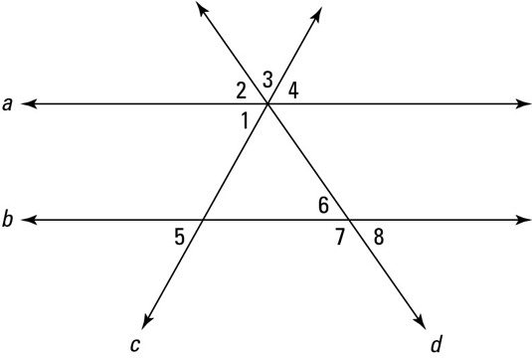

Name the Angle Pair Relationships!

Supplementary Angles, Vertical Angles, Alternate Interior Angles, Alternate Exterior Angles, Corresponding Angles, Consecutive Interior Angles, or No Relationship

1. Angles 1 and 4: _______________________________________
2. Angles 1 and 5: _______________________________________
3. Angles 4 and 5: _______________________________________
4. Angles 6 and 7: _______________________________________
5. Angles 5 and 7: _______________________________________
6. Angles 6 and 8: _______________________________________
7. Angles 2 and 8: _______________________________________
8. Angles 2 and 6: _______________________________________