Exponential Station #3

1. If a student deposits $1500 in the bank and earns an annual interest rate of 8% how much will he have after 15 years?

2. Kelly plans to put her graduation money into an account and leave it there for 4 years while she goes to college. She receives $900 in graduation money that she puts into an account earning 4.25% interest quarterly. How much will be in Kelly’s account at the end of four years?

3. A girl drops a ball from a height of 10 feet. Each time the ball hits the ground, it bounces to 2/3 its previous height. What equation gives y, the height of the ball after x bounces? What is the height after the fifth bounce?

4. What is the smallest positive integer for x, so that the value of f(x) = 200(2)^{x} is greater than the value of g(x) = 500x + 400.

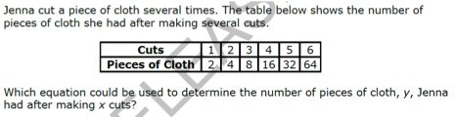
5.

6. A business had a profit of $32,000 in 1990 that increased by 15.5% per year.
a) Write the equation to model the situation.
b) Find the profit of the company after 3 years? __________ c) In 1998? __________

7. You buy a used car for $10,200. The value of the car depreciates at a yearly rate of 7%.
a) Write the equation to model the situation.
b) Find the value of the car after 4 years? __________ c) After 6 months? ______
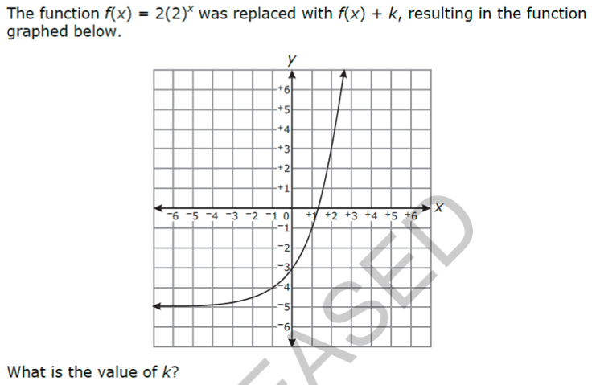
8.

9. The population of Winnemucca, Nevada, can be modeled by $P=6191{\left(1.04\right)}^{t}$ where t is the number of years since 1990. What was the population in 1990? By what percent did the population increase by each year?

10. The population of a town grows exponentially each year. Currently the population is 2,000, and it has continued to grow at a rate of 6% each year. What is the common ratio?

