Linear Station 1
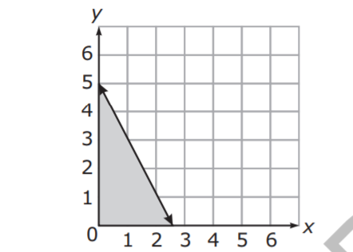
- What scenario could be modeled by the graph below?
- The number of pounds of apples, y, minus two times the number of pounds of oranges, x, is at most 5.
- The number of pounds of apples, y, minus half the number of pounds of oranges, x, is at most 5.
- The number of pounds of apples, y, plus two times the number of pounds of oranges, x, is at most 5.
- The number of pounds of apples, y, plus half the number of pounds of oranges, x, is at most 5.

- Which equation is the slope-intercept form of $y+2\left(x+5\right)=4x+5$

- $y=2x+20$
- $y=-4x+5$
- $y=2x-5$
- $y=5x+2$

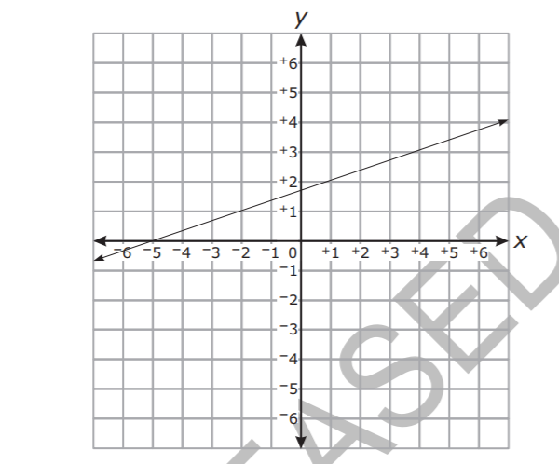
- Mario compared the slope of the function graphed below to the slope of a different function with an x-intercept of -2 and a y intercept of 1.

What is the slope of the function with the smaller slope?
- 1/5
- 1/3
- 3
- 5

- The average lifespan of an American woman has been tracked and is modeled by the equation $y=.2t+73$ where y is the lifespan and t is the years since 1960. What does the slope mean in context?

- Two boys, Shawn and Curtis, went for a walk. Shawn began walking 20 seconds earlier than Curtis.
- Shawn walked at a speed of 5 feet per second.
- Curtis walked at a speed of 6 feet per second.
For how many seconds had Shawn been walking at the moment when the two boys had walked exactly the same distance?

