Linear Station 2
- Which of the following represents the linear equation 3(x+2) = 12 – 2y in standard form?

a. y = -3/2x + 3
b. y = 3/2x - 3
c. 3x – 2y = 10
d. 3x + 2y = 6

- Which inequality is represented by the graph at the right?
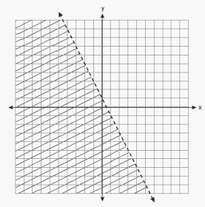
a.
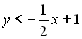
b.
c.
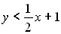
d.

- Cell phone Company Y charges a $10 start-up fee plus $0.10 per minute, x. Cell phone Company Z charges $0.20 per minute, x, with no start-up fee. Which function represents the difference in cost between Company Y and Company Z?

- f(x) = 0.10x − 10
- f(x) = 0.10x + 10
- f(x) = 10x – 0.10
- f(x) = 10x + 0.10

- Jessie’s bus ride to school is 5 minutes more than 2 3 the time of Robert’s bus ride. Which graph shows the possible times of Jessie’s and Robert’s bus rides?

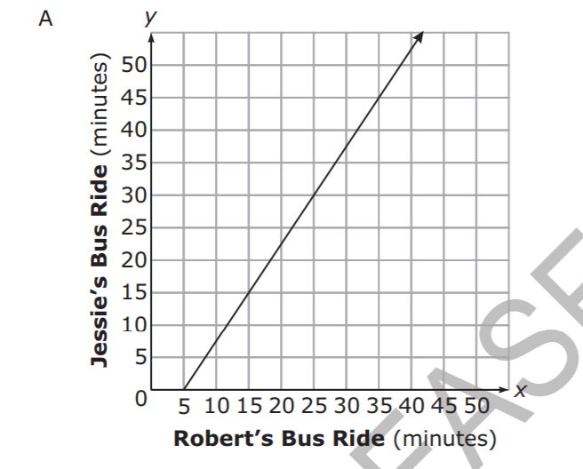
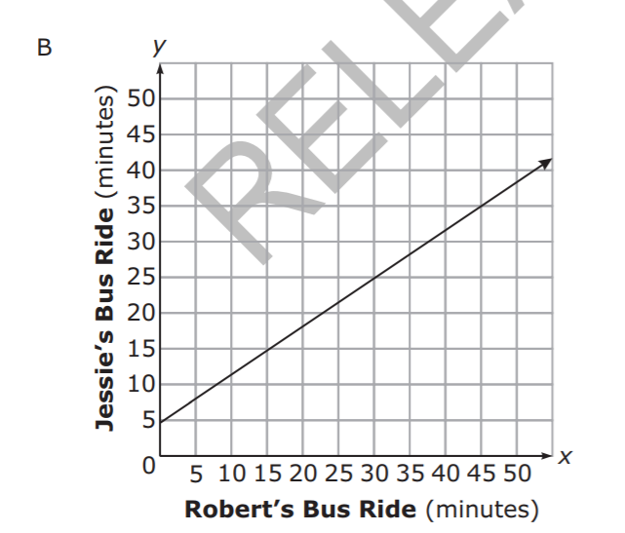
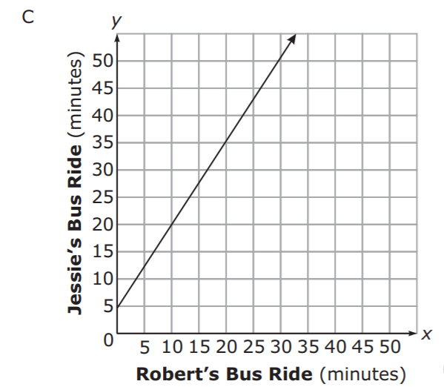
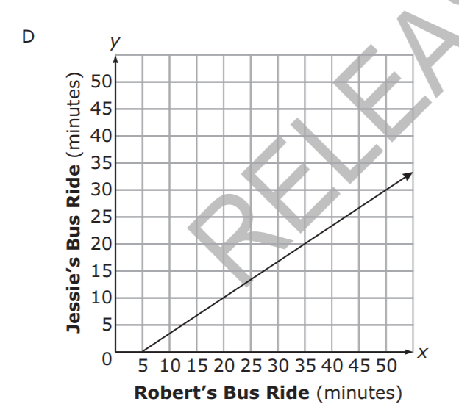

- Suppose that the function f(x) = 2x + 12 represents the cost to rent x movies a month from an internet movie club. Makayla now has $10. How many more dollars does Makayla need to rent 7 movies next month?

