Math III Unit 1: LINEAR MODELS AND PROGRAMMING
Lauren Winstead, Heritage High School

Main topics of instruction:
1) Parallel and perpendicular lines
1) Linear models and inequalities
2) Systems of linear equations and inequalities
3) Linear Programming
4) Arithmetic and geometric sequences and patterns

Day 1: Parallel & Perpendicular Lines

- Parallel lines: _____________________________________________________

________________________________________________________________________

- If two ______________________________ lines have the same _____________,
then they are parallel.

- Perpendicular lines: ________________________________________________

________________________________________________________________________

- If two lines are perpendicular, then their slopes are ________________________

_________________________ of each other, or they ____________________________

_______________________________________________________________________.

Try on your own! Are the following lines parallel, perpendicular, or oblique? Remember to put them in slope-intercept form first!

1) y = (1/4)x + 11 2) y = 5x – 8 3) 2y – 3x =2
y + 4x = -6 y = 5x + 1 y = -3x + 2

What if all you have are points?

Example 1: Are the lines passing through the sets of points parallel or perpendicular?
Use the slope formula to find out!
Line 1: (-1, 3) and (-1, 5)

Line 2: (0, 0) and (0, 6)

Try on your own!

1) Line 1: (-2, 3) and (-5, 2) 2) Line 1: (1, 1) and (3, 3)

Line 2: (4, 1) and (5, 3) Line 2: (2, 2) and (0, 4)

What if you have an equation and a given point?

Example 2: Write an equation in slope-intercept form of the line that passes through the given point and is parallel to each equation.
First, find the slope of the equation:

Then, use point-slope form ______________________________
to plug in the slope you found and your given point.
x – 3y = 8
(5, -4)

Try on your own! Write an equation in slope-intercept form of the line that passes through the given point and is parallel to each equation.

2x – 3y = 6
(-3, 2)

Example 3: Write an equation in slope-intercept form of the line that passes through the given point and is perpendicular to each equation.
First, find the slope of the equation:

Then, find its opposite reciprocal:

Then, use point-slope form ______________________________
to plug in the slope you found and your given point.
2x – 9y = 5
(6, -13)

Try on your own! Write an equation in slope-intercept form of the line that passes through the given point and is perpendicular to each equation.

y = (1/3)x + 2
(-3, 1)
Last one! Lines p, q, and r all pass through point (-3, 4). Line p has slope 4 and is perpendicular to line q. Line r passes through Quadrants I and II only.

- Write an equation for each line.

- Graph the three lines on the same coordinate plane.

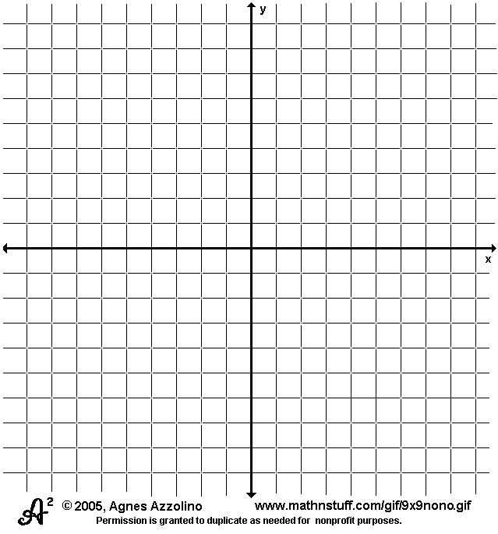

Day 2: Systems of Linear Equations and Inequalities

Example 1: Solving Systems of Linear Equations Graphically

A system of equations is _________________________________________________________

______________________________________________________________________________

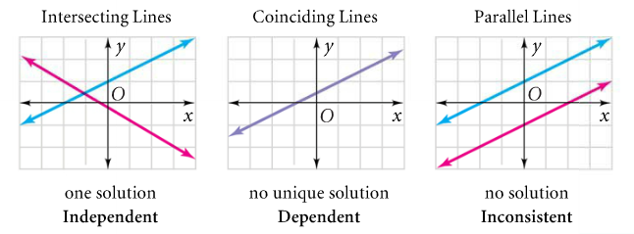

What ordered pair of numbers is the solution of the system?
$$\left\{\begin{aligned}x+2y=-7 \\ 2x-3y=0\end{aligned}\right.$$

*Make sure your equations are in
slope-intercept form before you graph
them!

Try on your own! (Use the same graph.)

$$\left\{\begin{aligned}2x+y=5 \\ y=2+x\end{aligned}\right.$$

Example 2: Use the data below to find the year when men and women will have the same 400-Meter Dash time.

Year | 1968 | 1972 | 1976 | 1980 | 1984 | 1988 | 1992 | 1996 | 2000
Men | 43.86 | 44.66 | 44.26 | 44.60 | 44.27 | 43.87 | 43.50 | 43.49 | 43.84
Women | 52.03 | 51.08 | 49.29 | 48.88 | 48.83 | 48.65 | 48.83 | 48.25 | 49.11

Answer in a complete sentence: __________________________________________________
Example 3: Solving Systems of Linear Equations by Substitution

$$\left\{\begin{aligned}4x+3y=4 \\ 2x-y=7\end{aligned}\right.$$

Step 1: Solve for one of the variables.

Step 2: Substitute the value of that variable into the other equation.

Step 3: Substitute the value of the solved variable back into either equation to solve for the other variable.

Try on your own! Solve the system of equations by substitution.

$$\left\{\begin{aligned}2x-3y=6 \\ x+y=-12\end{aligned}\right.$$

Example 4: Solving Systems of Linear Equations by Elimination

$\left\{\begin{aligned}4x-2y=7 \\ x+2y=3\end{aligned}\right.$ You need two of the terms to be additive inverses!

But what if they’re not?

$$\left\{\begin{aligned}3x+7y=15 \\ 5x+2y=-4\end{aligned}\right.$$

What kind of systems are these? _________________________

Sometimes, there are special cases! Try these on your own.

$\left\{\begin{aligned}2x-y=3 \\ -2x+y=-3\end{aligned}\right.$ $\left\{\begin{aligned}2x-3y=18 \\ -2x+3y=-6\end{aligned}\right.$

System type: _____________________ System type: _____________________

Example 5: Graphing Systems of Linear Inequalities

Good news! Graphing is the only way to solve a system of linear inequalities. But, two things matter here:

1. Solid line: _____________________ $\left\{\begin{aligned}x-2y<6 \\ y≤-\frac{3}{2}x+5\end{aligned}\right.$

Dashed line: ___________________

2. How do you decide whether to shade
above or below the line? Choose a test point!

Example 6: An entrance exam has two parts, a verbal part and a math part. You can score a maximum total of 1600 points. For admission, the school of your choice requires a math score of at least 600. Write a system of inequalities to model scores that meet the school’s requirements. Then, solve the system.

x =

y =

{

Day 3: Solving Three-Variable Systems of Equations by Substitution & Elimination

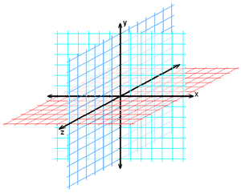
- The solution of a three-variable system of equations is an _________________, and the solution exists in a _____________________.

Try plotting these points in the 3-D plane.

(4, 2, 1)
(3, -2, 4)
(5, 0, -1)

Example 1: Use elimination to solve the 3-variable system.

$$\left\{\begin{aligned}3x+2y+4z=11 \\ 2x-y+3z=4 \\ 5x-3y+5z=-1\end{aligned}\right.$$

Step 1: Eliminate one of the variables using two of the original equations.

Step 2: Eliminate the same variable using another set of two original equations.

Step 3: Use elimination on your new two-variable equations to solve for one of the variables.

Step 4: Use back substitution to solve for the other two variables.

You try!

- $\left\{\begin{aligned}-x-5y+z=17 \\ -5x-5y+5z=5 \\ 2x+5y-3z=-10\end{aligned}\right.$ b) $\left\{\begin{aligned}-6x-2y+2z=-8 \\ 3x-2y-4z=8 \\ 6x-2y-6z=-18\end{aligned}\right.$

Example 2: Sometimes, a variable is already given to us or one variable is missing from an equation, and we can simply use substitution to solve a three-variable system.

Use substitution to solve the 3-variable system.

- $\left\{\begin{aligned}x-2y+3z=9 \\ y+3z=5 \\ 2z=4\end{aligned}\right.$ b) $\left\{\begin{aligned}x+y+z=6 \\ 2x-y+z=3 \\ 3x-z=0\end{aligned}\right.$

You try!

- $\left\{\begin{aligned}-x+y-z=0 \\ 2y+z=3 \\ \frac{1}{2}z=0\end{aligned}\right.$ b) $\left\{\begin{aligned}x+y+z=2 \\ -x+3y+2z=8 \\ 4x+y=4\end{aligned}\right.$

Example 3: Let’s try applying what you know! Suppose you have saved $3,200 from a part-time job, and you want to invest your savings in a growth fund, an income fund, and a money market fund. To maximize your return, you decide to put twice as much money in the growth fund as in the money market fund. Your return on investment will be 10% of the growth fund, 7% of the income fund, and 5% of the money market fund. How should you invest the $3,200 to get a return of $250 in one year?

You try! A theater has tickets at $6 for adults, $3.50 for students, and $2.50 for children under 12 years old. A total of 278 tickets were sold for one showing with a total revenue of $1,300. If the number of adult tickets sold was 10 less than twice the number of student tickets, how many of each type of ticket were sold for the showing?

Day 4: Solving 3-Variable Systems with Matrices & Exploring Linear Models and Inequalities

Example 1: Solving a 3-variable system of equations using matrices

Use a matrix!

$\left\{\begin{aligned}x-3y+3z=-4 \\ 2x+3y-z=15 \\ 4x-3y-z=19\end{aligned}\right.$ $\left[\begin{aligned} \\ \\ \\ \\ \end{aligned} \right]∙\left[\begin{aligned} \\ \\ \\ \\ \end{aligned} \right]=\left[\begin{aligned} \\ \\ \\ \\ \end{aligned}\right]$

A B

Try on your own! Remember, your variables need to be in alphabetical order.

$\left\{\begin{aligned}x+z-2y=-4 \\ y-2z=1+4x \\ -z=10-2x-2y\end{aligned}\right.$ $\left[\begin{aligned} \\ \\ \\ \\ \end{aligned} \right]∙\left[\begin{aligned} \\ \\ \\ \\ \end{aligned} \right]=\left[\begin{aligned} \\ \\ \\ \\ \end{aligned}\right]$

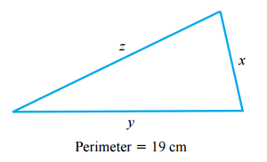
Example 2: Let’s apply what you know! The perimeter of a triangle is 19 cm. If the length of the longest side is twice that of the shortest side and 3 cm less than the sum of the lengths of the other two sides, find the lengths of the three sides.

You try! The measure of the largest angle of a triangle is 10°more than the sum of the measures of the other two angles and 10° less than 3 times the measure of the smallest angle. Find the measures of the three angles of the triangle.

Example 3: Jacksonville, Florida has an elevation of 12 ft. above sea level. A hot air balloon taking off from Jacksonville rises 50 ft./min. Write an equation to model the balloon’s elevation as a function of time.

Balloon’s elevation = __________ $∙$ ___________ + ________________

Let h = ________________

Let t = _________________________________________

Write the equation: _________________________________________

Graph the equation:

What is the h-intercept? ________________

What does the h-intercept represent? ______________

Try on your own! If the balloon begins descending at a rate of 20 ft./min from an elevation of 1,350 ft., write a new equation to model the balloon’s elevation as a function of time.

___________________________________________________

Graph the new equation.

Example 4: A candle is 6 in. tall after burning for 1 hour. After 3 hours, it is 5.5 in. tall. Write a linear equation to model the height y of the candle after burning for x hours.

Step 1: Identify your data points. ( ) and ( )

Step 2: Find the slope of the line.

Step 3. Use one of the points and the point-slope form __________________________ to write an equation for the line.

What does the slope -$\frac{1}{4}$ represent?

Try on your own! Another candle is 7 in. tall after burning for 1 hour and 5 in. tall after burning for 2 hrs. Write a linear equation to model the height of the candle.

What will the height of the candle be after 4 hours?

Example 5: A woman is considering buying a car built in 1999. She researches prices for various years of the same model and records the data in a table.

Model Year | 2000 | 2001 | 2002 | 2003 | 2004
Prices | $5,784 | $6,810 | $8,237 | $9,660 | $10,948

Let x represent the model year and y represent the price. Let’s use the calculator to find a linear model that will represent this data!

On your graphing calculator, go to STAT EDIT and enter your x-values into L₁. Instead of using actual years, _____________________________________________________________

Enter your y-values into L₂.

Go to STAT CALC LinReg. If you have a TI-83 Plus, enter (L₁, L₂). On any other calculator, verify that it is using the proper lists and click Calculate.

What is your linear regression for this data? _________________________________________

Using this data, how much do you think the car should cost in 2009? _____________________

Example 6:

Stan decided to visit Tomas’s Tacqueria for lunch one day, and he only had $60 in his wallet. If each taco costs $5 and each burrito costs $3, write an inequality representing the number of tacos and burritos Stan can purchase.
What does the line represent? ________________________

________________________

________________________

________________________

________________________

What does the shaded area represent? _______________

________________________

________________________

________________________

_________________________
Let t = _____________________________________

Let b = ____________________________________

Write the inequality: __________________________

Graph the inequality.

*Remember, before you graph, your inequality must be in slope-intercept form!

Day 5: Linear Programming (Graphing Only)

Linear Programming is _________________________________________________________

______________________________________________________________________________

This quantity is modeled with an _________________________________.

Limits on the variables in the objective function are known as _____________________, written

as __________________________________.

Example 1:

$$\left\{\begin{aligned}x≤10 \\ y≤7 \\ y≥4 \\ \frac{3}{4}x+y≥10\end{aligned}\right.$$

Objective function: Maximize C if $C=8x+12y$

Step 1: Graph the constraints.

*Remember, the constraints have to be in
slope-intercept form before you graph them!

Step 2: Find the area and the vertices that bound the area shaded by all four constraints. This is

known as the _________________________.
Vertex Principle of Linear Programming

If there is a maximum or a minimum value of the linear objective function, it occurs at

___________________________________________________________________________.
Step 3: List your vertices in the computation box, and plug each into the objective function.

Computation Box

Try on your own!

$\left\{\begin{aligned}y≥\frac{3}{2}x-3 \\ y≤-x+7 \\ x≥0 \\ y≥0\end{aligned}\right.$

Maximize $P=3x+2y$

Computation Box:

Try on your own!

$\left\{\begin{aligned}x+y≥6 \\ y≤5 \\ x≤8 \\ \end{aligned}\right.$

Minimize $C=x+3y$

Computation Box:

Day 6: Linear Programming (Word Problems)

State the variables, the objective function, and the constraints. Graph the system of inequalities, find your feasible region, list the points of your feasible region and then optimize your solution.

1. You are going to make and sell bread. A loaf of Irish soda bread is made with 2 c flour and ¼ c sugar. Banana nut bread is made with 4 c flour and 1 c sugar. You will make a profit of $1.50 on each loaf of Irish soda bread and a profit of $4 on each Banana nut. You have 16 c flour and 3 c sugar. How many of each kind of bread should you make to maximize the profit? What is the maximum profit?

Variables:  x =  y = | Objective Function: | Constraints: | Computation Box: | Answer in complete sentence:

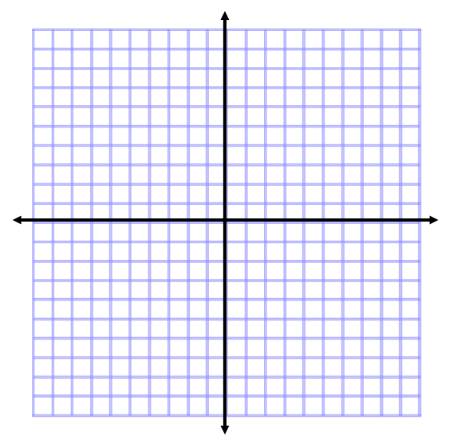

2. A factory produces short-sleeved and long-sleeved shirts. A short-sleeved shirt requires 30 minutes of labor, a long-sleeved shirt requires 45 minutes of labor, and 240 hours of labor are available per day. The maximum number of shirts that can be packaged in a day is 400, so no more than 400 shirts should be produced each day. If the profits on a short-sleeved shirt and a long-sleeved shirt are $11 and $16, respectively, find the maximum possible daily profit.

Variables:  x =  y = | Objective Function: | Constraints: | Computation Box: | Answer in complete sentence:

3. A nutrition center sells health food to mountain-climbing teams. The Trailblazer mix package contains one pound of corn cereal mixed with four pounds of wheat cereal and sells for $9.75. The Frontier mix package contains two pounds of corn cereal mixed with three pounds of wheat cereal and sells for $9.50. The center has available 60 pounds of corn cereal and 120 pounds of wheat cereal. How many packages of each mix should the center sell to maximize its income?

Variables:  x =  y = | Objective Function: | Constraints: | Computation Box: | Answer in complete sentence:

Day 7: Arithmetic Sequences

In an arithmetic sequence, ________________________________________________________.

That difference is called the ______________________________. It can be positive, which

means ________________________________________________________________________

or negative, which means ________________________________________________________.

Example 1: Is the given sequence arithmetic? If so, state the common difference.

- 2, 4, 8, 16,…

- 3, 0, -3, -6,…

- 2, 5, 7, 12,…

- 39, 42, 45, 48,…

Example 2: Use the arithmetic mean to find the missing term(s) in the arithmetic sequence.

Arithmetic mean =

- 84, ____, 110

- 25, ____, -10

- $\frac{13}{2},$ ____, $\frac{51}{2}$

- a₁₀, ____, a₁₂

- 2, ____, ____, ____, -22

- 660, ____, ____, ____, 744

Example 3: Suppose a trolley stops at a certain intersection every 14 minutes. The first trolley of the day gets to the stop at 6:43 AM. How long do you have to wait for a trolley if you get to the stop at 8:15 AM? At 3:20 PM?

Essentially, you have been using a recursive formula: _________________________________

Example 4: Write the recursive formula for the following sequences. Then, find the 8th term.

- 2, 4, 6, 8, 10…

- -4, -8, -12, -16, -20

But sometimes, you need to find a much higher term, such as the 58th term in a sequence, and using the recursive formula would be too time-consuming.

Instead, we can use an explicit formula: ____________________________________________

Example 5: Find the explicit formula for each sequence. Then, find the 35th term.

- 27, 15, 3, -9, -21…

- -32, -20, -8, 4, 16…

- -5, -3.5, -2, -0.5, 1…

Example 6: Given the following formula, find the first 4 terms: a₁ = 8, a_{n} = a_{n-1} + 6

Try on your own! Find the first four terms. a₁ = -4, a_{n} = a_{n-1} + 2

Example 7: Given the recursive formula, find the explicit formula for a₁ = -4, a_{n} = a_{n-1} + 2

Try on your own! Given the recursive formula, find the explicit formula for a₁ = 0, a_{n} = a_{n-1} + 6

Example 8: Given the explicit formula, write the recursive formula for a_{n} = 3n – 1.

Try on your own! Given the explicit formula, write the recursive formula for a_{n} = -5n + 2.

Example 9: You can also plot arithmetic sequences! But, what do their graphs look like? Fill in the table based on the information given and graph the data to find out!

Jacob is planning to mow lawns this summer to earn money. He is planning to charge $50 for gas and $5 for each acre mowed.
# of acres mowed | $ charged  What is the recursive formula for Jacob’s payment plan?  What is the explicit formula?
0
1
2
3
4
5
6

You try! Courtney decides to raise money for the children’s hospital, and she decides she’ll kick off the donations by placing $50 in the jar at school. Her goal is to raise $120 per day. John thinks it would be fun to make the fundraiser a competition, so he puts his own jar in the cafeteria and throws in $75. His goal is to raise $100 per day.

- Write recursive and explicit formulas for Courtney and John’s fundraising. Then, graph them.
 | Recursive | Explicit
Courtney
John

- When will they have raised the same amount of money?
How do you know?

