Math III Unit 6: LINES, ANGLES, QUADRILATERALS, & PROOFS
Lauren Winstead, Heritage High School

Main topics of instruction:
1) Lines, angles, and intro to proofs
2) Intro to flow charts and two-column proofs
3) Parallelograms

Day 1: Lines, Angles, & Intro to Proofs
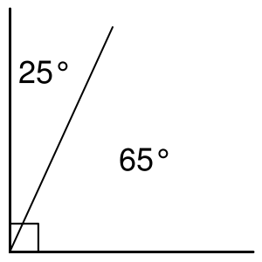

- Angles whose measures have a sum of 90° are __________________________.

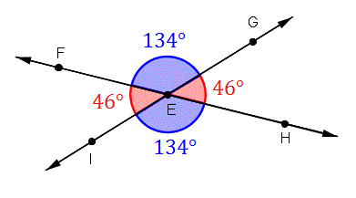

- Vertical angles have equal measures, so they are _________________________.

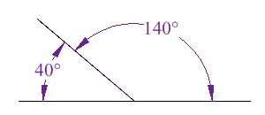
- Angles whose measures have a sum of 180° are ________________________.

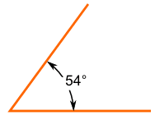
- An angle that measures less than 90° is an _________________ angle.

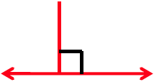
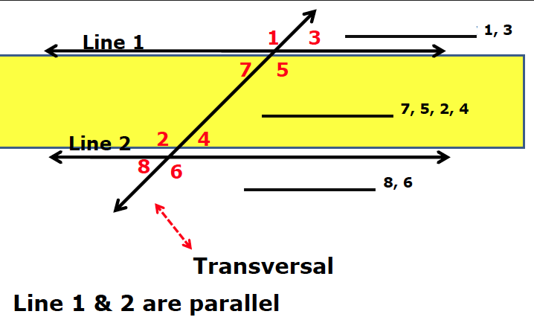
Parallel lines do not intersect, but perpendicular lines intersect at a _______________.

A transversal is __________________________________________________________

________________________________________________________________________

_______________________________________________________________________.

Alternate angles ____________________________________________________.
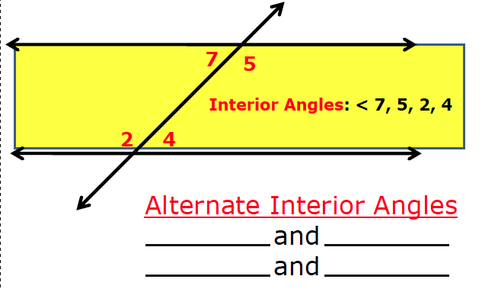

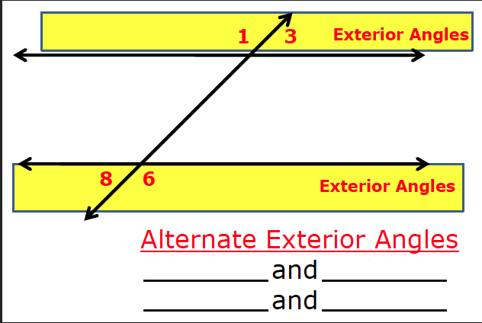

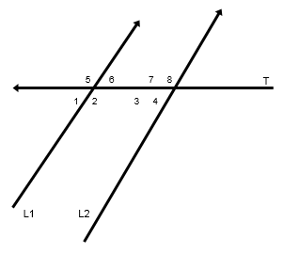
You try! If $m∠2=2x+5$ and $m∠7=4x-13$,
find the measures of all angles.

Corresponding angles ____________________________________________________

_______________________________________________________________________.
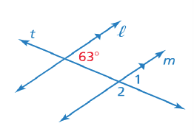
The $63°$ angle and $∠1$ are corresponding angles, because they are matching pairs created by two parallel lines and a transversal.

Intro to Two-

lumn Proofs
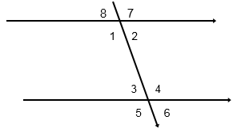
You try! Given $m∠1=2x+18$ and $m∠5=5x-21$,
find all the angles.

THEOREMS:

- If two lines are parallel, then the ______________________________ are congruent.
- If two lines are parallel, then the ______________________________ are congruent.
- If two lines are parallel, then the ______________________________ are congruent.

The CONVERSE is also true:

- If alternate interior/alternate exterior/corresponding angles are congruent, then ____________________________________________________________.
Let’s try some proofs!

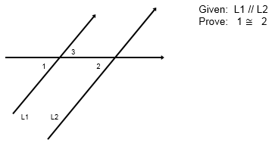
Reasons
Statements

Try on your own:

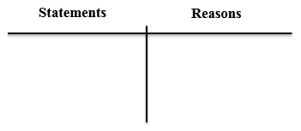
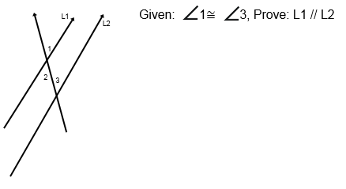

Try one more!
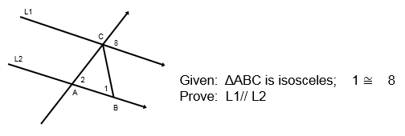

Try a few more… this time with equations! Solve for x.
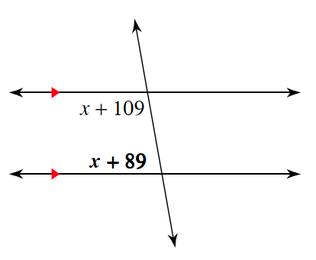
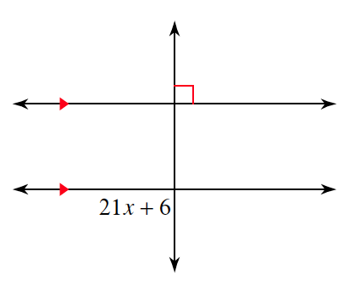
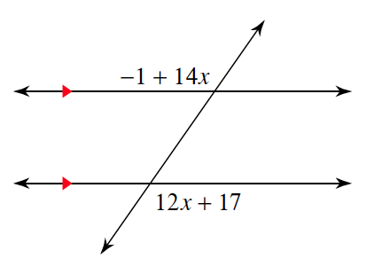

Day 2: More Work with Proofs

Consecutive angles: ______________________________________________________

_______________________________________________________________________.

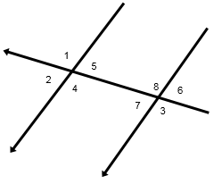
Which pairs of angles in the diagram are consecutive?
______________________________

THEOREM: If 2 lines are parallel, then consecutive angles are _________________.

CONVERSE: If consecutive angles are supplementary, then two lines are ______________________.

You try! In the diagram above, $m∠4=2x^{2}+5x+50$ and $m∠7=-x^{2}+2x+100.$
Find $m∠5$.

Let’s practice some more proofs!

Example 2: Use what you know about angles to write a two-column proof.
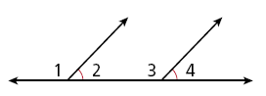
Given: $∠2≅∠4$
Prove: $m∠1≅m∠3$

Statements Reasons

Try on your own! Use what you know about angles to write a two-column proof.
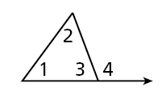
Given: $m∠1+m∠2=m∠4$
Prove: $m∠3+m∠1+m∠2=180°$

Statements Reasons

Try one more! Use what you know about angles to write a two-column proof.
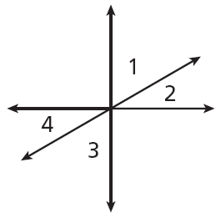
Given: $∠1$ and $∠2$ are complementary.
Prove: $∠3$ and $∠4$ are complementary.

Statements Reasons

