**HW 7-1**

1. **Find the value of each variable.**

$a˚$ =_______________

b˚=

$c˚$_______________

=_______________

1. **Find the value of each variable.**

$${50}^{o}$$

x

$${70}^{o}$$

x



**Determine whether a tangent line is shown in each diagram. Explain.**

4. 5. 6.

In the figure, name an example of each of the following:

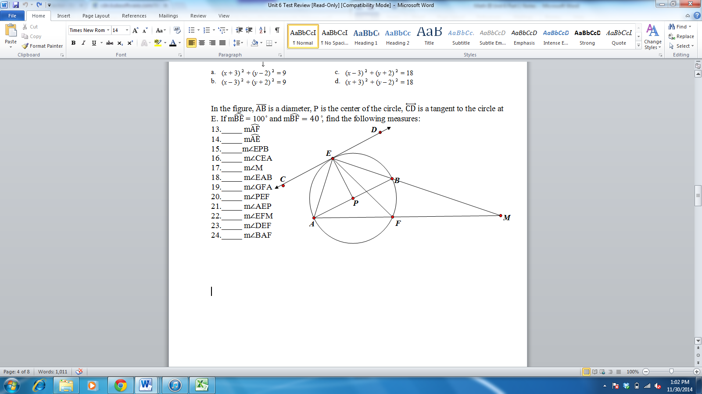7. tangent line_____

13. arc_____

14. major arc_____

15. minor arc_____

16. semi-circle_____

17. inscribed angle_____

18. circumscribed angle_____

19. central angle _____

8. radius_____

9. diameter_____

10. secant line_____

11. chord_____

12. circle_____

**HW 7-2**

Convert the following degree measures into radians.

1. 180 $°$ 2. 225 $°$ 3. 80 $°$ 4. 270 $°$

Convert the following radian measures into degrees.

5. 6. 7. 8.

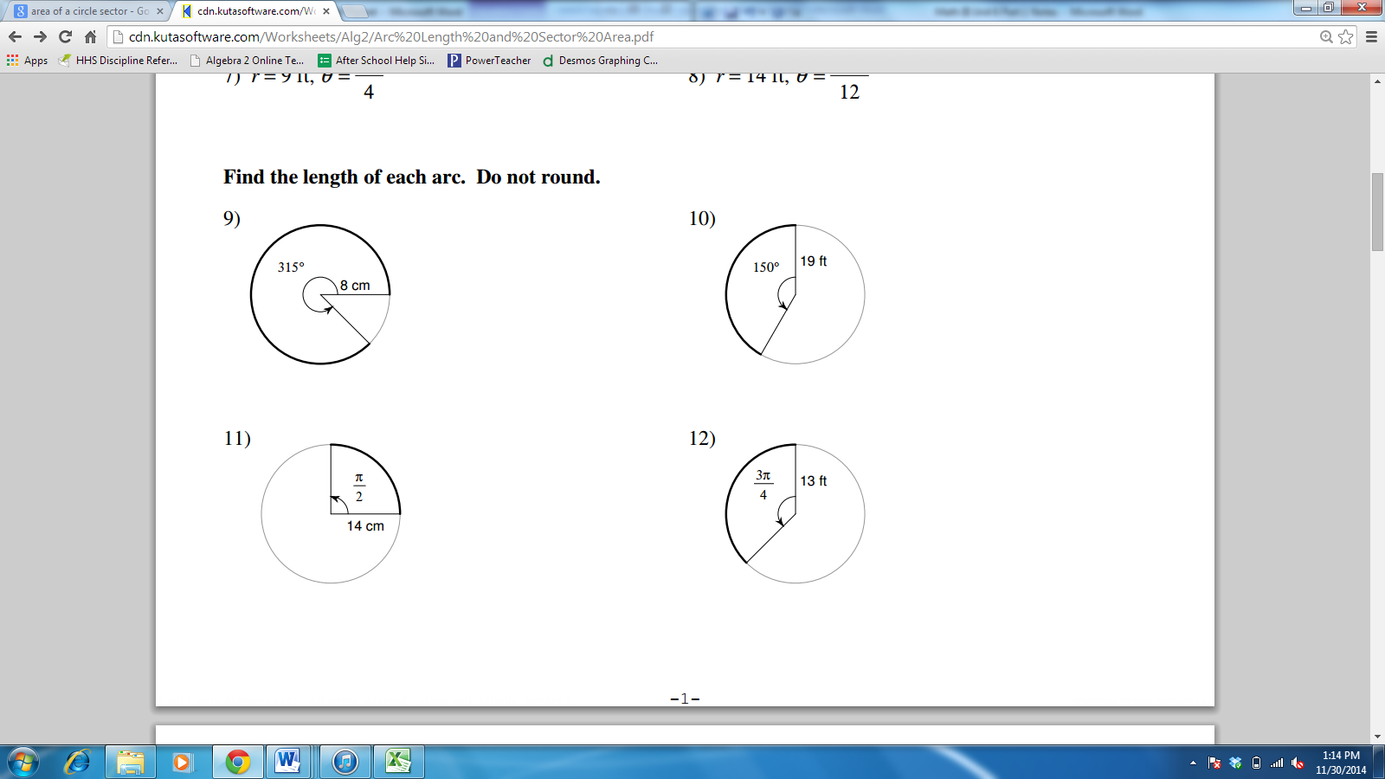

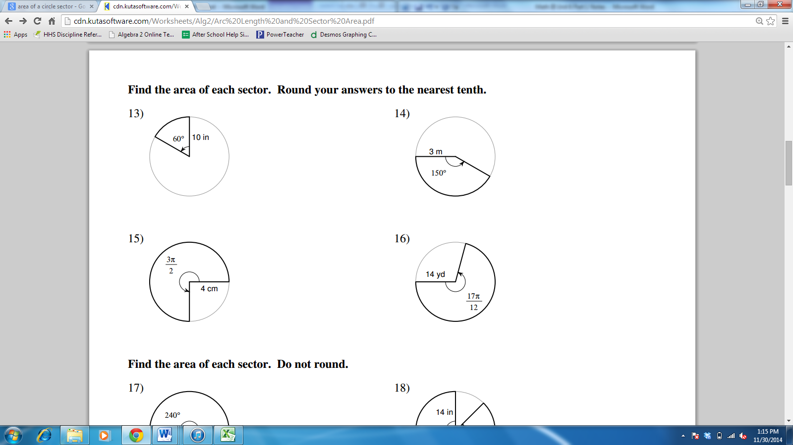

**HW 7-3**

Assume that lines that appear to be tangent are tangent. *O* is the center of each circle. Find the value of *x*.

1.  2. 3.

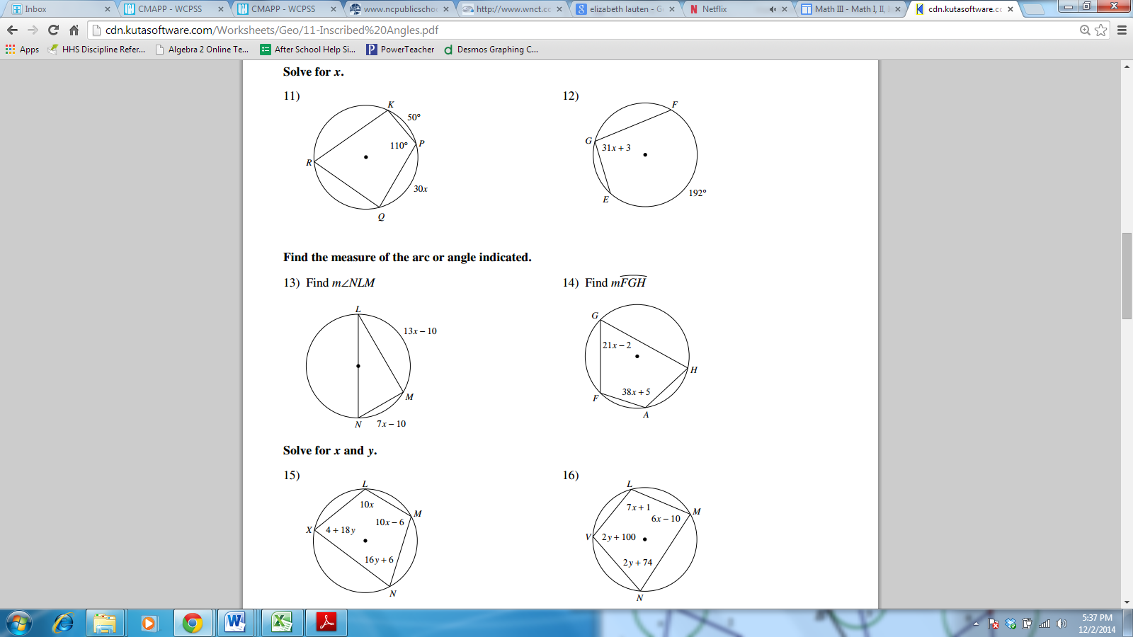

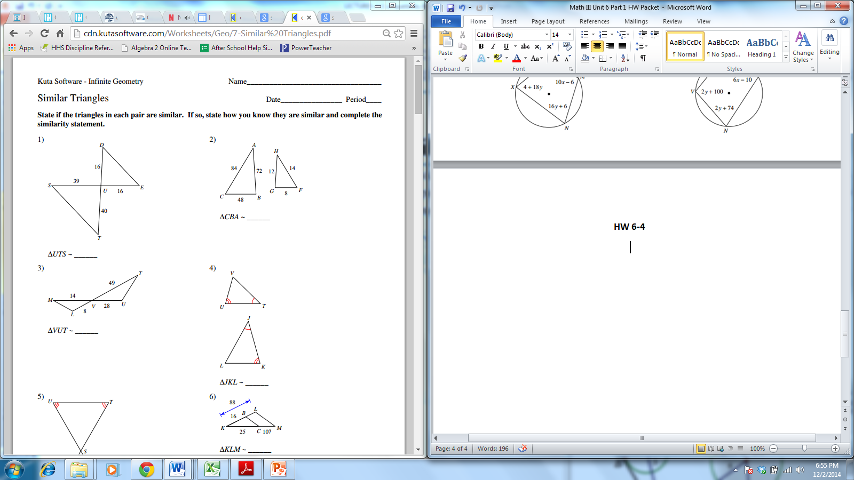**HW 7-4**

