Module 7b Review

Solve the following:

- $x^{2}+9x+18=0$

- $x^{2}-11x=42$

- $x^{2}-10x+25=0$

- $2x^{2}+9x+9=0$

- $3x^{2}+x+5=9$

- $4x^{2}-81=0$

- $9x^{2}-32=4$

Answer the following questions about the word problem:
- If Alanis and Lauren are playing catch and Lauren throws the ball in a path that can be modeled by the equation $h=-16t^{2}+48t+5$ where h is height in feet and t is time in seconds. Make sure to write your answers in the correct units.
  - What is the initial velocity of the throw?

  - What is the initial height of the throw?

  - When will her throw hit the ground?

  - When will her throw hit its maximum height?

  - When will the throw reach 36 feet for the first time?

  - When will the throw reach 21 feet on the way down?

  - What is the maximum height of the throw?

- Create an equation to model Alanis’s throw back to Lauren if it has the same acceleration and same initial height, but an initial velocity of 59 feet per second.
  - What is the maximum height of her throw?
  - When will it hit its maximum height?
  - When will it reach 49 feet for the first time?

Given the following graph, answer the questions that follow.
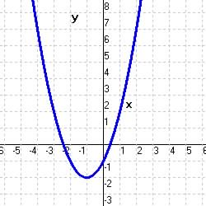
a) Axis of Symmetry: ____________
b) Vertex: ____________
c) y-intercept: ____________
d) x – intercepts: ____________
e) Increasing Interval: ____________
f) Decreasing Interval: ____________
g) Domain: ____________
h) Range: ____________

- Given the function $y=x^{2}-12x+20$ answer the following:
a) Axis of Symmetry: ____________ b) Vertex: ____________

c) y-intercept: ____________ d) Solutions: ____________

e) Increasing Interval: ____________ f) Decreasing Interval: ____________

g) Domain: ____________ h) Range: ____________

