Module 9 Review

The table below contains high temperatures measured in the month of May in Sullivan, Illinois. Use the date to find the following:
$$78°$$ | $$55°$$ | 91$°$ | 83$°$ | 61$°$ | 72$°$ | 81$°$ | 78$°$ | 83$°$ | 77$°$ | 86$°$ | 71$°$ | 68$°$ | 75$°$ | 32$°$ | 59$°$ | 54$°$ | 63$°$

1. Mean ___________________ 8. Minimum _____________

2. Median __________________ 9. Interquartile Range ___________

3. Mode ___________________ 10. Range ____________

4. Quartile 3_____________________ 11. Standard Deviation _______

5. Quartile 1 ____________________ 12. Maximum __________

6. What is the best measure of center? ________________________

7. What is the best measure of spread? __________________________

Use the table below about the Quiz grades and then complete problems 1-4.
Student | Quiz 1 | Quiz 2
Tim | 88 | 76
Jamal | 67 | 91
Sam | 76 | 92
Tom | 88 | 88
Billy | 75 | 76
Nathan | 65 | 88
Bob | 92 | 89
Noah | 87 | 86
Jake | 68 | 79
Eric | 87 | 90

$$\overline{x}$$ | σ
- Find the mean and standard deviation for Quiz 1.

$$\overline{x}$$ | σ
- Find the mean and standard deviation for Quiz 2.

- Complete the five number summary for Quiz 1.
Min | Q₁ | Med | Q₃ | Max
- Complete the five number summary for Quiz 2.
Min | Q₁ | Med | Q₃ | Max
- Are there any outliers for either Quiz 1 or Quiz 2? If so state the outlier and which Quiz it is in.

- Is either team more consistent? Explain your reasoning using complete sentences.

Given this table of data answer the following questions.

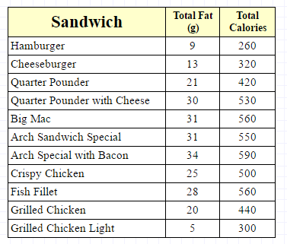
- What is its line of best fit?

- What is its correlation coefficient (r value)?

- Is it a good or bad fit?

- Describe the slope in context.

- Describe the y-int in context

- Estimate how many calories would be in a sandwich with 18 grams of fat.

Match the following scatter plots to their correlation coefficients.
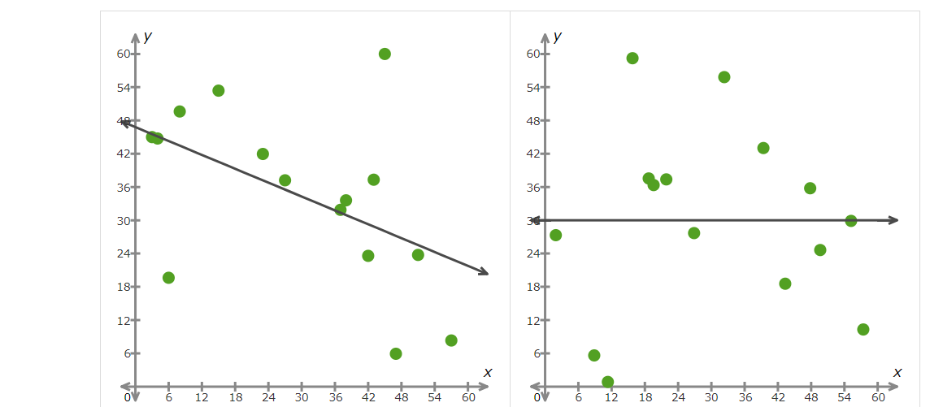

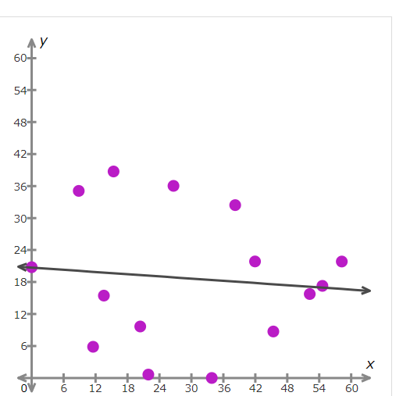
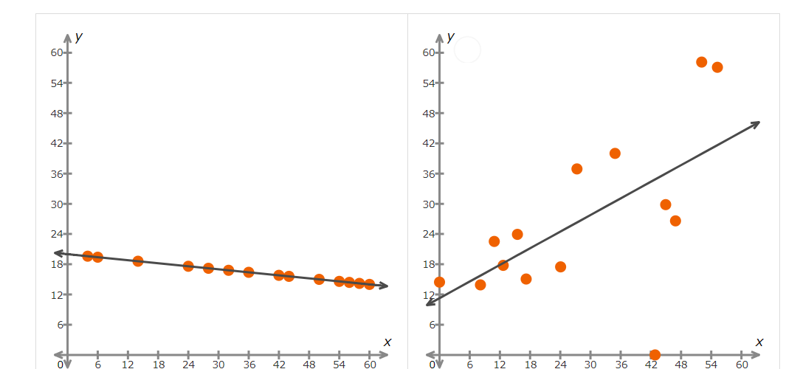

- -1
- 0.6
- 0
- 0.5
- -0.1

Multiple Choice Practice:
