Unit 5 Placemat (Foundations skills needed for Unit 5)
Label each side of the triangle (legs vs. hypotenuse) | 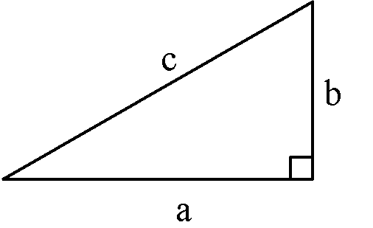  Use the Pythagorean Theorem to solve for the missing side in each triangle.  - $a=2, b=3, c=?$  - $b=?, c=7, a=5$  - $c=5, b=3, a=?$  - $a=6, b=4, c=?$ |  | 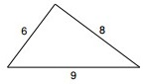  Determine if the following triangles could be sides of a right triangle by using Pythagorean Theorem. Circle all of the right triangles:  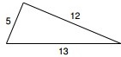  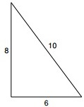  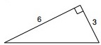  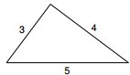
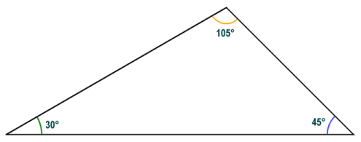
Classify each of the following triangles by their sides (scalene, equilateral, isosceles) AND by their angles (right, acute, obtuse).
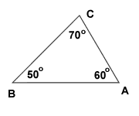
- 3.

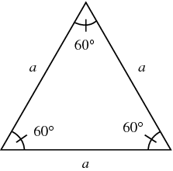
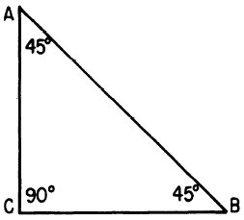

- 4.

Find each of the missing angle measurements using what you know about the sum of all measures of a triangle.

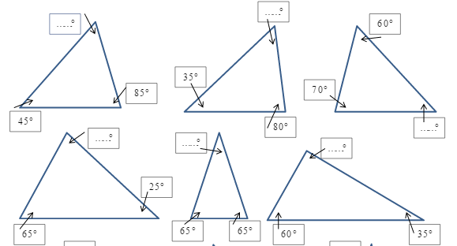
Simplify each of the following radicals:  - $\sqrt{162}$  - $\sqrt{432}$  - $\sqrt{128}$ |  | Solve each equation for the variable  - $4^{2}+b^{2}=25$  - $6^{2}+8^{2}=c^{2}$  - $a^{2}+{15}^{2}={25}^{2}$  - ${30}^{3}+{40}^{2}=c^{2}$

