Honors Math 3 Name: ___________________________
Proofs – Extra Practice
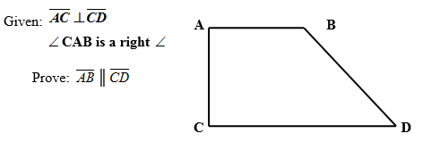
In your group, complete each proof.
- 2)

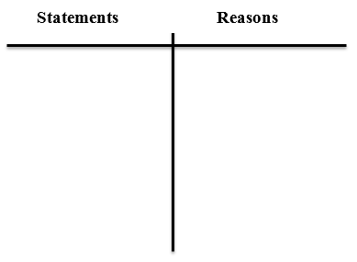
p

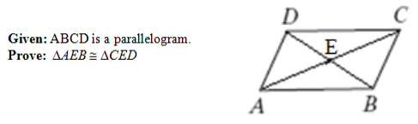
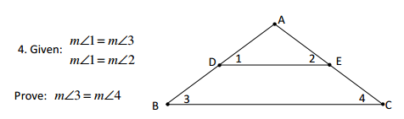
- 4)

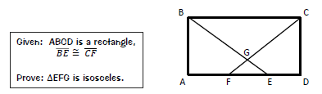
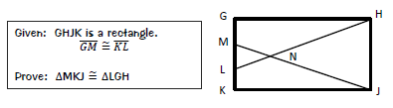
5) 6)

