Quadratics Station

1. Factor the following:

a. b. c.

2. The path of a projectile shot out of a cannon follows the path modeled by the equation $f\left(x\right)= -16x^{2}+95x+4$, when x is time in seconds and f(t) is height in feet.

a. What is the maximum height that the projectile reaches?

b. What is the initial height of the projectile?

c. When will the projectile reach the ground?

d. When does the projectile reach its maximum height?

e. When will the projectile reach 100 feet the first time?

3. Solve the following:

a. 16x2 = 4 b. 2x2 +8x = 24 c. 3x2 – 13x = 30

4. Suppose that the equation $V=20.8x^{2}-458.3x+3500$ represents the value of a car from 1964 to 2002. What year did the car have the least value? (x = 0 in 1964)

5. Which of the following statements is a correct comparison between the vertex for equation A and the vertex for equation b.

a. The x and y values of the vertex for equation A is larger than the x and y values for equation B.

b. The x value for equation A is larger than equation B, and the y value for equation A is smaller than equation B.

c. The x value for equation B is larger than equation A, and the y value for equation B is smaller than equation A.

d. The x and y values of the vertex for equation B is larger than the x and y values for equation A.

Equation A Equation B

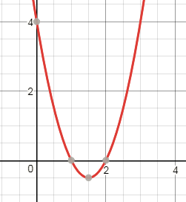

|  |  |
| --- | --- |
| x | y |
| -5 | -2 |
| -4 | 1 |
| -3 | 2 |
| -2 | 1 |
| -1 | -2 |

5. The area of a trapezoid is found using the equation $A= \frac{1}{2}h(b_{1}+b_{2})$. Find the area of the trapezoid below. Simplify your answer.

x + 5

x + 2

3x - 1

6. The area of a rectangle is represented as A = 3x2 – 4x – 15. If the area is 104 units2 find the value of x.

Calculator INACTIVE Questions:

7. Which is the graph of the function f(x) = 4x2 – 8x + 7?

a. b.



c. d.

8.

9.

10. 