Quarter 2 Review

1. Sam and Heather are the same height. Sam is on the balcony of a 150 ft tall hotel at the beach. Heather is on the beach is making eye contact with him at a 62° angle. How far away from the hotel is Heather standing on the beach? Round to the nearest tenth.
2. You are 15 feet from a tree. The angle of elevation from your eyes, which are 5.5 feet off the ground, to the top of the tree is 61 degrees. To the nearest foot, how tall is the tree?
3. A marine sniper is on a building. The combined height of the building and up to his eye level is 146 feet. He is looking at a target at a 30° angle of depression. How far is the target from the base of the building? Round to the nearest tenth.
4. From an airplane at an altitude of 1400 meters, the angle of depression to a rock on the ground measures 18 degrees. Find the distance from the plane to the rock to the nearest hundredth.
5. From a plane flying due east at 235 meters above sea level, the angles of depression of 2 ships sailing due east measure 45 degrees and 15 degrees. How far apart are the ships?
6. Solve each of the following for x.

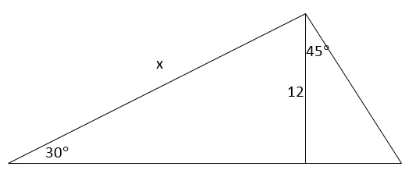

18

x

29°

12in

18in

x

18

x°

13

1. Given *C* (8, -2), what would the image of C be under the following transformations. Make sure you ALWAYS start with the pre-image of C.

a. Translate down 3, right 4 b. Dilate 4 c. Rotate 270

d. Reflect x-axis e. Rotate 180 f. Reflect y-axis

g. Rotate 90 h. Reflect y = x i. Reflect y-axis, rotate 180

j.Reflected over x-axis and then translated up 7 and left 1.

1. If P”(4, -6) was found after reflecting across the line y=x and the translating according to T(5, -3), then find P.
2. If P’’’(-12,10) was found after rotating 90°Clockwise, reflecting across the y-axis, and dilating by a factor of 2, then find the pre-image.
3. Name the type of each given angle pair.
$∠3 and ∠5$

$∠1 and ∠7$

$∠4 and ∠8$

$∠7 and ∠2$

$∠6 and ∠3$

4. Given: $a∥b$ and $m∠5=112°$. In the diagram above, Find the measure of each of the following:

$m∠1=_____________$, $m∠2=_____________$, $m∠3=_____________$, $m∠4=_____________$,

$m∠6=_____________$, $m∠7=_____________$, $m∠8=_____________$

1. Use the diagram below to answer parts a-c

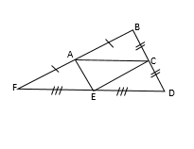 a) If AE=6x + 5 and BD = 6x + 13. Find CD.

b) FE = 2x + 4 and ED = 7x – 26. Find FD.

c) If the perimeter of ∆ACE= 720, what is the perimeter of ∆FBD.

1. Find the measure of angle M.

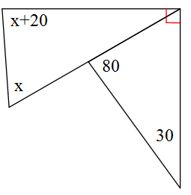

M

1. If $TQ=5x-1$, and you are given the following diagram, find the length of $TS$.

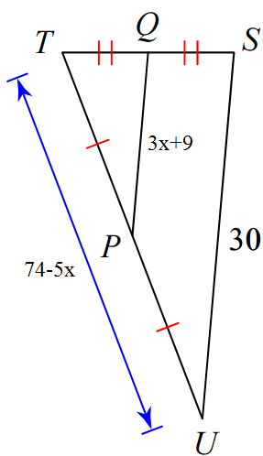

1. Given $∆WVX≅∆TSU$, $WV=4x+1$, $TS=x+7$, and $TU=4-x$, solve for *TU*.
2. Given $∆WVX≅∆TSU$, $m<W=2x-7$, $m<U=3x-15$, and $m<S=47$, solve for x.
3. In $∆WVX$: WV=15, VX=15, m<W=50. Solve for m<V.
4. In a school of 320 students, 85 students are in the band, 200 students are on sports teams, and 60 students participate in both activities.

a. Create a Venn Diagram of the information given above.

b. What is the probability that a random student chosen is only in the band?

c. How many students are only on a sports team?

1. 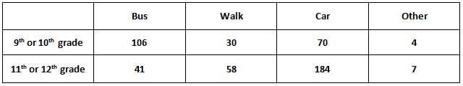Given the two-way table, answer the following questions.
2. What is the probability that a student chosen at random walks to school?
3. What is the probability that a student chosen at random walks to school and is in the 9th/10th grade?
4. What is the probability that a student takes the bus to school given that they are in the 9th/10th grade?
5. What is the probability that a student chosen at random takes a car to school or is in the 11th/12th grade?
6. Given a standard deck of cards, answer the following:
7. P(heart or face card)
8. P(face card followed by an ace)
9. P(Queen $\left|Red)\right.$
10. P(diamond and not a facecard)
11. P(Black $\left|King)\right.$
12. Odds of a five
13. A bag contains 26 tiles with a letter on each, one tile for each letter of the alphabet. What is the probability of reaching into the bag and randomly choosing a tile with one of the letters in the word ENGLISH on it or randomly choosing a tile with a vowel on it, assuming that y is not a vowel?
14. In Tania's homeroom class, 9% of the students were born in March and 40% of the students have a blood type of O+. In the class 6% of the students were born in March and have the blood type O+. What is the probability of a student chosen at random from Tania's homeroom class being born in March and having a blood type of O+?
15. If the probability of making a field goal in any particular game is 65%, what is the probability of not making a field goal 4 attempts in a row?
16. Ariana has 7 jackets, 6 scarves, 3 pairs of mittens, and 5 hats. Determine the number of different outfits consisting of a jacket, hat, and either a scarf or a pair of mittens that Ariana can wear.
17. The probability of owning a jet ski is 73% and the probability of owning a boat is 42%. If 38% of people own both a jet ski and a boat, find each of the following:
    1. P(owning a jet ski or a boat)
    2. P(owning boat $\left|own a jet ski\right.$)
18. Given $\frac{\overline{AC}}{\overline{DC}}=\frac{\overline{BC}}{\overline{EC}}$

Prove $∆ABC\sim ∆DEC$

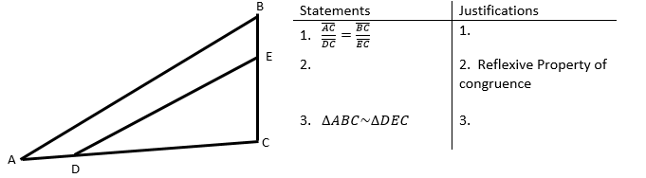

1. Prove $∆NAP\sim ∆KIN$

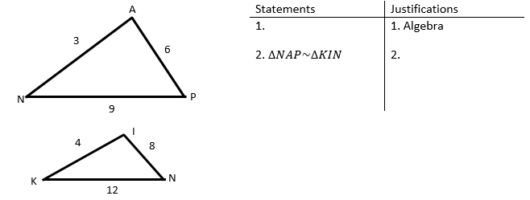

|  |  |
| --- | --- |
| Statements | Justifications |
| 1. $\overline{AB}∥\overline{DE}$ | 1. Given |
| 2. $∠D≅∠A$ | 2. |
| 3. | 3. Reflexive Property of congruence |
| 4. $∆ABC\sim ∆DEC$ | 4. |

1. Given $\overline{AB}∥\overline{DE}$

A

C

B

E

D

Prove $∆ABC\sim ∆DEC$

1. Given $∆GAB$ with $\overline{GS}$ $\overline{AB}$, and $\overline{GA}≅\overline{GB}$.

Prove .

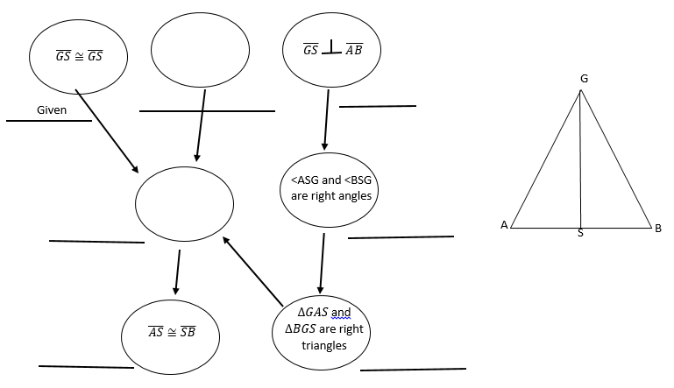

1. 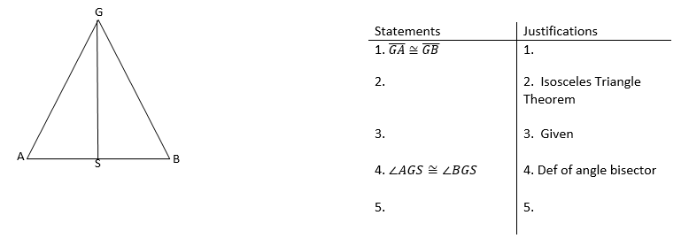Given $\overline{GA}≅\overline{GB}$ and $\overline{GS}$ is an angle bisector, prove $∆GAS≅∆GBS$.
2. Given $\overline{ST}≅\overline{CK}$ and $\overline{ST}∥\overline{CK}$, prove $∆STA≅∆CKA$

