System station #1

- What is the solution to the system: $\left\{\begin{aligned}2x+3y=11 \\ 4x-5y=11\end{aligned}\right.$

- (4, 0) b) (1, 4) c) (4, 1) d) (-1, 4)

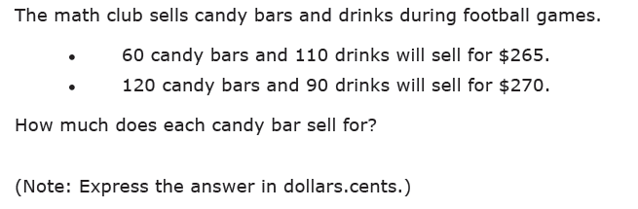

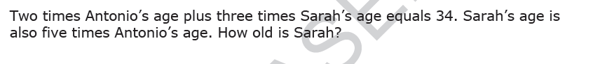

- A sum of money amounting too $3.70 consists of dimes and quarters. There are 19 coins in all, how many are quarters?
- 12 quarters b) 9 quarters c) 7 quarters d) 17 quarters

