TI Calculator Stats Sheet
Find the mode, median, mean, lower quartile, upper quartile, interquartile range, and population standard deviation for the data set {13, 3, 10, 9, 7, 10, 12, 8, 6, 3, 9, 6, 11, 5, 9, 13, 8, 7, 7}
1. Enter the data into a list | 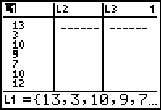 | 2. Go to STAT → CALC #1 1-Var Stats. Then choose L1. | 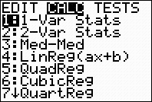
= mean  = sum of the data  = sum of squares of the data  = sample standard deviation  = population standard deviation  n = sample size (# of pieces of data)  = smallest data entry  = first quartile  = median (second quartile)  = third quartile  = largest data entry |  | 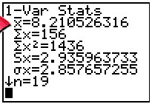  Mode = 7, 9  Median = 8  Mean = 8.21  lower quartile = 6  upper quartile = 10 | 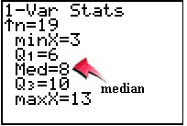  Interquartile range = 10 – 6 = 4  Population  standard deviation = 2.86

TI Calculator Stats Sheet
Find the mode, median, mean, lower quartile, upper quartile, interquartile range, and population standard deviation for the data set {13, 3, 10, 9, 7, 10, 12, 8, 6, 3, 9, 6, 11, 5, 9, 13, 8, 7, 7}
1. Enter the data into a list |  | 2. Go to STAT → CALC #1 1-Var Stats. Then choose L1.
= mean  = sum of the data  = sum of squares of the data  = sample standard deviation  = population standard deviation  n = sample size (# of pieces of data)  = smallest data entry  = first quartile  = median (second quartile)  = third quartile  = largest data entry |  | Mode = 7, 9  Median = 8  Mean = 8.21  lower quartile = 6  upper quartile = 10 | Interquartile range = 10 – 6 = 4  Population  standard deviation = 2.86

