# Unit 1 Review Sheet Name ___________________________

## Honors Math 3 Date ___________ Period ______

|  |
| --- |
| 1) a) Find the slope-intercept form of the equation that is parallel to 3x + 4y = -12 and passes through (-2, 5).  b) Find the slope-intercept form of the equation that is perpendicular to 3x + 4y = -12 and passes through (4, -1).  c) Of the following set of linear equations, two of them are either parallel or perpendicular. Which are they? Are they parallel or perpendicular? 1) y = -2x + 3  2)  3) |
| 1. Fill in the following with Same, Different, or Doesn’t Matter.   Parallel lines have the ____________ slope and _____________ y-intercept.  Perpendicular lines have the _____________ slope and ______________ y-intercept.  Oblique lines have the _____________ slope and ______________ y-intercept. |

3. Cheapo Rentals charges a flat rate of $30 to rent a car and $0.25 each for every mile driven. Deluxe Rentals charges no flat rate, but they charge $0.35 for every mile driven. Which system of equations should be used to solve the problem?

**a.  b.  c.  d. **

Solve the system of equations

4**.  __________ 5. **

Solve each system of inequalities by graphing.

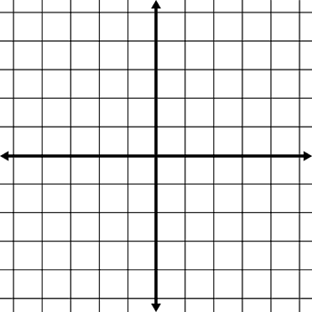 **6. **

|  |  |
| --- | --- |
| 7. Write the system as a matrix equation and find the solution. | 8. Solve the system. . |
| 1. Write a system for the problem. Solve using any method. DEFINE VARIABLES!     Chloe bought 3 marbles and 5 jacks and her total charge was $7.25. Sam bought 2 marbles and 9 jacks and she paid $10.50. How much does each marble and jack cost? | 10. Given the following vertices for the feasible region of a linear programming graph, at which point does the minimum value occur given the objective quantity?  **a)** (-1,-5)  **b)** (-6,5)  **c)** (5,2)  **d)** (6,-5) |
| http://mathbits.com/MathBits/StudentResources/GraphPaper/14by14%20axes.jpg11. The Northern Wisconsin Paper Mill can convert wood pulp to either notebook paper or newsprint. The mill can produce at most 200 units of paper a day. At least 10 units of notebook paper and 80 units of newsprint are required daily by regular customers. If profit on notebook paper is $500 per unit and profit on newsprint is $350 per unit, how much should the manager have the mill produce to maximize his profits? How many units of notebook paper and how many units of newsprint must be produced to maximize profits?   |  |  | | --- | --- | | Variables:  x =  y = | Objective Function: | | Constraints: | Computation Box: | | Answer in complete sentence: | | | |
|  | |