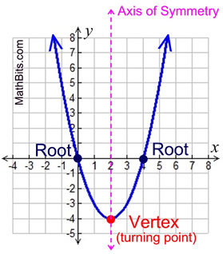
Unit 2: Quadratics Part 2

By the end of the unit students will be able to:
- Identify types of numbers based on the number system.
- Identify and simplify using complex numbers.
- Solve quadratic equations by using the quadratic formula.
- Solve quadratic equations by completing the square.
- Use various methods to solve quadratic equations.

Day | Date | Lesson | Assignment
1 | Monday  Feb. 6th | Number System and Intro to Complex Numbers | HW 2-1
2 | Tuesday  Feb. 7th | Complex Numbers | HW 2-2
3 | Wednesday  Feb. 8th | Quadratic Formula and Discriminant | HW 2-3
4 | Thursday  Feb. 9th | Review and Quiz
5 | Friday  Feb. 10th | Completing the Square  **Early Release Day** | HW 2-5
6 | Monday  Feb. 13th | Completing the Square | HW 2-6
7 | Tuesday  Feb. 14th | Review for test | Study and complete review sheet!!
8 | Wednesday  Feb. 15th | Unit 2 Test | Unit 3 Placemat

