Fundamentals of Math
Unit 2 Day 3

Title For Your Notebook: Prime Factorization

A PRIME NUMBER is a number _____________________________________________________

FACTORS are ____________________________________________________________________

.
Find the factors of the following and write in order from least to greatest.
- 12 2. 24 3. 45 4. 27

U TRY!!
- 50 2. 32 3. 15 4. 17

5. 80 6. 44 7. 100 8. 7

Prime Factorization is ____________________________________________________.

To find the Prime Factorization, you will use ________________ __________________.

Find the prime factorization.
- 21 2. 36 3. 12

U TRY These!
- 8 2. 28 3. 80

4. 6 5. 32 6. 75

A _________________________ of a number is a product of that number and any whole number.
The smallest multiple that 2 or more numbers have in common is the _____________ _________________ ___________________.

- 6 and 9 2. 3 and 4 3. 2 and 9

You TRY!!!!!
4. 12 and 20 5. 20 and 30 6. 7 and 9

Fundamentals of Math
Unit 2 Day 4

Title For Your Notebook: Simplifying fractions

A fraction is in _________________ ___________________ when the top and bottom cannot be any smaller (while still being whole numbers)
How to Simplify Fractions:

Simplify the following fractions:
- $\frac{6}{8}$ 2. $\frac{5}{10}$ 3. $\frac{9}{12}$ 4. $\frac{12}{18}$

U Try!
- $\frac{4}{10}$ 2. $\frac{6}{12}$ 3. $\frac{20}{30}$ 4. $\frac{4}{6}$ 5. $\frac{15}{20}$

Fundamentals of Math http://www.mathplayground.com/howto_comparefractions.html
Unit 2 Day 5

Title for Your Notebook: Comparing Fractions

To compare fractions you determining which fraction is the ______________________ and which

fractions is the _____________________.

There are two ways to do this:
Method 1: Method 2:

Let’s Try! Compare the fractions:
1. $\frac{2}{5} \frac{4}{5}$ 2. $\frac{3}{4} \frac{2}{3}$ 3. $\frac{1}{6} \frac{5}{8}$ 4. $\frac{4}{6} \frac{10}{15}$

U Try!
1. $\frac{1}{6} \frac{4}{6}$ 2. $\frac{1}{4} \frac{1}{8}$ 3. $\frac{3}{6} \frac{8}{12}$ 4. $\frac{5}{6} \frac{2}{15}$

5. $\frac{1}{15} \frac{4}{5}$ 6. $\frac{3}{4} \frac{1}{3}$ 7. $\frac{2}{4} \frac{4}{8}$ 8. $\frac{3}{7} \frac{2}{3}$

Fundamentals of Math http://www.educationworld.com/a_lesson/dailylp/dailylp/dailylp201.shtml
Unit 2 Day 6

Title for Your Notebook: Fraction and Decimal Conversion

Turning a Decimal into a fraction:

______________________ it. ________________________ it. _______________________ it.

Let’s try it!

- 0.7 2. 0.2 3. 0.4

4. 0.13 5. 0.25 6. 0.52

U Try!
1. 0.25 2. 0.8 3. 0.75

4. 0.6 5. 0.88 6. 0.94

Turning a Fraction into a Decimal:

Remember a fraction is another way to write ___________________________.

So, to turn a fraction into a decimal you divide the _____________________ by the ______________________.
Let’s Try It!

1. $\frac{2}{8}$ 2. $\frac{1}{3}$ 3. $\frac{5}{6}$ 4. $\frac{6}{10}$

U Try!

1. $\frac{7}{10}$ 2. $\frac{4}{9}$ 3. $\frac{6}{12}$ 4. $\frac{4}{5}$

Fundamentals of Math
Unit 2 Day 7

Title For Your Notebook: Adding and Subtracting Fractions

First of all, what is a fraction? ____________________________________________________________.
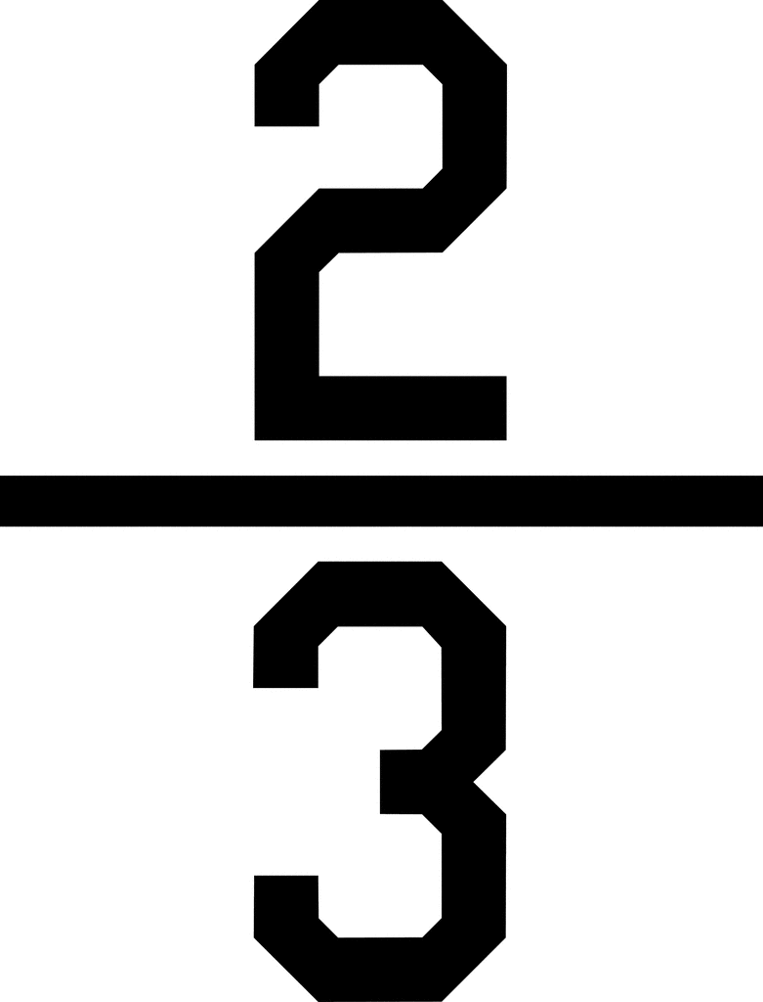
What does it look like?

Think about a pizza. If a pepperoni pizza is cut into five slices and you eat one, then a cheese pizza is cut into five slices and you eat two, you’ve eaten $\frac{1}{5}$ and $\frac{2}{5}$ of each pizza. How much pizza have you eaten total?

So, when you add fractions with the same denominator, the only things you add are the
_______________________!

Let’s try!

But what if the denominators aren’t the same? We need to find the ____________________________!
Example 1: Add $\frac{3}{5}+\frac{7}{10}$
Step 1) What is the smallest number that both 5 and 10 multiply into? ______
That will be our new denominator!
Step 2) But wait, you can’t just change the denominator without changing the numerator! What could you multiply 5 by to get 10? _______ Multiply 3 by that same number!
Step 3) Our problem now looks like…
__________________________
Step 4) Now that our denominators are the same, just add the numerators!

Let’s try some more!

You’ll use a similar method for subtracting!
Subtracting with Like Denominators

Subtracting with Different Denominators
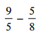
Use the same process you used with adding, but subtract this time!
Subtract

Step 1) What is the smallest number that both 5 and 8 multiply into? ______
That will be our new denominator!
Step 2) But wait, you can’t just change the denominator without changing the numerator! What could you multiply 5 and 8 by to get 40? _______ Multiply the numerators by those numbers!
Step 3) Our problem now looks like…
__________________________
Step 4) Now that our denominators are the same, just subtract the numerators!

Fundamentals of Math

Title For Your Notebook: Multiplying Fractions and Dividing Fractions
Unit 1, Day 9

Multiplying fractions is even easier than adding and subtracting them!
All you have to do is __________________________________________________________________
Example 1 : Multiply and simplify $\frac{5}{6}∙\frac{4}{3}$

Example 2: Multiply and simplify $-\frac{3}{5}∙\frac{7}{3}$

Practice!

Dividing fractions is a little tricker! In order to divide, we have to use the
_________________ - ___________________ - __________________ method! Then, we just multiply!

Example 1: Divide and simplify $\frac{1}{2}÷\frac{8}{7}$
Step 1: Keep – change – flip!
Step 2: Multiply numerators and denominators.
Step 3: Simplify if necessary.

Example 2: Divide and simplify $-\frac{1}{7}÷\frac{9}{4}$

Practice!

