Math III – Unit 3 Polynomials
Date | Lesson/Objective |  |  | Homework |  |  | Checked
Day 1:  Monday  Oct 3 | Polynomial Degree and End Behavior  Objective: To determine the degree and end behavior of a given polynomial  Objective: To factor a quadratic equation set equal to aero and then solve for the variable. |  |  | 3-1
Day 2:  Tuesday  Oct 4 | Bus Project  Objective: to determine a mathematical expression for the turning of a bus  Objective: to determine why a bus must take wide turns
Day 3:  Wednesday  Oct 5 | Polynomial Graphs (zeros and multiplicity)  Objective: to determine the zeros and multiplicity for the given polynomial  Objective: to determine the graph of a function based on the zeros and multiplicity of the polynomial |  |  | 3-2
Day 4:  Thursday  Oct 7 | Imaginary and Irrational Root Theorem  Objective: To determine the polynomial from the roots and multiplicity (including imaginary and irrational roots)  Objective: to add polynomials and write in standard form |  |  | 3-3
Day 5:  Friday  Oct 8 | Multiply polynomials  Objective: to multiply polynomials using the box method and write in standard form |  |  | 3-4
Day 6:  Monday  Oct 11 | Long Division  Objective: To use long division to divide polynomials |  |  | 3-5
Day 7:  Tuesday  Oct 12 | Synthetic Division  Objective: To use synthetic division to divide polynomials  Objective: To determine when to use synthetic or long division |  |  | 3-5
Day 8:  Wednesday  Oct 13 | Remainder Theorem  Objective: use synthetic division to determine whether a polynomial is a factor of another polynomial. |  |  | 3-6
Day 9:  Thursday  Oct 14 | Review |  |  | Review
Day 10:  Friday  Oct 15 | Unit 3 Test |  |  | Unit 4 Pretest

HW 3-1
Write each polynomial in standard form and classify it by degree and number of terms. Then, state the end behavior for each based on its degree and leading coefficient.
- $2x^{3}+4x-x^{2}$ 2. $y^{2}+3y+6-4y^{2}-6y$

Degree:____________L.C.:___________ Degree:____________L.C.:___________
Classification: _______________________ Classification: _______________________
End Behavior: _______________________ End Behavior: _______________________

3. $8-6w-12w-8w^{2}-7-3w^{3}$ 4. $6x^{5}+3x^{3}-7x^{5}-4x^{3}$

Degree:____________L.C.:___________ Degree:____________L.C.:___________
Classification: _______________________ Classification: _______________________
End Behavior: _______________________ End Behavior: _______________________
5. a) What is the domain and range of $5x^{4}-6x^{3}+2x-5$?
Domain: ___________ Range: _________________
b) Suppose the polynomial $5x^{4}-6x^{3}+2x-5$ represents the temperature of a body of water over several days. What are the practical domain and range?
Practical domain: __________________ Practical range: ______________________
6. For the following set of points, which type of model fits best? A linear, quadratic, cubic, or quartic model? Write the equation for the model and find the value of the function at x = 30. Make sure you turn your diagnostics on!
x | 0 | 5 | 10 | 15 | 20
y | -4 | 60 | 230 | 490 | 860
Model: _________________________________________
f(30) = _______________________
HW 3-2
Using the given equation in the table, fill in the rest for each example. Lastly, match each polynomial to its correct graph shown below. The first one is done for you. Some of them don’t have matches!
Equation | Graph | Degree | (Root, multiplicity)
$$y=x{\left(x+2\right)}^{2}{(x-3)}^{3}$$ | D | 6 | (0,1) (-2,2) (-3, 3)
$$y=x^{2}{\left(x+2\right)}^{2}{(x-3)}^{3}$$
$$y={\left(x+5\right)}^{2}{(x-1)}^{}$$
$$y={\left(x+5\right)}^{2}{(x-1)}^{2}$$
$$y={-(x-1)}^{3}{\left(x+1\right)}^{}{(x+2)}^{}$$
$$y={(x-1)}^{3}{\left(x+1\right)}^{}{(x-2)}^{}$$
$$y={\left(x-4\right)}^{2}{(x+3)}^{2}$$
$$y={-\left(x-4\right)}^{2}{(x+3)}^{2}$$
$$y=x^{2}{\left(x-2\right)}^{3}{(x-3)}^{}$$
$$y={-x}^{2}{\left(x-2\right)}^{3}{(x-3)}^{2}$$
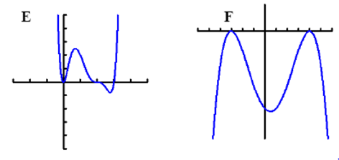

Describe the zeros, multiplicity, and end behavior of the graph of each function.

- $y=-x{\left(x+2\right)}^{2}(x-3)$

- $y=x^{2}(x-1)(x+3)$

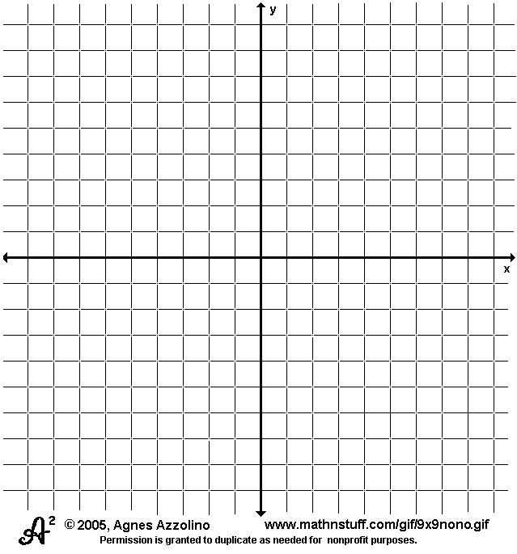
Sketch the graph of the polynomial based on the end behavior, zeros, and multiplicity.
- $y=-{\left(x+4\right)}^{2}(x-2)$ 4. $y=\left(x+2\right){\left(x-3\right)}^{3}(x+1)$

5. A meteorologist is using the polynomial $y=x^{2}{\left(x+2\right)}^{2}{(x-3)}^{3}$ to model the temperature at the beginning of winter as the months pass. What are the practical domain and range of the model?

HW 3-3
A polynomial function with rational coefficients has the follow zeros. Find all additional zeros and write all zeros in binomial form. (ex. A zero at 4 would be written (x-4).
- -5, i | - $2, -2+\sqrt{10}$
- $-3+\sqrt{5}, i$ | - 2-2i, 1-2i

Simplify each expression.

- $\left(5p^{2}-3\right)+(2p^{2}-3p^{3})$

- $\left(2n^{3}+4\right)+(5n^{3}+2)$

- Write a polynomial function in factored form with roots at x = -2, multiplicity 2, x = 1/2, multiplicity 3, and x = 0, multiplicity 2.
- $\left(5a+4\right)-(5a+3)$

- (${-4k}^{4}+14+{3k}^{2})+({-3k}^{4}-{14k}^{2}-8)$

- Find a 3rd degree polynomial equation with rational coefficients that has 2 and 4 + i as roots.

HW 3-4
Multiply and simplify the following:

- $:$

- :
- :

- :

5. The glass portion of a window has a height to width ratio of 3:2, so the height of the glass portion can be represented as 3x and the width of the glass can be represented as 2x. The wood trim adds 7 inches total to the width and 8 inches total to the height. Write a polynomial expression that represents the total area of the window including the glass and wood. Simplify the expression.

6. You are making a new serving tray for your coffee table, and you want to maximize the volume of the tray while minimizing the metal used. You begin with a piece of metal that is 12 inches long by 7 inches wide, then cut squares from each corner and fold them up to create edges. What should the side length of your square be in order to maximize the volume of the tray? What will the volume be?

HW 3-5
Divide using long division.
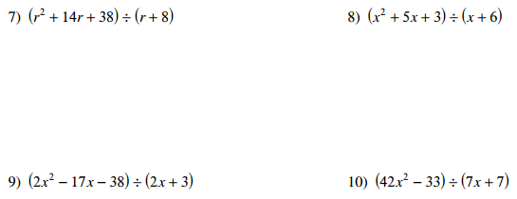

Use synthetic division to find out whether the divisor is a factor of the polynomial.

HW 3-6
Use the Remainder Theorem to find out if the divisor is a factor. If not, what is the remainder?
- $(2x^{2}-3x+1) ÷(x-2)$ 2) $\left(x^{4}-5\right)÷(x-1)$

3) $x^{3}-x^{2}+2x-1÷(x+3)$ 4) $x^{5}-{2x}^{4}+3x^{2}-20x+3÷(x+1)$

Use your calculator to find a zero of the given polynomial. Then, use division to find the remaining factors.
5) $5x^{3}-7x^{2}-49x+51$ 6) $5x^{3}-12x^{2}-23x+42$

