4-1 Homework
Find any points of discontinuity for each rational function.
- $y=\frac{x+5}{x^{2}+9x+20}$ 2. $y=\frac{(x-2)(x+1)}{3x^{2}-7x+2}$

Domain: _________ Range: __________ Domain: _________ Range: __________

Find the vertical asymptotes of the graph of each rational function.

3. $y= \frac{x-3}{(x+3)(x+2)}$ 4. $y= \frac{x^{2}+2x+3}{x^{2}+2x-3}$

Domain: _________ Range: __________ Domain: _________ Range: __________

Find the vertical asymptotes and holes for the graph of each rational function, then find the domain and range.

5. $y=\frac{3}{x-2}$ 6. $y= \frac{x+5}{x+5}$ 7. $y=\frac{(x+3)(x-2)}{(x-2)(x+1)}$ 8. $y= \frac{x^{2}-4}{x+2}$

VA: ______________ VA: ______________ VA: ______________ VA: ______________
Holes: ___________ Holes: ___________ Holes: ___________ Holes: ___________
Domain: __________ Domain: _________ Domain: ___________ Domain: __________
Range: ___________ Range: __________ Range: ____________ Range: ___________

4-2 Homework
Find any vertical or horizontal asymptotes of the graph of each rational function.
- $y=\frac{5}{x+6}$ 2. $y=\frac{x+2}{{2x}^{2}-8}$ 3. $y=\frac{x^{2}+2}{x^{2}-1}$

VA and HA: ____________ VA and HA: ____________ VA and HA: ____________
Domain: _______________ Domain: ________________ Domain: _______________
Range: ________________ Range: _______________ Range: ________________

4. Sketch a graph of: $\frac{3x}{x-4}$ 5. Sketch a graph of: $\frac{x+3}{(x-1)(x-6)}$
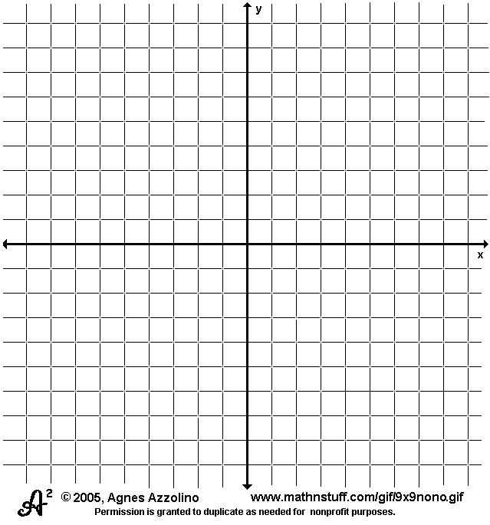

Domain: _______________ Domain: ________________
Range: ________________ Range: _______________

- Your class is going on a field trip to a local theater. It costs $60 to rent the bus. Each theater ticket costs $5.50.
  - Write a function c(x) to represent the cost per student if x students sign up.
  - How many students must sign up if the cost is to be no more than $10 per student?
  - What number of students would make an undefined solution?
  - How many students would need to go for the trip to cost nothing per person? How would this look on your graph?

9. A student listed the asymptotes of the function $y=\frac{x^{2}-3x+2}{x^{2}+6x+5}$ as shown below. Explain the student’s error. What are the correct asymptotes?
Vertical asymptotes: x = 1, x = 2
Horizontal asymptotes: y=-1, y=-5

4-3 Homework
Simplify each rational expression. State any restrictions on the variables.
- $\frac{3x-3}{x^{2}-x}$ 2. $-\frac{5x^{3}y}{15xy^{3}}$ 3. $\frac{6c^{2}+9c}{3c}$ 4. $\frac{x^{2}+8x+16}{x^{2}-2x-24}$

Multiply. State any restrictions on the variables.
5. $\frac{4x^{2}}{5y}∙\frac{7y}{12x^{4}}$ 6. $\frac{8y-4}{10y-5}∙\frac{5y-15}{3y-9}$

7. $\frac{x^{2}-4}{x^{2}-1}∙\frac{1-x}{x^{2}+2x}$ 8. $\frac{x^{2}-4}{\left(x-2\right)\left(x+6\right)}∙\frac{x^{2}-36}{\left(x+2\right)\left(x-3\right)}$

Homework 4-4
Divide. State any restrictions on the variables.
1. $\frac{3x^{3}}{5y^{2}}÷\frac{6y^{-3}}{5x^{-5}}$ 2. $\frac{3y-12}{2y+4}÷\frac{6y-24}{8+4y}$ 3. $\frac{\frac{(y-3)(y-2)}{y^{3}}}{\frac{y^{2}+3y-10}{{4y}^{2}}}$

4. $\frac{y^{2}-5x+6}{2y+4}÷\frac{2y-6}{(y-2)(y+5)}$ 5. $\frac{(2y-5)(y+3)}{y^{2}+7x-18}÷\frac{y^{2}+6y+9}{(y+9)(y-3)}$

Homework 4-5
Find the least common multiple on each pair of polynomials.
- 9(x+2)(2x-1) and 3(x+2) 2. $x^{2}-1 and x^{2}+2x+1$

Simplify each sum or difference. State any restrictions on the variables.
$3. \frac{a+11}{3a-5}+\frac{a-21}{3a-5}$ 4. $\frac{1}{x^{2}-4}+\frac{6}{x+2}$

5. $\frac{m}{3m+6}-\frac{4m}{m+2}$ 6. $\frac{b-4}{b^{2}+2b-8}-\frac{b+2}{b^{2}-16}$

7. $\frac{5x}{x^{2}-x-6}+\frac{4}{(x+2)(x+2)}$ 8. $\frac{1}{2x}+\frac{1}{2x}$

4-6 Homework
Simplify each complex fraction

- $\frac{\frac{1}{x}}{\frac{2}{y}}$ 2. $\frac{1-\frac{1}{4}}{2-\frac{3}{5}}$ 3. $\frac{\left(\frac{2}{x+y}\right)}{\frac{5}{x+y}}$ 4. $\frac{\frac{3}{x-4}}{1-\left(\frac{2}{x-4}\right)}$

5. a. $\frac{\frac{1}{2}-\frac{x+5}{4}}{\frac{x^{2}}{2}-\frac{5}{2}}$ b. $\frac{\frac{x-6}{6}-\frac{x-2}{x-6}}{\frac{36}{x-2}+\frac{4}{9}}$

6. Simplify the complex fraction: $\frac{\frac{1}{xy}-\frac{1}{y^{2}}}{\frac{1}{x^{2}y}-\frac{1}{xy^{2}}}$

4-7 Homework
Solve each equation. Check each solution.
- $\frac{5a+1}{6}=\frac{a-1}{3}$ 2. $\frac{2}{n}+\frac{n+2}{n+1}=-\frac{2}{n^{2}+n}$

$3. \frac{1-3x}{4x}=\frac{7}{x}$ 4. $\frac{5}{2x}-\frac{2}{3}=\frac{1}{x}+\frac{5}{6}$

5. $\frac{3}{2x}-\frac{5}{3x}=2$ 6. $\frac{5x}{4}-\frac{3}{x}=\frac{1}{4}$

