**Unit 4: Transformations of Functions**

|  |  |  |  |
| --- | --- | --- | --- |
| **Day** | **Date** | **Lesson** | **Assignment** |
| 1 | Monday  March 6th | Graphing Quadratics | HW 4-1 |
| 2 | Tuesday  March 7th | Quadratic Transformations (More practice) | Handout |
| 3 | Wednesday  March 8th | Quadratic Graphing in Calculator with Applications | HW 4-2 |
| 4 | Thursday  March 9th | Quadratic Inequalities | HW 4-3 |
| 5 | Friday  March 10th | Systems of Quadratic Equations and Inequalities | HW 4-4 |
| 6 | Monday  March 13th | Review and Quiz | HW 4-5 (Variation Review) |
| 11 | Tuesday  March 14th | Radical Functions | HW 4-6 |
| 12 | Wednesday  March 15th | Reciprocal Functions | HW 4-7 |
| 13 | Thursday  March 16th | Review | Review |
| 14 | Friday  March 17th | Test Unit 4 | Unit 5 Placemat |

|  |  |  |  |
| --- | --- | --- | --- |
| HW 1 | HW2 | HW3 | HW4 |
| HW 5 | HW6 | HW7 | HW8 |

**HW 4-1**

I. For each graph fill in the blanks for the requested information.

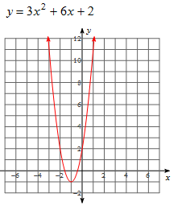a) Vertex:______

Zeroes:_____________

y-intercept:_________

Axis of symmetry:_________

Decreasing interval:_________

Increasing interval:__________

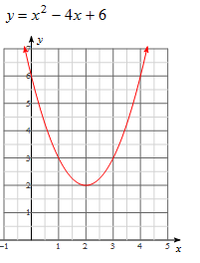b) Vertex:______

Zeroes:_____________

y-intercept:_________

Axis of symmetry:_________

Decreasing interval:_________

Increasing interval:__________

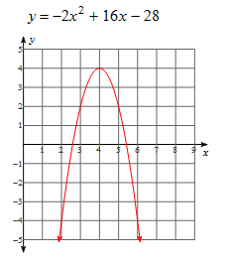

c) Vertex:______

Zeroes:_____________

y-intercept:_________

Axis of symmetry:_________

Decreasing interval:_________

Increasing interval:__________

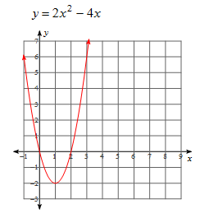d) Vertex:______

Zeroes:_____________

y-intercept:_________

Axis of symmetry:_________

Decreasing interval:_________

Increasing interval:__________

II.

Equation Axis of Symmetry Vertex x-intercept y-intercept

y = x2 +8x +15

*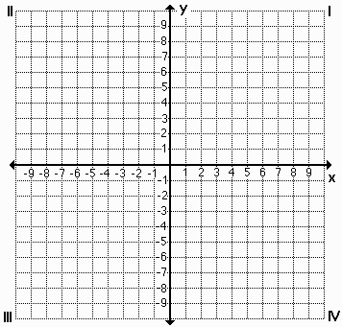 Graph the function above Graph the function below*

Equation Axis of Symmetry Vertex x-intercept y-intercept

$$y=x^{2}+2x-24$$

**More Practice**

**How much the graph of y = x2 be changed to produce each of the following graphs? Write *shift up, shift down, shift left, shift right, narrower or flatter* in the blank. If more than one change is needed, you may write up to 3 of these options in the blank.**

1.  1. _____________________________________
2.  2. _____________________________________
3.  3. _____________________________________
4.  4. _____________________________________
5.  5._____________________________________
6.  6. _____________________________________
7.  7. _____________________________________
8.  8. _____________________________________
9.  9. _____________________________________
10.  10. ____________________________________
11.  11. ____________________________________
12.  12. ____________________________________

*For the following functions* ***describe the transformation,*** *state the* ***End Behavior*** *and find the* ***domain and range****.*

1. y = x2 + 2 2. y = 3x2 - 1 3. y = ½ (x + 1)2

Transformation: T: T:

Domain: D: D:

Range: R: R:

End Behavior: EB: EB:

Increase Interval Increase Interval Increase Interval

Decrease Interval Decrease Interval Decrease Interval

4. y = (x – 3)2 + 2 5. y = -3(x – 1)2 - 2 6. y = -½ (x+2)2 - 5

T: T: T:

D: D: D:

R: R: R:

EB: EB: EB:

Increase Interval Increase Interval Increase Interval

Decrease Interval Decrease Interval Decrease Interval

7. y = 5(x + 1)2 - 2 8. y = -(x + 3)2 - 6 9. y = 1/3 (x – 3)2 + 12

T: T: T:

D: D: D:

R: R: R:

EB: EB: EB:

Increase Interval Increase Interval Increase Interval

Decrease Interval Decrease Interval Decrease Interval

**HW 4-2**

1. A ball is thrown straight up with an initial velocity of 56 feet per second. The height of the ball ***t*** seconds after it is thrown is given by the formula:

MCj04324650000[1]**h(t) = 56t – 16t2.**

1. What is the height of the ball after 1 second?_______________________
2. What is its maximum height?____________________________________
3. After how many seconds will it return to the ground? _________________
4. A baseball is projected upward from the top of a 448 foot tall building with an initial velocity of 48 feet per second. The distance **s** of the baseball from the ground at any time **t**, in seconds, is given by the equation s = -16t2 + 48t + 448.

a. Find the time it takes for the baseball to strike the ground. ________

b. What is the baseball’s maximum height?___________

Use the formula where **h(t)** is the height of an object in feet,  is the object's initial velocity in feet per second, and **t** is the time in seconds for #3.

3. An arrow is shot upward with a velocity of 64 feet per second. Ignoring the height of the archer, how long after the arrow is released does it hit the ground?_____________

4. At 1821 feet tall, the CN Tower in Toronto, Ontario, is the world’s tallest self-supporting structure. Suppose you are standing in the observation deck on top of the tower and you drop a penny from there and watch it fall to the ground. The [table](javascript:def('/Glossary/glossaryterm.aspx?word=Table',%20500,%20500);) below shows the penny’s distance from the ground after various periods of time (in seconds) have passed. Where is the penny located after falling for a total of 10.5 seconds?

|  |  |  |  |  |  |  |
| --- | --- | --- | --- | --- | --- | --- |
| Time(seconds) | 0 | 2 | 4 | 6 | 8 | 10 |
| Distance(feet) | 1821 | 1757 | 1565 | 1245 | 797 | 221 |



a. Find the quadratic model.

b. Where is the penny located after falling for a total of 10.5 seconds?_____

**More Quadratic Applications**

I. Greg, Keith and Dan were at the skate park. They decided to use a three foot ramp to see who could jump the highest. The paths of their jumps are given below.

|  |  |
| --- | --- |
| x | y |
| 0 | 3 |
| 4 | 5 |
| 6 | 3 |

Greg: y = -x2 + 4x + 3 Keith: Dan:

1. Who had the highest jump?
2. Who had the lowest jump?
3. Who had the longest jump?
4. What was the difference in height between the highest and the lowest jumps?

**HW 4 – 3 Graphing Quadratic Inequalities**

Graph each quadratic inequality.

1.  2.  3. 

4.  5.  6. 

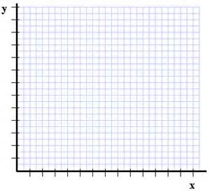7. The number of people that attend an sale can be modeled by the inequality $y≤{-4x}^{2}+24x$, where x represents the number of days into the sale and y represents the people attending **in hundreds**.

1. Graph the inequality.
2. What is the maximum and what does it represent?
3. How long does the sale last for?
4. The store has to have extra staff when the attendance

is 2000 people of more. Write the inequality for this situation,

and graph.

1. According to your graph, on what days does the

company need to have extra staff working?

**HW 4 – 4 Intersection of lines and Parabolas**

**Graph each of the following and name an ordered pair that satisfies the system.**

1. $y≥{2x}^{2}-3x+4$

$$y<-2x+5$$

2. $y≤ -4x^{2}+3x+2$

$y>7x+2$

3. $y>x^{2}+5x$

$y≤3x^{2}+3$

4. $y<{\left(x-2\right)}^{2}-1$

$y≤x^{2}-6x+3$

**5.**  and y = -2x + 4 **6.** x2 + 3x + 2 and y = x + 2

**HW 4-5 Direct, Inverse and Joint Variation**

State whether each of the equations represents direct, inverse, or joint variation:

1. 2. 3. 4.

5. The frequency of a vibrating string varies inversely as its length. A string 3 feet long vibrates 175 cycles per second. Find the frequency of a 5 foot string.

6. The force of the wind blowing on a vertical surface varies jointly as the area of the surface and the square of the velocity. If a wind blowing at 50 mph exerts a force of 75 pounds on a surface of 500 ft2, how much force will a wind of 75 mph place on a surface of 10 ft2?

7. The time required to process a shipment of goods at Wal-Mart varies directly with the number of items in the shipment and inversely with the number of workers assigned. If 15,000 items can be processed by 8 workers in 10 hours, then how long would it take 12 workers to process 20,000 items?

**HW 4 – 6 Radical Functions**

For the following functions **describe the transformation,** state the **End Behavior** and find the **domain and range***.*

1. 2. 3.

T: T: T:

D: D: D:

R: R: R:

EB: EB: EB:

Increase Interval Increase Interval Increase Interval

Decrease Interval Decrease Interval Decrease Interval

4. 5. 6.

T: T: T:

D: D: D:

R: R: R:

EB: EB: EB:

Increase Interval Increase Interval Increase Interval

Decrease Interval Decrease Interval Decrease Interval

7. 8. 9.

T: T: T:

D: D: D:

R: R: R:

EB: EB: EB:

Increase Interval Increase Interval Increase Interval

Decrease Interval Decrease Interval Decrease Interval

**HW 4-7 Reciprocal Functions**

Write an equation for a translation of $y= -\frac{3}{x}$ that has the given asymptotes.

1. x = 2, y = 1 2. x = -3, y = 0 3. x = 4, y = -2 4. x = 0, and y = 6

For each of the following functions: a) graph each equation, b) list the horizontal and vertical asymptotes, c) State the domain and range of the function, d) state the end behavior, e) state the intervals of increasing and decreasing.

5. 6.

|  |  |  |  |  |  |  |  |  |  |  |  |
| --- | --- | --- | --- | --- | --- | --- | --- | --- | --- | --- | --- |
|  |  |  |  |  |  |  |  |  |  |  |  |
|  |  |  |  |  |  |  |  |  |  |  |  |
|  |  |  |  |  |  |  |  |  |  |  |  |
|  |  |  |  |  |  |  |  |  |  |  |  |
|  |  |  |  |  |  |  |  |  |  |  |  |
|  |  |  |  |  |  |  |  |  |  |  |  |
|  |  |  |  |  |  |  |  |  |  |  |  |
|  |  |  |  |  |  |  |  |  |  |  |  |
|  |  |  |  |  |  |  |  |  |  |  |  |
|  |  |  |  |  |  |  |  |  |  |  |  |
|  |  |  |  |  |  |  |  |  |  |  |  |
|  |  |  |  |  |  |  |  |  |  |  |  |
|  |  |  |  |  |  |  |  |  |  |  |  |

|  |  |  |  |  |  |  |  |  |  |  |  |
| --- | --- | --- | --- | --- | --- | --- | --- | --- | --- | --- | --- |
|  |  |  |  |  |  |  |  |  |  |  |  |
|  |  |  |  |  |  |  |  |  |  |  |  |
|  |  |  |  |  |  |  |  |  |  |  |  |
|  |  |  |  |  |  |  |  |  |  |  |  |
|  |  |  |  |  |  |  |  |  |  |  |  |
|  |  |  |  |  |  |  |  |  |  |  |  |
|  |  |  |  |  |  |  |  |  |  |  |  |
|  |  |  |  |  |  |  |  |  |  |  |  |
|  |  |  |  |  |  |  |  |  |  |  |  |
|  |  |  |  |  |  |  |  |  |  |  |  |
|  |  |  |  |  |  |  |  |  |  |  |  |
|  |  |  |  |  |  |  |  |  |  |  |  |
|  |  |  |  |  |  |  |  |  |  |  |  |

7. 8.