**Homework 5-1**

**Use Pythagorean Theorem to solve for the missing side in each triangle.**

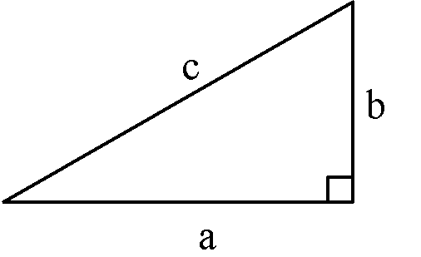

1.

2.

3.

4. .

1. The slide at the playground has a height of 6 feet. The base of the slide measured on the ground is 8 feet. What is the length of the sliding board?
2. The bottom of a 13-foot straight ladder is set into the ground 5 feet away from a wall. When the top of the ladder is leaned against the wall, what is the distance above the ground it will reach?
3. In shop class, you make a table.  The sides of the table measure 36" and 18".  If the diagonal of the table measures 43", is the table “square”?  (In construction, the term "square” just means the table has *right angles* at the corners.)
4. In the Old West, settlers made tents out of a piece of cloth thrown over a clothesline and then secured to the ground with stakes forming an isosceles triangle. How long would the cloth have to be so that the opening of the tent was 6 feet high and 8 feet wide?
5. A baseball “diamond” is actually a square with sides of 90 feet.  If a runner tries to steal second base, how far must the catcher, at home plate, throw to get the runner “out”? Given this information, explain why runners more often try to steal second base than third.

**Homework 5-2**

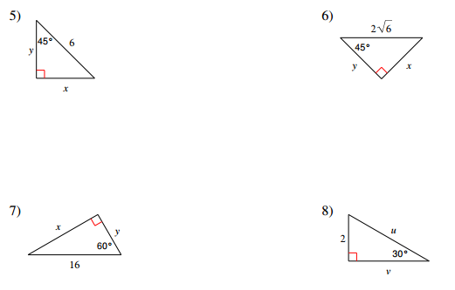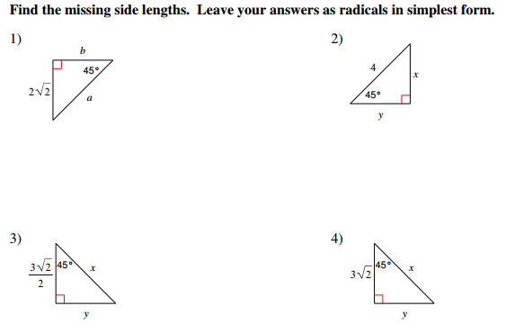

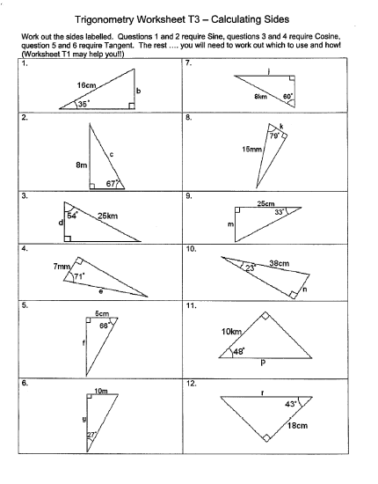

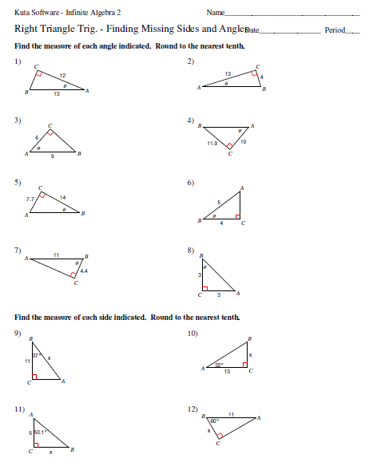

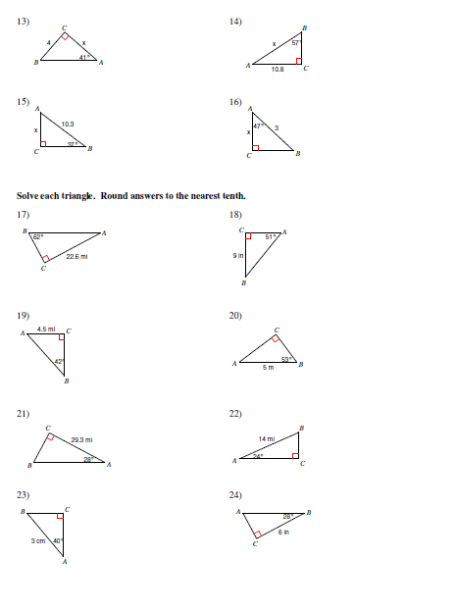

Angle of Elevation and Depression HW

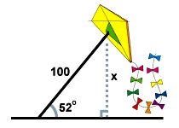**Find all values to the nearest tenth.*x* = 10 sec(20) latex_img1510.64 . The second boat must travel about 10.6 miles to get as far west as the first boat.**

[**Close**](http://www.sparknotes.com/math/trigonometry/solvingrighttriangles/problems_1.html#explanation1#explanation1)

1. A man flies a kite with a 100 foot string. The angle of elevation of the

string is 52 o . How high off the ground is the kite?

*x* = 100 sin(52) latex_img1578.8 . The kite is about 79 feet above the ground. [Close](http://www.sparknotes.com/math/trigonometry/solvingrighttriangles/problems_1.html#explanation2#explanation2)

2. From the top of a vertical cliff 40 m high, the angle of depression of an object that is level with the base of the cliff is 34º.  How far is the object from the base of the cliff?

3. An airplane takes off 200 yards in front of a 60 foot building. At what angle of elevation must the

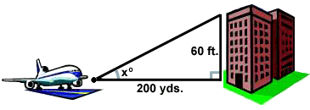 plane take off in order to avoid crashing into the building? Assume that the airplane flies in a

straight line and the angle of elevation remains constant until the airplane

flies over the building.

*x* = arctan(latex_img28) latex_img155.72 o . The plane must take off at an angle of elevation of about 5.72 o in order to avoid hitting the building.

[Close](http://www.sparknotes.com/math/trigonometry/solvingrighttriangles/problems_1.html#explanation3#explanation3)

4. A 14 foot ladder is used to scale a 13 foot wall. At what angle of elevation must the ladder be situated in

order to reach the top of the wall?

5. A person stands at the window of a building so that his eyes are 12.6 m above the level ground. An object is on the ground 58.5 m away from the building on a line directly beneath the person. Compute the angle of depression of the person’s line of sight to the object on the ground.

*x* = arcsin(latex_img31) latex_img1568.3 o . The ladder must be situated with about a 68.2 o angle of elevation in order to reach the top of the wall.

[Close](http://www.sparknotes.com/math/trigonometry/solvingrighttriangles/problems_1.html#explanation4#explanation4)

http://img.sparknotes.com/figures/C/c92e38c46d6be4610999d7936fd45ce2/prob235.gif6. A ramp is needed to allow vehicles to climb a 2 foot wall. The angle of elevation in order for the vehicles to

safely go up must be 30 o or less, and the longest ramp available is 5 feet

long. Can this ramp be used safely?