HW 5-1

Find an equation $f^{-1}(x)$ for the inverse of each of the following functions. Then, graph each function and its inverse.

- $y=x^{2}-5$ 2. $y=3^{x}+2$ 3. $4+\log_{3}{x}=y$

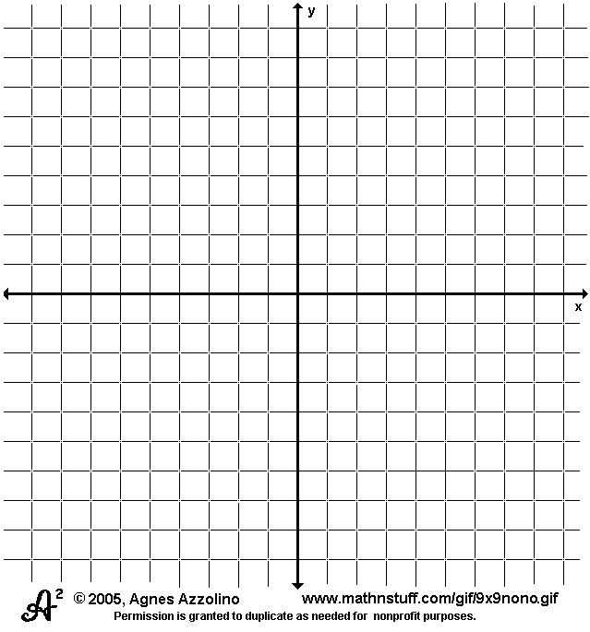

 | Domain | Range |  | Domain | Range |  | Domain | Range
$$f\left(x\right)$$ |  |  | $$f\left(x\right)$$ |  |  | $$f\left(x\right)$$
$$f^{-1}\left(x\right)$$ |  |  | $$f^{-1}\left(x\right)$$ |  |  | $$f^{-1}\left(x\right)$$

Convert each of the following to a log function.

4. $4^{3}=x$ 5. $c^{x+5}=7$ 6. $x^{6y}=8$

Evaluate each log expression. Try without a calculator and then check with a calculator!

7. $\log_{3}{27}$ 8. $\log_{7}{1}$ 9. $\log{10000}$

How was each function translated from $y=\log{x}$?

10. $y=\log\left(x-3\right)+1$ 11. $y=5\log_{4}\left(x+2\right)-4$ 12. $y=\frac{1}{2}\log_{3}\left(x\right)+3$

HW 5-2

Graph the following, then state the translations, domain, range, and asymptotes.

 | Translations | Domain | Range | Asymptote
$$1. f\left(x\right)={2e}^{x}$$
$$2. f\left(x\right)=e^{x+1}-3$$
$$3. f\left(x\right)=\ln\left(x+2\right)+1$$
4. $f\left(x\right)=\ln\left(x-3\right)+5$

Convert the following to either log or exponential.

5. $\ln\left(x+2\right)=3$ 6. $e^{2x}=4$ 7. $\log\left(2x-3\right)=5$ 8. ${10}^{x-2}=2$

Simplify each expression.
9. $\ln\left(1\right)$ 10. $\frac{ln⁡(e)}{4}$ 11. $\ln\left(e^{83}\right)$ 12. $\frac{ln⁡(e^{2})}{2}$

13. $ln⁡(e^{10})$ 14. $10\ln\left(e\right)$ 15. $\frac{ln⁡(e^{4})}{8}$

HW 5-3

Write each expression as a single logarithm.

- $\log{7+\log{2}}$ 2. $5\log{3+\log{4}}$ 3. $\ln_{7}{x+\ln_{7}{y}}-\ln_{7}{z}$

4. $4\log{m-\log{n}}$ 5. $x\ln_{4}{m+y\ln_{4}{n}}-\ln_{4}{p}$

Expand each logarithm.

7. $\log{x^{3}y^{3}}$ 8. $\ln{{\left(2x\right)}^{2}}$ 9. $\log{\frac{a^{2}b^{3}}{c^{4}}}$

10. $\log_{5}{\frac{25}{x}}$ 11. $\log{\frac{m^{3}}{n^{4}p^{2}}}$

HW 5-4

Solve the equation. Round your answer to two decimal places.

- ${20}^{r}=56$ 2. ${11}^{n-8}-5=54$ 3. $8^{-5a}-5=53$

4. $3.4e^{2-2n}=5$ 5. $\ln\left(4x-1\right)=36$ 6. $2\ln{2x^{2}=1}$

7. $3\log{x}-\log{6+\log{2.4=9}}$ 8. $\log\left(7x+1\right)=\log\left(x-2\right)+1$

9. $\ln\left(5x-4\right)=3$ 10. $\ln{{\left(t-1\right)}^{2}=3}$

HW 5-5

Doug is investing $1500 in an account that earns 3.5% interest and is compounded quarterly.

1. To calculate the amount of money in his account after t years what formula should Doug use?
2. Here P = 1500, ___= .035, and ___= 4.
3. How much money will be in the account after 10 years?
4. Predict how much money will be in the account after 20 years?
5. How much money will actually be in the account after 20 years? Were you correct with your prediction? If you predicted that there would be twice as much money as in question 3, why do you think that you were wrong?
6.
a. What is twice the amount from question 3?

b. Plug this formula into y= in your calculator and determine how many years it will take to obtain the value from question 3?

7. Beth is investing $5000 in an account that earns 6.75% interest and compounds continuously.

- What is the formula that she should use to keep track of the amount of money in the account?

- How much money will she have after 7 years?

- How long will it take for the account to have twice as much money as she invested?

- How long will it take for the account to have 4 times as much as she invested?

8. Tammy wants to invest in an account that earns 7.5% interest, and compounds monthly. If she wants the account to have $5000 after 9 years, how much should she invest?

HW 5-6

I. Graph the following piece-wise functions on graph paper. Then, state the domain and range for each.

1. $f\left(x\right)=\left\{\begin{aligned}3x, -2<x≤1 \\ x+1, x>2\end{aligned}\right.$ 2. f(x) = 3. f(x) =
What is $f\left(3\right)+2f\left(0\right)?$ What is $-3f\left(5\right)-\frac{1}{2}f\left(2\right)?$ What is $4f\left(1\right)-f\left(6\right)?$

II. Applications of Piece-wise functions. Set up a piece-wise function and solve for the given variable.

5. The Yummy Candy Company can produce up to 100 candy bars at a cost of $1.50 per bar. If they make more than 100 bars at one time, their cost goes down to $1.10 per bar, after their first 100 bars are made.

- Find a piece-wise function that gives the cost of producing any number of candy bars.

$$f\left(x\right)=\left\{\begin{aligned} if \\ if \\ \end{aligned}\right.$$

- Find the cost for 75 bars.

- Find the cost for producing 200 bars.

