Name _________________________ Unit 6 Test Review

- The equation can be used to estimate the speed, s, of a car in miles per hour, given the length in feet, x, of the tire marks it leaves on the ground. A car traveling at a speed of 90 miles per hour came to a sudden stop. According to the equation, how long would the tire marks be for this car?  - 355 feet  - 380 feet  - 405 feet  - 430 feet | - Find the vertex of  $$y={(x-3)}^{2}-2$$

- Find the domain and range, and increasing/decreasing intervals of each:
- $y=\sqrt{x-2}+3$ | - $y= \frac{2}{x-4}-3$ |  | - $y= \frac{-4}{x+9}+1$
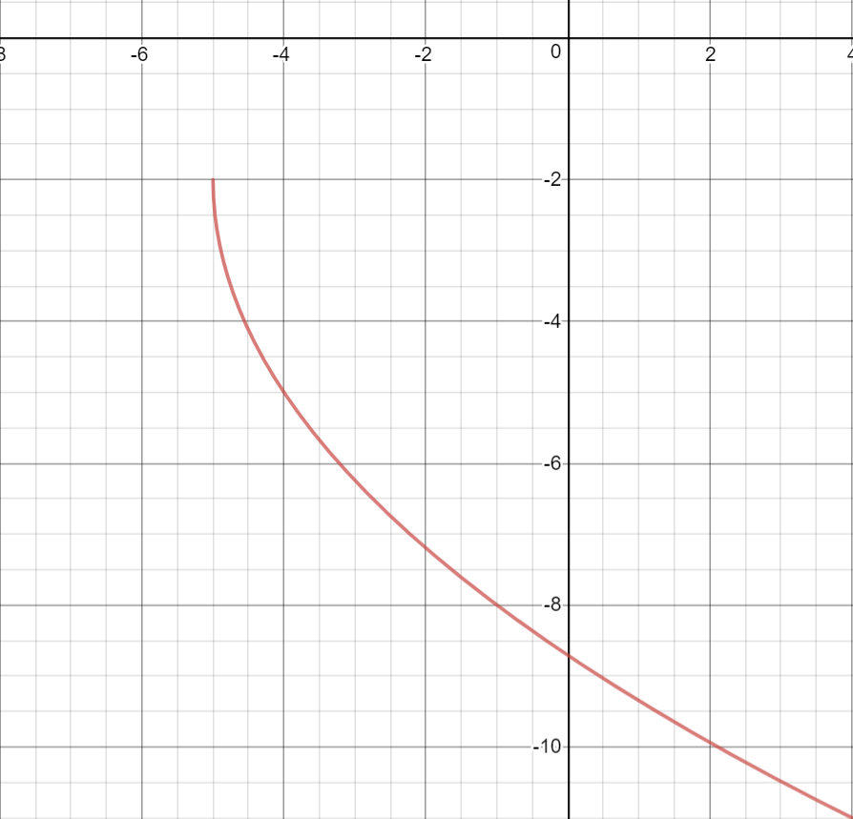  - Write an equation for the following |  | - Write an equation for the following graph.  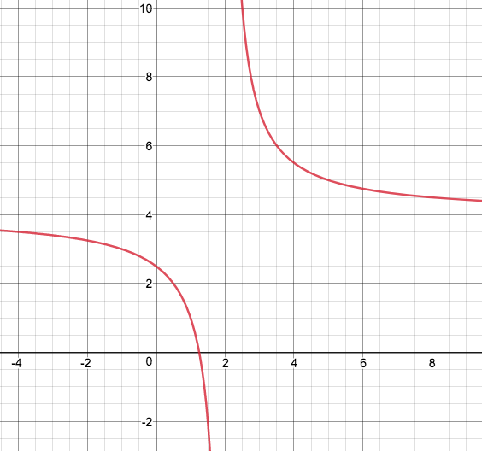
- Write the equation of the square root function that is compressed vertically by a factor of 1/3, shifted up 9, and left 2.

- Write the equation of a reciprocal function (inverse variation) that is compressed vertically by a factor of 2/3, translated left 4 and down 6.

Find each of the following, using PROPER NOTATION:
- $y=2x^{2}+1$ Transformations: __________________________________________________
- $y=-3\sqrt{x}$ Domain: ________________
- $y=0.5\sqrt{x+2}-5$ End Behavior: _________________________________
- $y=\frac{-2}{x}-3$ Increasing Interval: __________________________
- $y=\frac{10}{x+8}$ Range: _____________________
- $y={0.3\left(x-5\right)}^{2}+2$ Vertex: _____________
- $y=\frac{5}{6x}-1$ Transformations: _________________________________________________
- $y=-\sqrt{x+7}+3$ Decreasing Interval: __________________________
- $y=\sqrt{x}-5$ y-intercept: ___________
- $y=\frac{3}{4\left(x+1\right)}$ Transformations: __________________________________________________
- $y=\frac{2}{x}+7$ Vertical Asymptote: ________________
- $y=-\frac{1}{x+4}$ End Behavior: _________________________________
- $y=\frac{-2}{x}-3$ Horizontal Asymptote: __________________________
- $y=.5\sqrt{x+1}-8$ Range: _____________________
- $y={0.3\left(x+1\right)}^{2}-10$ Vertex: _____________
- $y=-\sqrt{x+2}-7$ Transformations: _________________________________________________
- $y=\frac{1}{x+3}+8$ Decreasing Interval: __________________________
- $y=6{\left(x-2\right)}^{2}-8$ y-intercept: ___________

