**HW 8-1**

**Solve for x in the following:**



x

12

50

36

9

30

x

55

1. 4.

16

x

13

x

**Find a coterminal angle between 0° and 360°.**

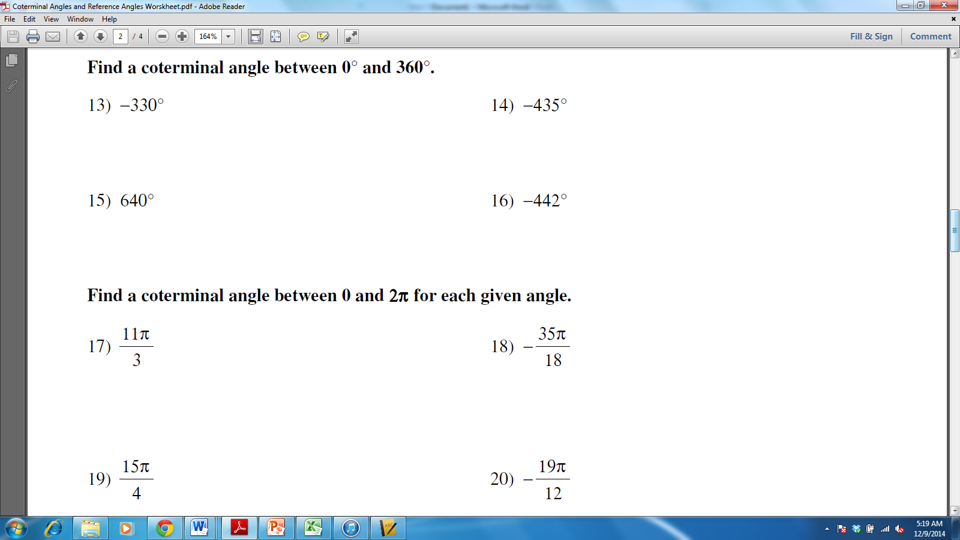

**Find a coterminal angle between 0 and 2π.**



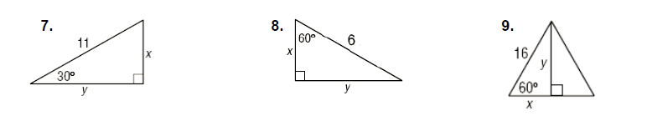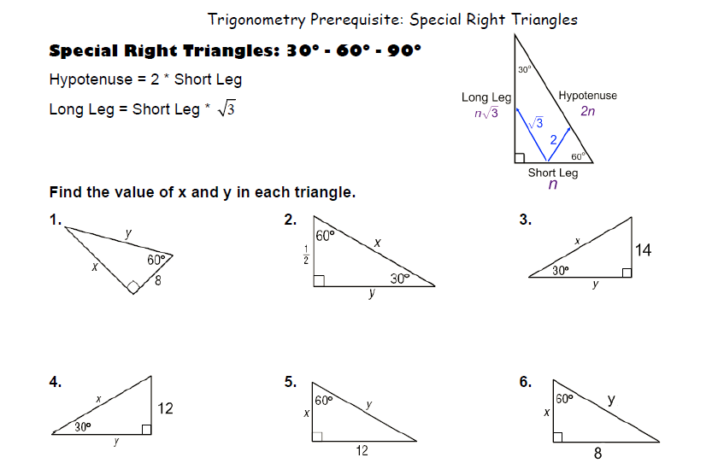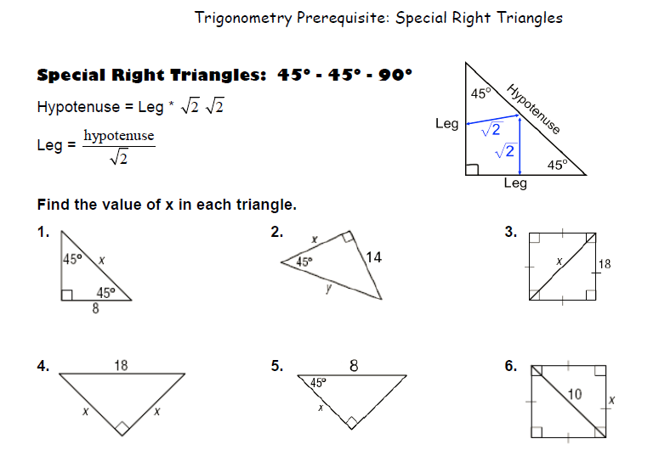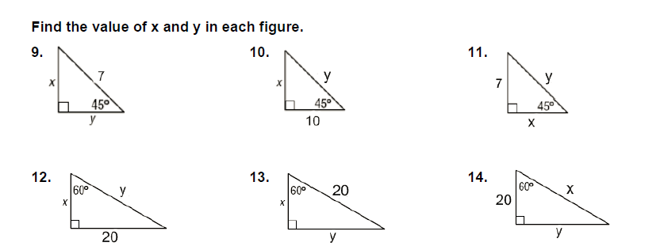

**HW 8-2**

**Use the information provided to write the standard form equation of the circle.**

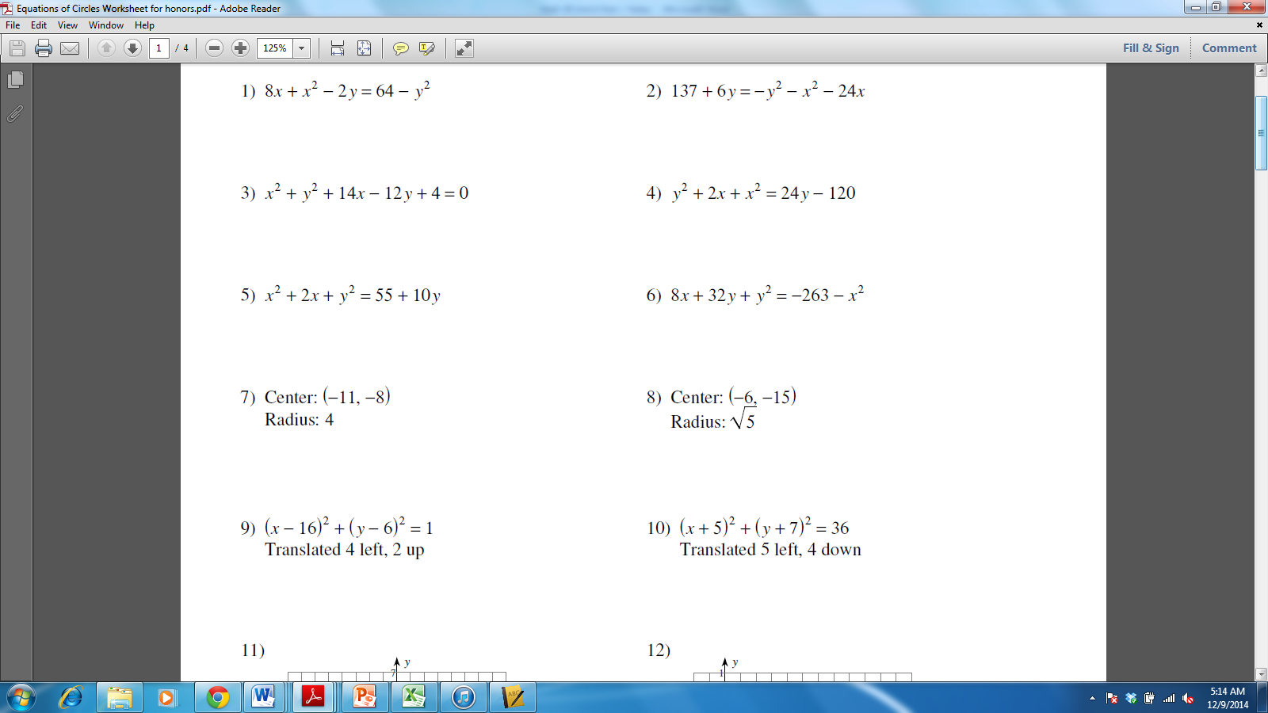

**HW 8-3**

**State the sign (+ or -) for a) sinθ, b) cosθ, and c) tanθ.**

1. $\frac{π}{2}$ 2. -450° 3. $\frac{4π}{3}$ 4. $\frac{7π}{4}$
2. a) a) a)
3. b) b) b)
4. c) c) c)

**Without using a calculator, find the exact value.**

5. 6. 7. 8.

9. 10. 11. 12. $\tan{-2π}$

**HW 8-4**

**Find the values of the six trigonometric functions of an angle in standard position if the given point lies on the terminal side.**

1. $(-1,5)$ 2. $(6,8)$ 3. $(\sqrt{2},-\sqrt{2})$ 4. $(\frac{\sqrt{3}}{2},-\frac{1}{2})$

|  |  |  |  |  |  |  |  |
| --- | --- | --- | --- | --- | --- | --- | --- |
| $$\sin{θ=}$$ |  | $$\sin{θ=}$$ |  | $$\sin{θ=}$$ |  | $$\sin{θ=}$$ |  |
| $$\cos{θ=}$$ |  | $$\cos{θ=}$$ |  | $$\cos{θ=}$$ |  | $$\cos{θ=}$$ |  |
| $$\tan{θ=}$$ |  | $$\tan{θ=}$$ |  | $$\tan{θ=}$$ |  | $$\tan{θ=}$$ |  |
| $$\csc{θ=}$$ |  | $$\csc{θ=}$$ |  | $$\csc{θ=}$$ |  | $$\csc{θ=}$$ |  |
| $$\sec{θ=}$$ |  | $$\sec{θ=}$$ |  | $$\sec{θ=}$$ |  | $$\sec{θ=}$$ |  |
| $$\cot{θ=}$$ |  | $$\cot{θ=}$$ |  | $$\cot{θ=}$$ |  | $$\cot{θ=}$$ |  |

**Suppose $θ$ is an angle in standard position whose terminal side lies in the given quadrant. For each function, find the values of the remaining five trigonometric functions of**

5. quadrant I 6. quandrant IV

|  |  |  |  |
| --- | --- | --- | --- |
| $$\sin{θ=}$$ |  |  | $$\cos{θ=}$$ |
| $$\tan{θ=}$$ |  |  | $$\tan{θ=}$$ |
| $$\csc{θ=}$$ |  |  | $$\csc{θ=}$$ |
| $$\sec{θ=}$$ |  |  | $$\sec{θ=}$$ |
| $$\cot{θ=}$$ |  |  | $$\cot{θ=}$$ |