Unit 8 Review Name___________________
Part 1 Given $∆LEG≅∆ARM$, answer the following questions:
- If $LE≅EG$ and $m<M$ is $43°$, what is $m<R$?

- If $LE=12$ and $AM=5$ and $m<A=90°$, what is $EG?$

- If $GE=3x-7$ and $AM=11x-18$ and $MR=2x+2$, what is $\sqrt{AM}$?

Part 2 State the postulate that could be used to prove the triangles congruent.
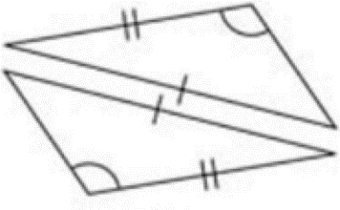 | 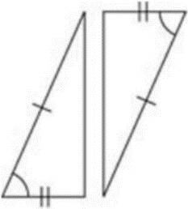 | 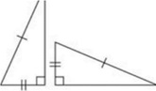
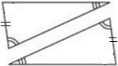 | 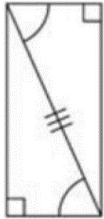 | 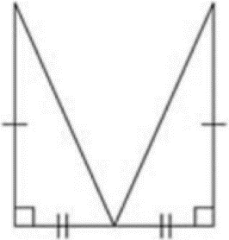
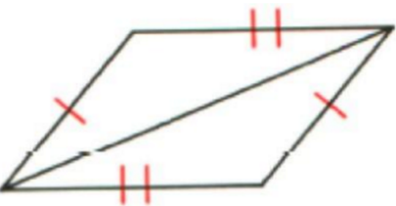 | 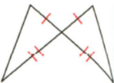 | 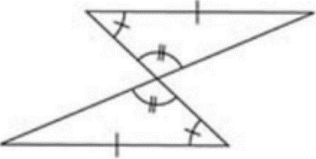
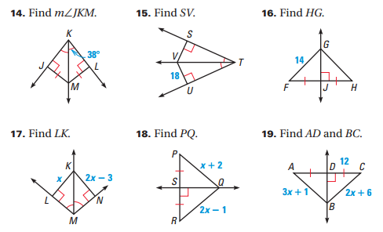
Solve the following

Part 3 Definitions. Make sure you know the following:

- SSS Congruence Postulate
- SAS Congruence Postulate
- ASA Congruence Postulate
- AAS Congruence Theorem
- HL Congruence Theorem
- Isosceles Triangle Theorem
- Converse of Isosceles Triangle Theorem
- Perpendicular Bisector
- Angle Bisector
- Segment Bisector
- Reflexive Property of Congruence
- Transitive Property of Congruence
- Alternate Interior Angles Theorem
- Corresponding Angles Theorem
- SSS Similarity Theorem
- SAS Similarity Theorem
- Angle Angle Similarity Theorem

- CPCTC – If two triangles are congruent, then their corresponding parts are ______________.

Part 4 Proofs
G
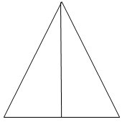
Given $∆GAB$ with $\overline{GS}$ $\overline{AB}$, and $\overline{GA}≅\overline{GB}$.
Prove $\overline{AS}≅\overline{SB}$.
S
B
AT
Given
$$\overline{AS}≅\overline{SB}$$
$∆GAS$ and $∆BGS$ are right triangles
<ASG and <BSG are right angles
$$\overline{GS}≅\overline{GS}$$
$\overline{GS}$ $\overline{AB}$

