Math 3 Name: __________________________
Unit 7 Review 1

- Write the standard equation for the circle with center (5, -6) and diameter 8 in. | 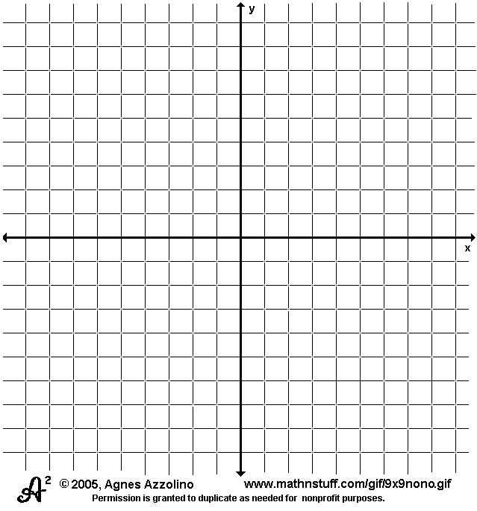  - Write the standard equation for the circle with center (–4, 3), that is tangent to the y-axis.
- Switch to DMS or decimal form.  - $13°5'20"$  - $43°25'8"$  - 154.28°  - 237.12° | - Put the following general form equation into the standard form equation of a circle: $2x+x^{2}-6y=16-y^{2}$  Center:  Radius:
- Find a coterminal angle between 0° and 360° or between 0 and 2π radians.  - -210°  - 520°  - $\frac{15π}{3}$  - $-\frac{15π}{4}$ | - The terminal side of an angle in standard position contains the point (-5,7). Find all of the trigonometric ratios for this angle.  $$\sin{θ=}$$ $$\csc{θ=}$$  $$\cos{θ=}$$ $$\sec{θ=}$$  $$\tan{θ=}$$ $$\cot{θ=}$$
- Without a calculator, find the values or ratios for sinθ, cosθ, tanθ, secθ, cscθ, and cotθ.  $$θ=\frac{4π}{3}$$  $$\sin{θ=}$$ $$\csc{θ=}$$  $$\cos{θ=}$$ $$\sec{θ=}$$  $$\tan{θ=}$$ $$\cot{θ=}$$ | - Find the exact value of each expression using a coterminal angle:  - cos 495°  - sin $\frac{11π}{4}$
