5.

- Create a table of values.

- What type of pattern is this? (Hint: linear, quadratic, neither?) Why?
- Write the explicit equation.

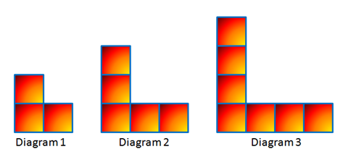

1.

a) Create a table of values.

b) What type of pattern is this? (Hint: linear, quadratic, neither?) Why?
c) Write the explicit equation.

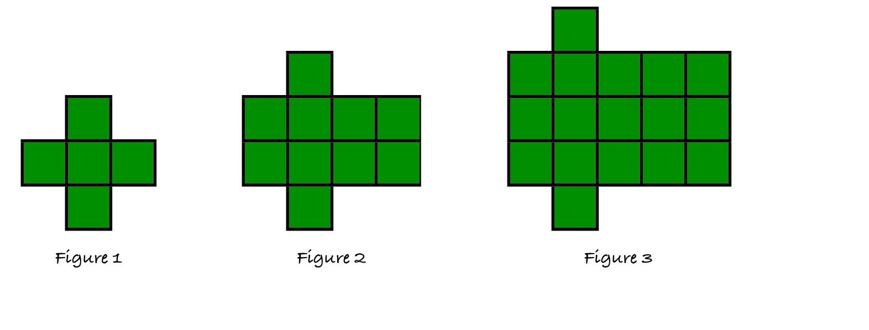
6.

a) Create a table of values.

b) What type of pattern is this? (Hint: linear, quadratic, neither?) Why?
c) Write the explicit equation.

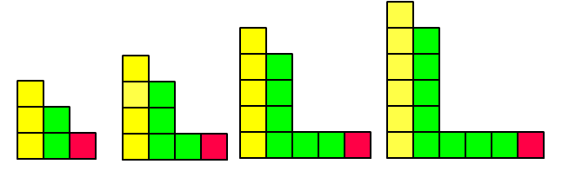
3.

a) Create a table of values.

b) What type of pattern is this? (Hint: linear, quadratic, neither?) Why?
c) Write the explicit equation.

2.

a) Create a table of values.

b) What type of pattern is this? (Hint: linear, quadratic, neither?) Why?
c) Write the explicit equation.

4.

a) Create a table of values.

b) What type of pattern is this? (Hint: linear, quadratic, neither?) Why?
c) Write the explicit equation.

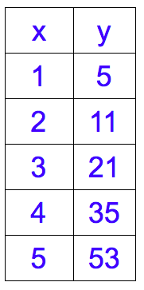
- Given the function…

a) Is the function linear or quadratic? Why?

b) Find the explicit equation that represents the function.

c) Draw the first 3 figures that represent the growth (Use color!).

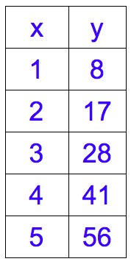
- Given the function…

a) Is the function linear or quadratic? Why?

b) Find the explicit equation that represents the function.

c) Draw the first 3 figures that represent the growth (Use color!).

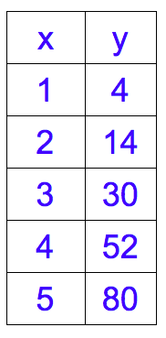
- Given the function…

a) Is the function linear or quadratic? Why?

b) Find the explicit equation that represents the function.

c) Draw the first 3 figures that represent the growth (Use color!).

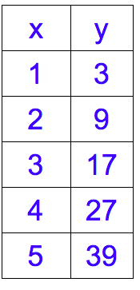
- Given the function…

a) Is the function linear or quadratic? Why?

b) Find the explicit equation that represents the function.

c) Draw the first 3 figures that represent the growth (Use color!).

