Honors- Math 3 Name: ___________________________
Unit 5 Review

- Find the inverse of $y=3^{x}$ and graph both functions. Then, state the domain, range, and asymptote of both.  Domain Range Asymptote  $$f\left(x\right)$$  $$f^{-1}\left(x\right)$$  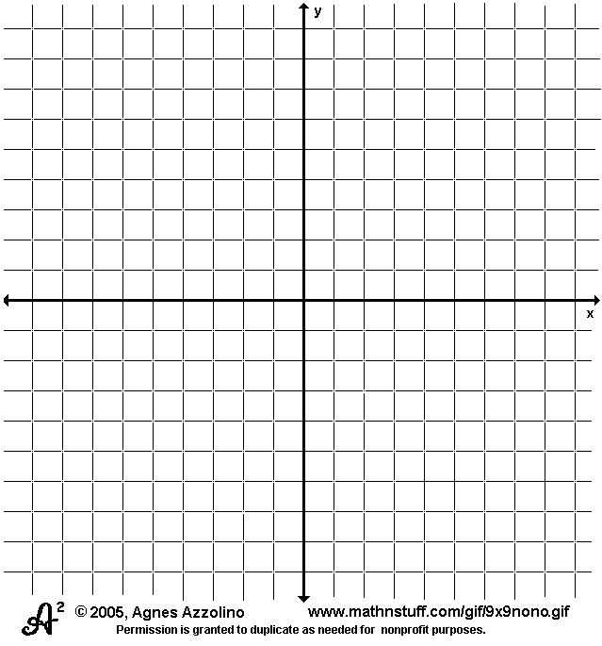 | - Find the inverse of $y=\log\left(x+4\right)$ and graph both functions. Then, state the domain, range, and asymptote of both.  Domain Range Asymptote  $$f\left(x\right)$$  $$f^{-1}\left(x\right)$$
- Find the inverse of $y=4^{x}-7$ and graph both functions. Then, state the domain, range, and asymptote of both.  Domain Range Asymptote  $$f\left(x\right)$$  $$f^{-1}\left(x\right)$$ | - Find the inverse of $y=\log_{4}{(x-3)}-2$ and graph both functions. Then, state the domain, range, and asymptote of both.  Domain Range Asymptote  $$f\left(x\right)$$  $$f^{-1}\left(x\right)$$
Solve each equation. Round each answer to the hundredths.
- $\log_{4}\left(2b-3\right)+\log_{4}\left(3\right)=\log_{4}{9}$ | - $ln\left(a-4\right)=3$
- Evaluate the following expressions:  - $\log_{5}{5^{12}}$  - $\log_{2}{3}$  - $4^{\log_{4}{5}}$  - $\ln{1}$ | - $-4+e^{2x+5}=18$
- Rewrite the equation $e^{4x}=7$ in natural log (ln) form.  - Rewrite $\log_{a}{b=8}$ in exponential form | - Condense the following logarithms:  - $2\log_{3}{x-\frac{1}{2}\log_{3}{x}}$  - $3\log_{a}\left(x-4\right)-2\log_{a}{(y+5)}$

