Honors Math 3 Name: ___________________________
Unit 5 Review

- Find the inverse of $y=2^{x}-6$ and graph both functions. Then, state the domain, range, and asymptote of both.  Domain Range Asymptote  $$f\left(x\right)$$  $$f^{-1}\left(x\right)$$  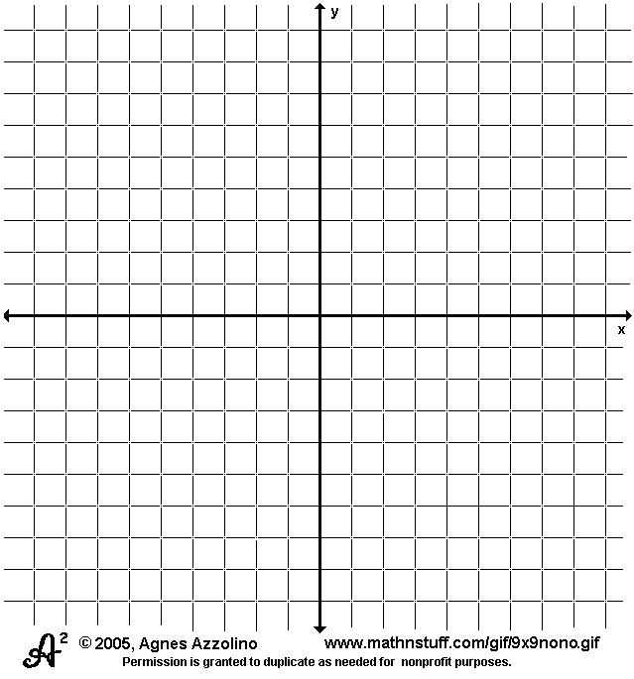 | - Find the inverse of $y=\log\left(x-2\right)+1$ and graph both functions. Then, state the domain, range, and asymptote of both.  Domain Range Asymptote  $$f\left(x\right)$$  $$f^{-1}\left(x\right)$$
- You invest $2,500 at 4% interest compounded monthly. How much will you have in your account after 6 years? | - You invest $2,000 at 12% interest compounded continuously. How much will you have in your account after 9 years?
- You want to double your investment of $2000. You invest at 8%. How long will it take to double your investment if interest is compounded continuously? | - You deposit $3100 into an account that earns 4% interest compounded continuously. How long will it take the account to triple?
Solve each equation. Round each answer to the hundredths.
- $\log_{3}\left(b+3\right)+\log_{3}\left(-2\right)=\log_{3}{(-8)}$ | - $ln\left(2a-5\right)=18$
- Convert to log:  $$3^{x-3}=5$$  $$4^{3}=x+2$$  $$e^{2}=y$$  $${10}^{x+2}=t$$ | - Convert to exponential  $$\log_{2}\left(x-3\right)=5$$  $$\log\left(x\right)=y+3$$  $$\ln\left(4\right)=2+x$$  $$\log_{7}\left(2x-5\right)=24$$
- Condense the following logarithms:  $$3\log_{2}{x}-\log_{2}{y}+\log_{2}\left(z\right)-4\log_{2}{2}$$ | - $3^{x-9}+3=21$

