**Math III Unit 7 Part 2: MODELING WITH TRIGONOMETRIC FUNCTIONS: THE UNIT CIRCLE AND PYTHAGOREAN IDENTITIES  
Lauren Winstead, Heritage High School**

**Main topics of instruction:**

1) Equations of Circles and Coterminal Angles

2) The Unit Circle and Reference Angles

3) Pythagorean Identities

4) Graphing Sine and Cosine in Radians

5) Amplitude, Period, and Shifts of Sine and Cosine Graphs

**Day 1: Equation of a Circle and Coterminal Angles**

**Deriving the Equation of a Circle**

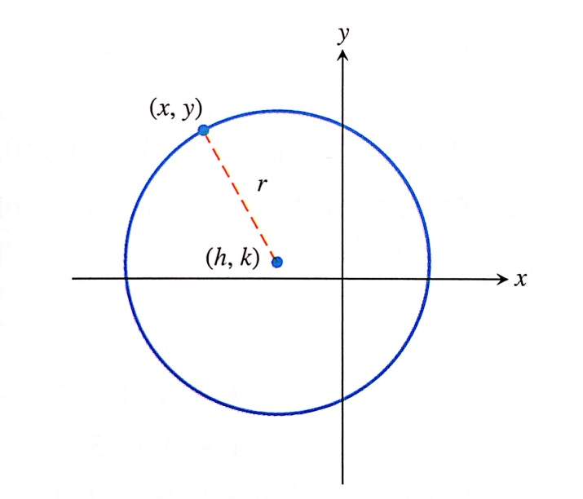

HHow would you find the length of the radius? Use the

Pythagorean Theorem!

Standard Form of the Equation of a Circle

__________________________________

**Example 1:** Find the standard form equation of the circle.

Center: (-4, 1), radius = 8

**You try!** Find the standard form equation of the circle.

1. Find the standard form equation of the circle with center (2, -4) and radius 3
2. Find the center and radius a circle with the equation of: ${(x-1)}^{2}+{(y+4)}^{2}=81.$

**Example 2:** Take the equation ${(x-2)}^{2}+{(y+3)}^{2}=9$ and multiply it out.

This is called the ______________________________.

To get an equation from general form back to standard form, you must _____________________

_______________________________.

Given $x^{2}-8x+y^{2}+11=0$, put in standard form.

**You try!** Put $x^{2}+y^{2}+4x-6y=-4$ in standard form.

**Coterminal Angles**

Coterminal angles: ______________________________________________________________

_____________________________________________________________________________.

**Example 3:** Find and draw a positive angle and a negative angle that are coterminal with the given angle.

1. 30° b) $\frac{2π}{3}$ radians

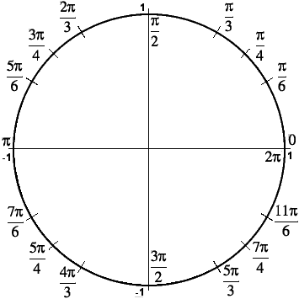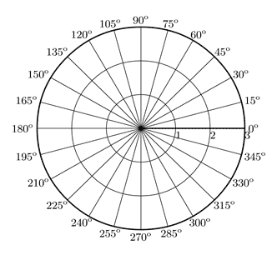

**You try!** Find a positive and negative coterminal angle for each of the following angles.

1. -150° b) $\frac{5π}{3}$ radians

**Working With DMS Measure**

* You already know that units of angular measure are called __________________.
* In the __________________-___________________-___________________ system of angular measure, each degree is subdivided into ______________________ (denoted by ’ ), and each minute is subdivided into __________________________ (denoted by ”).

**Example 4:** Convert 37.425° to DMS.

**You try!** Convert 34.624° to DMS.

**Example 5:** Convert 42°24’36” to degrees.

**You try!** Convert 74°12’18” to degrees.

**Day 2: The Unit Circle and Reference Angles**

What is the Unit Circle and why is it so important?

______________________________________________________________________________

_____________________________________________________________________________.

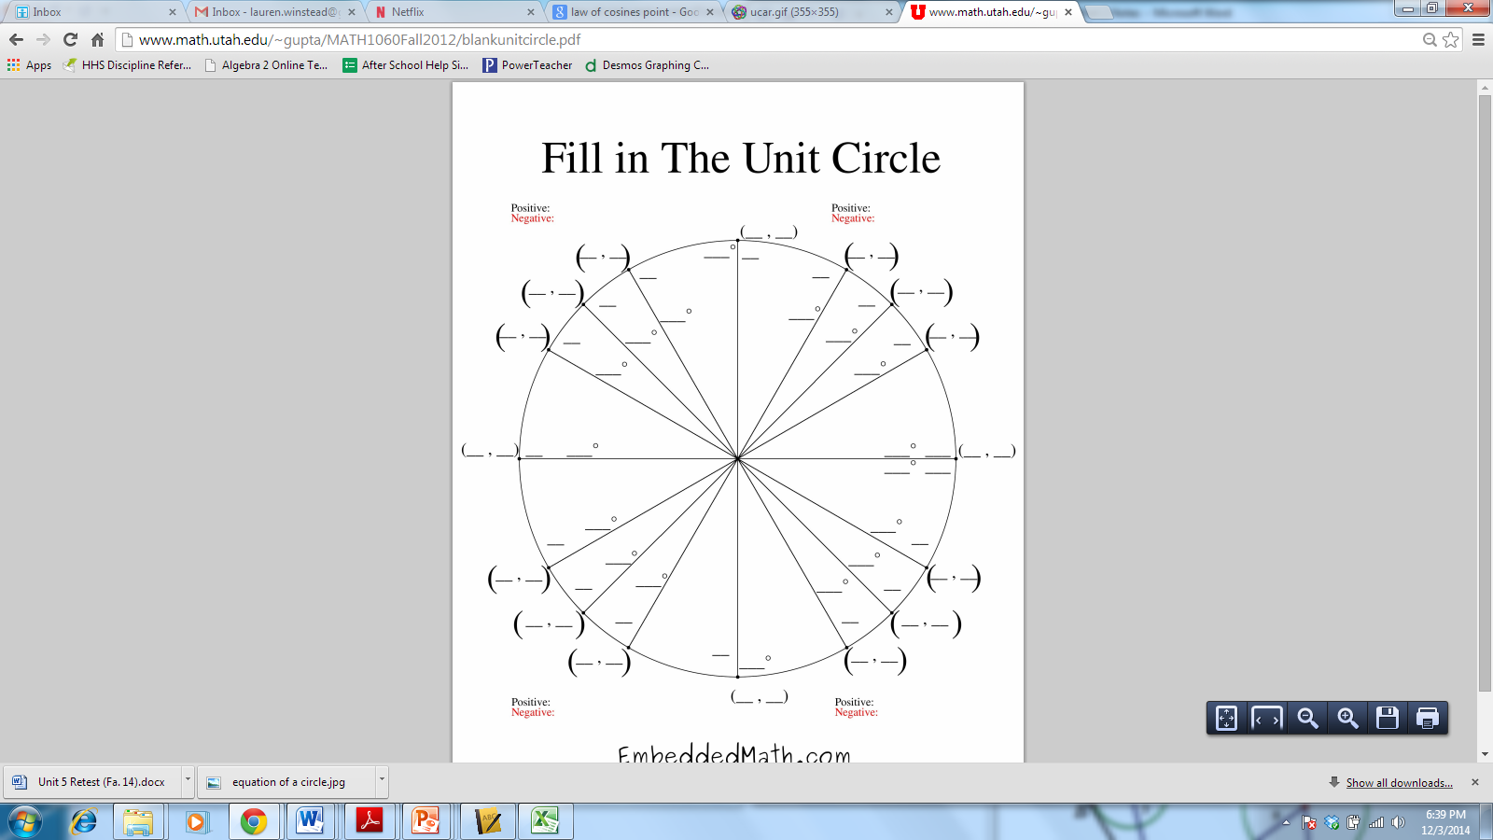

**Example 1:** Determine the sign (positive or negative) of the given value without the use of a calculator.

1. $\cos{143°}$ b) $\sin{\frac{7π}{6}}$ c) $\tan{192°}$

**You try!** Determine the sign of the given value without the use of a calculator.

1. $\tan{\frac{4π}{5}}$ b) $\cos{220°}$ c) $\sin{300°}$

**Example 2:** Evaluate without using a calculator. Use the Unit Circle!

1. $\cos{120°}$ b) $\sin{\frac{11π}{6}}$ c) $\tan{\frac{5π}{4}}$

**You try!** Evaluate without using a calculator. Use the Unit Circle!

1. $\cos{\frac{3π}{4}}$ b) $\tan{60°}$ c) $\sin{\frac{3π}{2}}$

**Day 3: Pythagorean Identity for Finding $\sin{x, \cos{x,}}$**  **and $\tan{x}$**

Based on what you learned yesterday about the Unit Circle…

* Which trigonometric function is associated with x-values? ________________
* Which trigonometric function is associated with y-values? ________________
* What is the center of the circle? _______________
* What is the radius of the circle? _______________

Using x and y, how would you write the equation for the Unit Circle? _____________________

Now, replace that equation with trigonometric functions! ___________________________

This is your very first **Pythagorean Identity!**

**Trigonometric Functions of Real Numbers**

$\sin{θ= }$ $\csc{θ}=$

$\cos{θ}$ = $\sec{θ}$ =

$\tan{θ}$ = (x $≠0$) $\cot{θ}$ = (y $≠0$)

**Finding Trigonometric Values of Angles**

**Example 1:** The terminal side of an angle  in standard position contains the point with coordinates (-3, -4). Find tan ****, cot ****, sec ****, and csc ****.

**You try!** If sec  = 2 and  lies in Quadrant IV, find sin ****, cos ****, tan ****, cot ****, and csc ****.

**Other Pythagorean Identities**

Let’s go back to your original Pythagorean Identity (_____________________________).

What would happen if you divided all terms by $\sin^{2}{θ}$?

What would happen if you divided all terms by $\cos^{2}{θ}$?

**These are your other two Pythagorean Identities!**

**Example 1:** We can simplify trigonometric expressions using these identities. Simplify the following as much as possible.

1. $\frac{1+\tan^{2}{x}}{\csc^{2}{x}}$ b) $\tan{x}\cos{x}$ c) $\frac{1-\cos^{2}{θ}}{sinθ}$

**You try!** Simplify as much as possible.

1. $\cos{x-\cos^{3}{x}}$ b) $\frac{\sin^{2}{θ+ \tan^{2}{θ+ \cos^{2}{θ}}}}{\sec{θ}}$

**Challenge Problem!**

Simplify $\frac{\sin^{4}{θ-\cos^{4}{θ}}}{\sin^{2}{θ-\cos^{2}{θ}}}$, where $\sin^{2}{θ≠\cos^{2}{θ}}$.