Module 8 Review

Using the following points and the graph at the right determine whether the following lines are parallel or perpendicular. Prove it algebraically: (Hint: do this by comparing slopes)

- $\overline{AB}$ and $\overline{CD}$ if A(5,6) B(3,2) C(-4,5) D(-3,7)
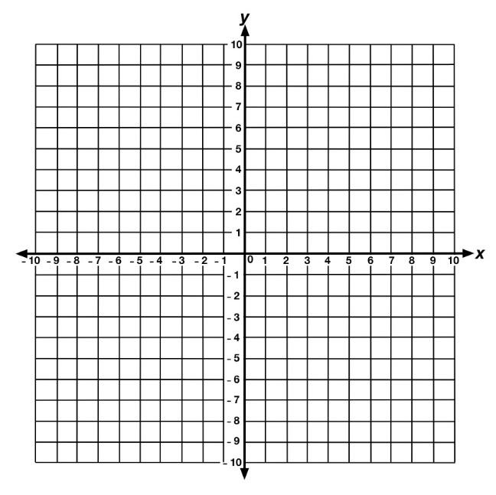

- $\overline{AB}$ and $\overline{CD}$ if A(3,2) B(5,7) C(-6,2) D(4,-2)

- $\overline{AB}$ and $\overline{CD}$ if A(-3,1) B(-7,-2) C(2,-1), D(8,4)
- $\overline{AB}$ and $\overline{CD}$ if A(-2,2) B(0,1) C(-4,-1), D(2,3)

- $\overline{AB}$ and $\overline{CD}$ if A(1,2) B(4,-3) C(-4,3), D(-1,-2)

Using the following points, determine whether the triangle is a right triangle or not. Also determine whether it is scalene, isosceles, or equilateral. Prove it algebraically: (hint use Pythagorean theorem and compare slopes)

- $∆ABC$ given by A(-2,-3) B(4,1) C(-1,7)
- $∆ABC$ given by A(-3,2) B(1,-2) C(8,5)

- $∆ABC$ given by A(3,4) B(5,1) C(2,-1)

Now determine the perimeter of the previous three triangles.

