MVP Math 2 Unit 4 Test Review Name:____________________________

Note: If needed, you can round your x-intercepts to the nearest hundredth.

Write in vertex form.
1. $y=x^{2}-6x+5$ 2. $y=x^{2}+16x+71$ 3. $y=-x^{2}-14x-59$

4. $y=2x^{2}-4x+5$ 5. $y=7x^{2}-14x-21$ 6. $y=-\frac{1}{2}x^{2}-4x-9$

For each of the following, identify the transformations and characteristics of the equations and then graph.
7. $y=-2(x-1)^{2}-1$ 8. $y=-(x-4)^{2}+2$
Transformations: Transformations:

Vertex: ___________ Vertex: ___________
Min or Max?________ Min or Max?_______
Aos: ______________ Aos: _____________
y-intercept__________ y-intercept_________
x-intercepts__________ x-intercepts__________
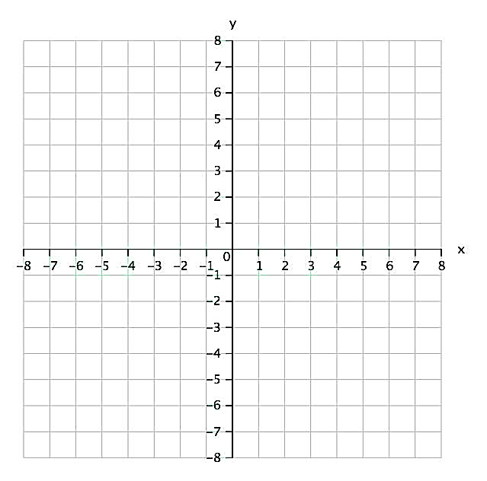

9.$y=3(x+2)^{2}+1$ 10. $y=2(x+3)^{2}-8$
Transformations: Transformations:

Vertex: ___________ Vertex: ___________
Min or Max?________ Min or Max?_______
Aos: ______________ Aos: _____________
y-intercept__________ y-intercept_________
x-intercepts__________ x-intercepts__________

11. Optima has an order for 3 quilt squares, with the dimension of each square increased by 4 inches. Draw a representation for the area, and then write two equivalent expressions to represent the scenario.

Factor the following:
12. $x^{2}-22x + 72$ 13. $4x^{2}-49$ 14. $3x^{2}-13x -10$

Based on the description of transformations from the parent function, write an equation representing the transformations in vertex form. All are representing QUADRATIC FUNCTIONS!

15. A vertical stretch of 8, shift right 4, up 7.

16. Reflection over the x-axis, vertical compression (or “shrink”) by ⅕, shift left 6, down 9.

17. Vertical compression (“or shrink”) of 1/9, shift left 7, up 12.

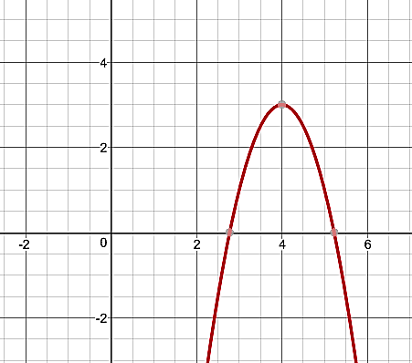
Given the following graph, complete the following:

18. Standard Form Equation: __________________________
Vertex Form Equation: __________________________
Vertex: _______________
X-intercepts: ___________
Y-intercept: _________
Minimum or Maximum? _______________

Given the following table, complete the following:
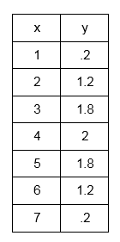
19. Standard Form Equation: __________________________
Vertex Form Equation: __________________________
Vertex: _______________
X-intercepts: ___________
Y-intercept: _________
Minimum or Maximum? _______________

x | y
1 | .2
2 | 1.2
3 | 1.8
4 | 2
5 | 1.8
6 | 1.2
7 | .2

