**Math 3 Unit 1 Homework Packet**

***Homework 1-1***

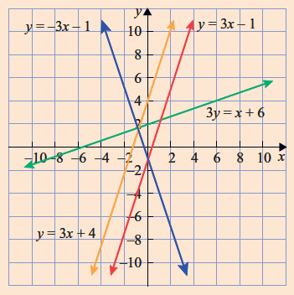**Discovering how parts of linear equations make lines parallel or perpendicular.**

1. Inspect the graph and determine the following:
2. Which pairs of equations produce parallel

lines? _________________ & _________________

1. Which pairs of equations produce perpendicular

lines? _________________ & _________________

1. **State the slope and the coordinates of the y-intercept.**
2. **y = 2*x* + 3 m = _________; b = _______________**
3. **y = –2*x* + 7 m = _________; b = _______________**
4. Find the slope of a line parallel and perpendicular to each of the lines below:
5. *y* = 3*x* + 8 (b) 2x + *y* = – 7 (c) 4x – 3y = 8

// m = _______ // m = _______ // m = ________

m = _______ m = _______ m = ________

1. Determine the equation of the line that is parallel to the given line and passes through the given point:

(a) *y* = 2*x* + 7 (b) *y* = 3*x* – 1 (c) *6x + 2y =* 2

*A*(2,9) *B*(0,12)  *C*(9,8)

1. Determine the equation of the line that is perpendicular to the given line and passes through the given point:

(a) *y* = 2*x* + 7 (b) *y* = 3*x* – 1 (c) *6x + 2y =* 2

*A*(2,9) *B*(0,12)  *C*(9,8)

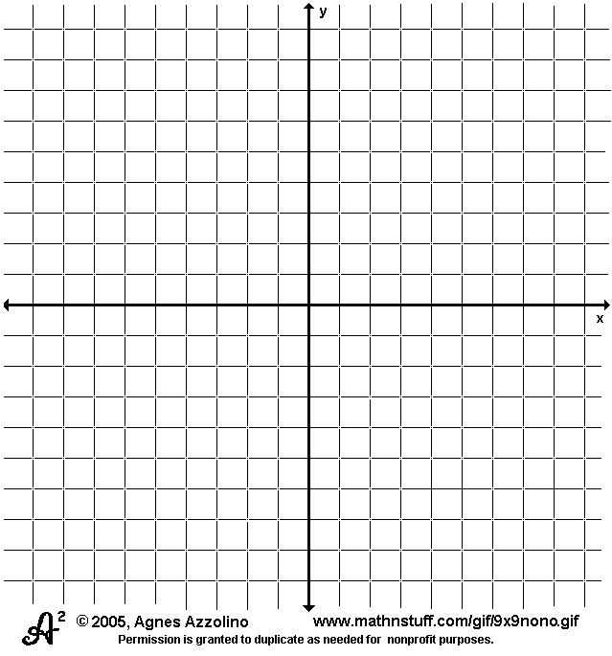6. Graph the following lines:

(a) y = 3x – 5

(b) 2x – 3y = 6

***Homework 1-2***: Solve the System using Substitution or Elimination

**1.**  **2.**  **3.**  **4.**

**5.**  **6.**  **7.**  **8.**

**9.**  **10.**  **11.**  **12.**

**14**. Graph the system of inequalities. **15**. Graph the system of inequalities.

3x + 9y > 27 7x + 5y < 35

4x -2y ≤ 12 8x – 7y ≤ 56

2x + 3y > -12

5x – 3y ≥ -15

Homework 1-3

Solve the system using the elimination method.

1.  2. 

3. Three bouquets of flowers are ordered at a florist. Three roses, 2 carnations, and 1 tulip cost $14, 6 roses, 2 carnations, and 6 tulips cost $38, and 1 rose, 12 carnations, and 1 tulip cost $18.   
How much does each item cost?

Solve the system of linear equations using the substitution method.

4.  5. 

6. A triangle has a perimeter of 120 centimeters.

n

a. Write and use a linear system to determine the lengths of

3n-m

sides of the triangle.

m= n + 10

Homework 1-4

Solve the system using matrices.

1.  2.  3. 

4. Your friend claims that she has a bag of 30 coins containing nickels, dimes, and quarters. The total value of the 30 coins is $3. There are twice as many nickels as there are dimes. Is your friend correct? Explain your reasoning.

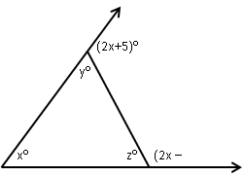

5)

5 . Find the measures of the angles marked   
  in the triangle.

(2x+5)°

y°

x°

z°

(2x – 5)°

(2x+5)°

y°

x°

z°

(2x – 5)°

6. A sapling is 3 inches tall and grow at a rate of 1.5 inches per month. Write and graph an equation to model the tree’s height *h* after *x* months.

7. There are 2 leaves along 3 inches of an ivy vine. There are 14 leaves along 15 inches of the same vine. How many leaves are there along 6 inches of the vine? *Find a linear model and use it to make a prediction*

***Homework 1-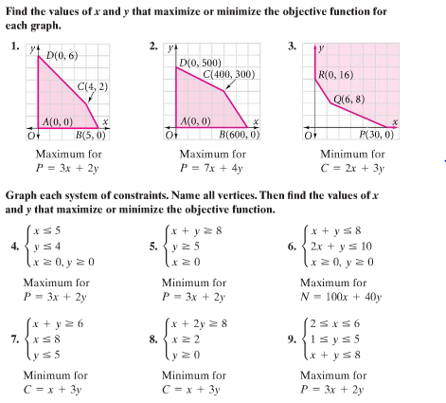6***

4 5.

6. 7.

**8.** **9.**

**Homework 1-7**

**On your own paper:** List the constraints and objective function needed to answer the problem. Graph the inequalities and list the vertices of the feasible regions. Answer the problem.

1. Trees in urban areas help keep air fresh by absorbing carbon dioxide. A city has $2100 to spend on planting spruce and maple trees. The land available for planting is 45,000 ft2. Spruces cost $30 to plant and require 600 ft2. Maples cost $40 to plant & require 900 ft2. Spruces absorb 650 lb/yr of carbon dioxide & maples absorb 300 lb/yr of carbon dioxide. How many of each tree should the city plant to maximize carbon dioxide absorption?

2. A toy manufacturer wants to minimize her cost for producing two lines of toy airplanes. Because of the supply of materials, no more than 40 Flying Bats and 60 Flying Falcons can be built each day. There are enough workers to build at least 70 toy airplanes each day. It costs $12 to manufacture a Flying Bat and $8 to build a Flying Falcon. What is the minimum cost each day?

3. A seafood restaurant owner orders at least 50 fish. He cannot use more than 30 amberjack or more than 35 flounder. Asian carp costs $4 each and flounder costs $3 each. How many of each fish should he use to minimize his cost?

4. Jermaine makes two types of wood clocks to sell at local stores. It takes him 2 hours to assemble a pine clock, which requires 1 oz of varnish. It takes 2 hours to assemble an oak clock, which takes 4 oz. of varnish. Jermaine has 16 oz. of varnish in stock, and can work 20 hours. If he makes $3 profit on each pine clock and $4 on each oak clock, how many of each type should he make to maximize his profits?

**Homework 1-8**

1. If the first term of an arithmetic sequence is 5 and the common difference is -2, find the next four terms.
2. If I know that the first term of the arithmetic sequence is -2 and the fifth term is 6, find the second, third, and fourth terms in the sequence.

*Is the given sequence arithmetic? If so state the common difference*

* + - 1. 12, 15, 18 2. 100, 110, 130 3. -2, -1, 0 4. 123, 221, 319

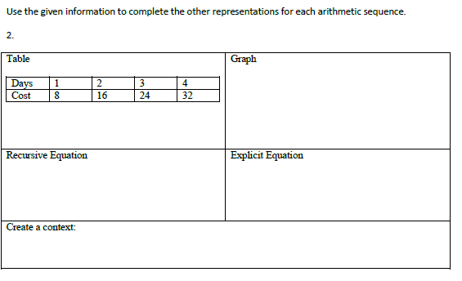

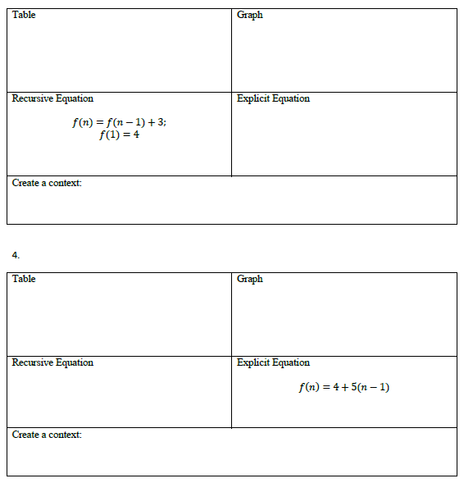

5.



6.

7. Find the 125th term of the sequence 5, 11, 17, 23, …

1. Abbie decides to start doing crunches as part of her daily workout. She decides to do 15 crunches the first day and then increase the number by 4 each day after that. Write an explicit formula for the number of crunches Abbie will do on day *n*. How many crunches would she do on day 25?
2. You are trying to save money for an Xbox One. You currently have $50 and save an additional $12 every week. Write the recursive and explicit formula for this arithmetic sequence and find how much money you will have after 12 weeks?
3. Amelia is tracking her mathematics test scores. She starts out slow, but continues to get better with each test. Her first test was a 75. Her second was a 78, and third was an 81. If this trend continues, what would her score on the 10th test be?

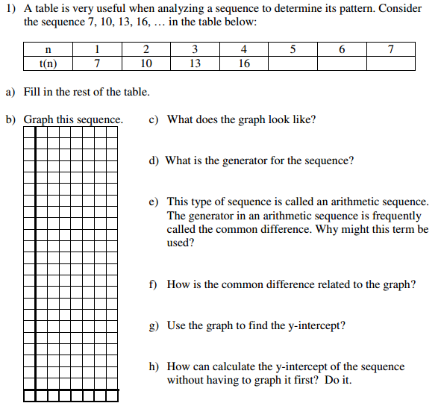

11.

1. **Fill in the rest of the table.**
2. **Graph the sequence.**

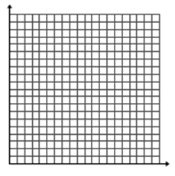

**c. How is the common difference related to the graph?**

**d. Use the graph to find the y-intercept**

**e. How can you calculate the y-intercept of the sequence without having to graph it first?**

**Unit One Part One Review SHOW ALL WORK TO RECEIVE FULL CREDIT**

1. Write the equation of the line in slope-intercept form that goes through and .

2. Write the equation of the line in standard form that goes through the point $(-5, 3)$& is parallel to the line .

3. Write the equation in standard form of the line perpendicular to y = 2x – 8 that goes through the point (-2, 6).

4. Solve the system with substitution:

5. Solve the system using elimination:

6. Solve the system:

7. Write the system as a matrix equation and find the solution. 

8. A mixture of dimes and quarters has a total value of $10.65. There are 57 coins in all. How many of each type of coin is present?

9. A theater at which a drug abuse program is being presented seats 150 people. The proceeds will be donated to a local drug information center. Admission is $2 for adults and $1 for students. $210 was donated to the center. How many adults and how many students attended the presentation?

10. Luisa, Yoko, and Amy all went to the matinee. Luisa took her two children and her mother who is a senior citizen. She paid $12. Yoko took her two children and her mother who is not a senior citizen. She paid $13. Amy took her son, her husband, and her mother and father, both of whom are senior citizens. She paid $16.50. What are the matinee ticket prices for adults, children, and senior citizens?

11. **For the following problem write a system of constraints and write and objective function, but DO NOT SOLVE!**

You are stenciling wooden boxes to sell at a fair. It takes you 2 hours to stencil a small box and 3 hours to stencil a large box. You make a profit of $10 for a small box and $20 for a large box. If you have no more than 30 hours available to stencil and want at least 12 boxes to sell, how many of each size box should you stencil to maximize our profit?

12. **Solve!** A small company produces knitted Afghans and sweaters and sells them through a chain of specialty stores. The company is to supply the stores with a total of no more than 100 Afghans and sweaters per day. The stores guarantee that they will sell at least 10 and no more than 60 Afghans per day and at least 20 sweaters per day. The company makes a profit of $10 on each afghan and a profit of $12 on each sweater. How many of each should the company produce to maximize profit?

**Objective Function**

**Define variables**

**Table**

**Constraints**

**Coordinates of Vertex Points**

**Answer:**______________________

13. You decide to train for a marathon and start out running 2 miles, adding 3 more miles each week. How many miles will you have run after 4 weeks? Write an explicit and recursive formula for this sequence and a7.