**Unit 4: Quadratics: Graphing and Systems**

**By the end of the unit students will be able to:**

* Graph quadratics using both the standard form and vertex form.
* Solve Systems involving lines, parabolas, and circles.

|  |  |  |  |  |
| --- | --- | --- | --- | --- |
| **Day** | **Date** | **Lesson** | **Assignment** | **Check** |
| 1 | Friday  Sep. 22nd | Systems of Lines & Parabolas (algebraic) | Homework 3-1 |  |
| 2 | Monday  Sep. 25th | Systems of Lines and Circles  (algebraic) | Homework 3-2 |  |
| 3 | Tuesday  Sep. 26th | **Quiz**  Graphing Quadratics | Homework 3-3 |  |
| 4 | Wednesday  Sep. 27th | Quadratic Transformations | Homework 3-4 |  |
| 5 | Thursday  Sep. 28th | Quadratic Graphing in Calculator with Applications | Homework 3-5 |  |
| 6 | Friday  Sep. 29th | **Quiz**  *EARLY RELEASE |  |  |
| 7 | Monday  Oct. 2nd | Quadratic Inequalities | Homework 3-7 |  |
| 8 | Tuesday  Oct. 3rd | Systems of Quadratic Equations and Inequalities | Homework 3-8 |  |
| 9 | Wednesday  Oct. 4th | Review | Review Sheet |  |
| 10 | Thursday  Oct. 5th | Unit 3 Test | Unit 4 Placemat |  |

**Homework 3-1 Intersection of lines and Parabolas**

**Graph each of the following**

**1.**  and y = -2x + 4 **2.** x2 + 3x + 2 and y = x + 2

Solve the system of equations Algebraically:

3. y = x2 – 4x + 9 4. y = -x2 + 2x - 4

y = 2x + 1 x + y = -4

5. Each year, Heritage’s Homecoming committee organizes a dance. Based on previous years, the organizers decided that the Income from ticket sales, I(t) is related to ticket price *t* by the equation *I(t) = 400t – 40t2. Cost* C(t) of operating the dance is also related to ticket price *t* by the equation *C(t) = 400 + 40t.*

* 1. What ticket price(s) would generate the greatest income? What is the greatest income possible? Explain how you obtained the value you got.

Ticket price(s) ______________ Income ________________

* 1. For what ticket price(s) would the operating costs be equal to the income from ticket sales? Explain how you obtained the answer.

**HW 3-2 Intersection of Circles and Lines**

**On separate paper Solve Algebraically**

1. x2 + y2 = 50 and y = x 2. x2 + y2 = 26 and 5y = x

**Circle the correct answer.**

3. x2 + y2 = 2 and y = x – 2 4. x2 + y2 = 25 and 2x – y = 5 5. y = 2x2 + 2x + 3 and y – x = 3

a) (2, -2) and (1, -1) a) (4, 3) a) (0, 3) and (3, 0)

b) (-1, 1) and (1, -1) b) (-5, 0) and (4, 3) b) (0, 3) and (-0.5, 2.5)

c) (-1, 1) c) (0, -5) and (4, 3) c) (0.5, 2.5) and (3, 0)

d) (1, -1) d) (0, -5) d) (-0.5, 2.5) and (-3, 0)

**HW 3-3**

I. For each graph fill in the blanks for the requested information.

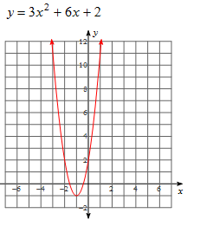a) Vertex:______

Zeroes:_____________

y-intercept:_________

Axis of symmetry:_________

Decreasing interval:_________

Increasing interval:__________

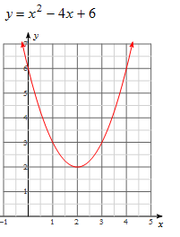b) Vertex:______

Zeroes:_____________

y-intercept:_________

Axis of symmetry:_________

Decreasing interval:_________

Increasing interval:__________

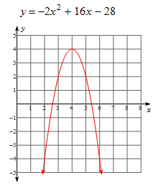

c) Vertex:______

Zeroes:_____________

y-intercept:_________

Axis of symmetry:_________

Decreasing interval:_________

Increasing interval:__________

d) Vertex:______

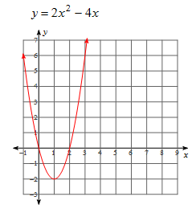 Zeroes:_____________

y-intercept:_________

Axis of symmetry:_________

Decreasing interval:_________

Increasing interval:__________

II.

Equation . Axis of Symmetry Vertex Factor x-intercept y-int

y = x2 +8x +15

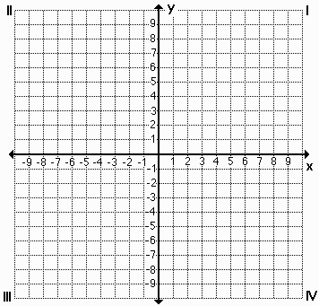 *Graph the function above Graph the function below*

Equation Axis of Symmetry Vertex Factor x-int y-int

$$x^{2}+2x-24$$

**More Practice**

**How much the graph of y = x2 be changed to produce each of the following graphs? Write *shift up, shift down, shift left, shift right, narrower or flatter* in the blank. If more than one change is needed, you may write up to 3 of these options in the blank.**

1.  1. _____________________________________
2.  2. _____________________________________
3.  3. _____________________________________
4.  4. _____________________________________
5.  5._____________________________________
6.  6. _____________________________________
7.  7. _____________________________________
8.  8. _____________________________________
9.  9. _____________________________________
10.  10. ____________________________________
11.  11. ____________________________________
12.  12. __________________________________

**HW 3-4**

*For the following functions* ***describe the transformation,*** *state the* ***End Behavior*** *and find the* ***domain and range****.*

1. y = x2 + 2 2. y = 3x2 - 1 3. y = ½ (x + 1)2

T: T: T:

D: D: D:

R: R: R:

EB: EB: EB:

Increase Interval Increase Interval Increase Interval

Decrease Interval Decrease Interval Decrease Interval

4. y = (x – 3)2 + 2 5. y = -3(x – 1)2 - 2 6. y = -½ (x+2)2 - 5

T: T: T:

D: D: D:

R: R: R:

EB: EB: EB:

Increase Interval Increase Interval Increase Interval

Decrease Interval Decrease Interval Decrease Interval

7. y = 5(x + 1)2 - 2 8. y = -(x + 3)2 - 6 9. y = 1/3 (x – 3)2 + 12

T: T: T:

D: D: D:

R: R: R:

EB: EB: EB:

Increase Interval Increase Interval Increase Interval

Decrease Interval Decrease Interval Decrease Interval

**HW 3-5**

1. A ball is thrown straight up with an initial velocity of 56 feet per second. The height of the ball ***t*** seconds after it is thrown is given by the formula

MCj04324650000[1]**h(t) = 56t – 16t2.**

1. What is the height of the ball after 1 second?_______________________
2. What is its maximum height?____________________________________
3. After how many seconds will it return to the ground? _________________
4. A baseball is projected upward from the top of a 448 foot tall building with an initial velocity of 48 feet per second. The distance **s** of the baseball from the ground at any time **t**, in seconds, is given by the equation s = -16t2 + 48t + 448.

a. Find the time it takes for the baseball to strike the ground. ________

b. What is the baseball’s maximum height?___________

Use the formula where **h(t)** is the height of an object in feet,  is the object's initial velocity in feet per second, and **t** is the time in seconds for #3.

3. An arrow is shot upward with a velocity of 64 feet per second. Ignoring the height of the archer, how long after the arrow is released does it hit the ground?_____________

4. At 1821 feet tall, the CN Tower in Toronto, Ontario, is the world’s tallest self-supporting structure. Suppose you are standing in the observation deck on top of the tower and you drop a penny from there and watch it fall to the ground. The [table](javascript:def('/Glossary/glossaryterm.aspx?word=Table',%20500,%20500);) below shows the penny’s distance from the ground after various periods of time (in seconds) have passed. Where is the penny located after falling for a total of 10.5 seconds?

|  |  |  |  |  |  |  |
| --- | --- | --- | --- | --- | --- | --- |
| Time(seconds) | 0 | 2 | 4 | 6 | 8 | 10 |
| Distance(feet) | 1821 | 1757 | 1565 | 1245 | 797 | 221 |



a. Find the quadratic model.

b. Where is the penny located after falling for a total of 10.5 seconds?_____

**More Quadratic Applications**

I. Greg, Keith and Dan were at the skate park. They decided to use a three foot ramp to see who could jump the highest. The paths of their jumps are given below.

|  |  |
| --- | --- |
| x | y |
| 0 | 3 |
| 4 | 5 |
| 6 | 3 |

Greg: y = -x2 + 4x + 3 Keith: Dan:

1. Who had the highest jump?
2. Who had the lowest jump?
3. Who had the longest jump?
4. What was the difference in height between the highest and the lowest jumps?

**HW 3-6 Graphing Quadratic Inequalities**

Graph each quadratic inequality.

1.  2.  3. 

4.  5.  6. 

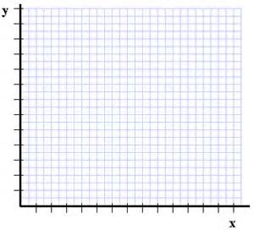7. The number of people that attend an sale can be modeled by the inequality $y≤{-4x}^{2}+24x$, where x represents the number of days into the sale and y represents the people attending **in hundreds**.

1. Graph the inequality.
2. What is the maximum and what does it represent?
3. How long does the sale last for?
4. The store has to have extra staff when the attendance

is 2000 people of more. Write the inequality for this situation,

and graph.

1. According to your graph, on what days does the

company need to have extra staff working?

**HW 3-7 Intersection of lines and Parabolas**

**Graph each of the following**

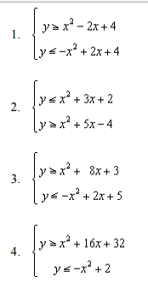

**5.**  and y = -2x + 4 **6.** y = x2 + 3x + 2 and y = x + 2