**Unit 1, HW 1  
Adding Integers**





**Unit 1, HW 2  
Adding and Subtracting Negative Numbers**

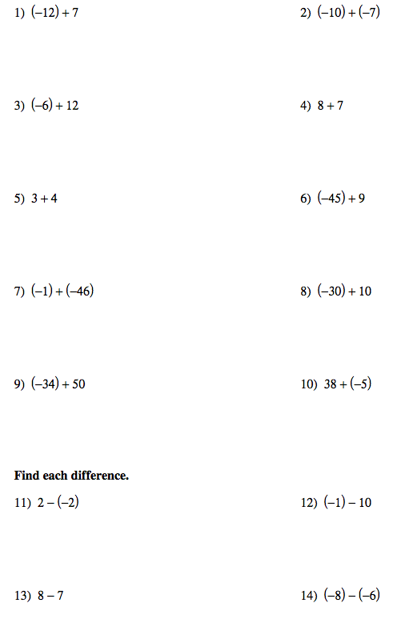

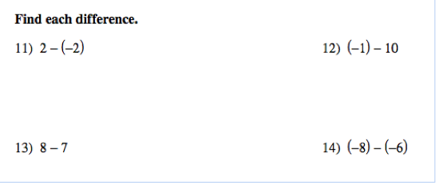

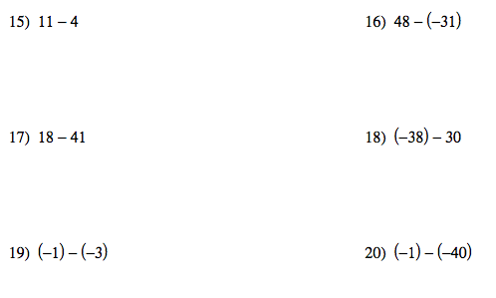

**Fundamentals of Math**

**Unit 1, HW 3  
Multiplying and Dividing Integers**

**\*Remember that when numbers are in parentheses next to each other, that means to multiply! When they look like fractions, just divide!**

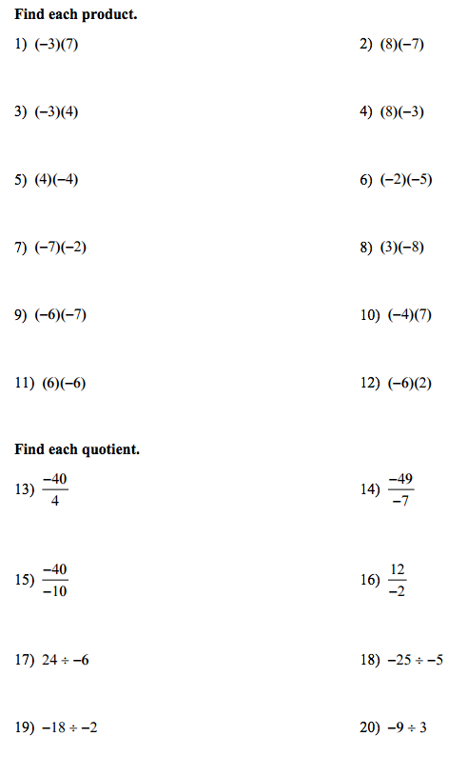

**Fundamentals of Math**

**Unit 1 Hw 5**

**Order of Operations**

1. 8 + 9 – 3 + 5 2. 

3.  4. (9 + 4)(8 - 7)

5. (16 + 5) – (13 + 2) 6. 

7.  8. 

9.  10. 

11.  12. 

13.  14. 6(38 – 12) + 4

**True or False?**

15.  16. 

**Unit 1 Hw 6**

**Evaluating expressions**



**Unit 1 Hw 7**

**Variables and expressions**

Write an algebraic expression for each word phrase.

1. 12 more than *m* machines.

2. Six times the daily amount of fiber *f* in your diet increased by 3.

3. Your aunt’s age *a* minus 25.

4. The total number of seashells *s* divided by 10.

5. 9 less than *k.*

6. The number *m* divided by 6.

7. Twice the sum of a number and 7.

8. 4 more than twice x.

9. The quotient of a number and 4.

10. Five more than a number squared.