**2-1 Homework**

Factor and solve.



$x^{2}+10x+16=0$

${-x}^{2}-x+20=0$

${5r}^{2}+23r+26=0$

${3x}^{2}+8x-16=0$

${12x}^{2}+3x=0$

$8t^{2}-16t=0$

$9x^{2}-1=0$

${25x}^{2}-49=0$

${5x}^{3}+50x^{2}-375x=0$

${ -3t}^{3}+{21t}^{2}+132t=0$

${ 4x}^{3}-9x^{2}-16x+36=0$

${ 3x}^{3}+{12x}^{2}-3x-12=0$

$x^{2}+10x+25=0$

${ x}^{2}+8x+16=0$

${4x}^{2}+40x+100=0$

**2-2 Homework**

Simplify the following radicals

|  |  |  |  |  |
| --- | --- | --- | --- | --- |
| 1. | 2. | 3. | 4. | 5. |
| 6. | 7. | 8. | 9. | 10. |
| 11. | 12. | 13. | 14. | 15. |

Factor the following and solve.

1.  17.  18. 

19. 9x2 + 11x + 2 20. 8x2 + 13x – 6 21. 3x2 - 20x – 63

**2-3 Homework**

Use completing the square to solve the following.

1. $x^{2}+4x=21$ 2. $x^{2}-8x=33$ 3. $x^{2}+10x=-5$
2. $3x^{2}+10x+3=0$ 5. $x^{2}+7x=0$ 6. $2x^{2}-7x-4=0$

Complete the square for the following and set equal to zero.

1. $3x^{2}+4x=3$ 8. $x^{2}-5x-5=0$ 9. $x^{2}-x-7=0$

Solve the following using the quadratic formula

10. 11.

12. 13.

Simplify Fractions for the Quadratic Formula

1.  15. 

**2-4 Homework**

1. Write the following expressions in standard form.
$\sqrt{-16}+5$

$-\sqrt{-48}-12$

$-\sqrt{-32}+1$

$\sqrt{-162}-21$

$-\sqrt{90}+5$

2. Simplify/Rationalize the following expressions:
   1. (3 – 12i) + (5 – 3 i)
   2. (5 + 4i) – (3 – 2i)
   3. (4i)(-3i)
   4. (2i)(-5i)(3i)
 $\frac{5+4i}{2i}$

  5. (2 + 4i)(7 – i)

$\frac{5-8i}{9-3i}$

$\frac{3-2i}{1+1i}$

$\frac{2-i}{3i}$

**2-5 Homework**

Solve the following using either the quadratic formula or completing the square.

1. 2.

3. 4.

5. 6.

Factor by either substitution or sum and difference of cubes and solve:

|  |  |  |
| --- | --- | --- |
|  |  | 1. = 0 |
|  |  |  |

**2-6 Homework**

Identify the axis of symmetry, the vertex and then graph:

1. 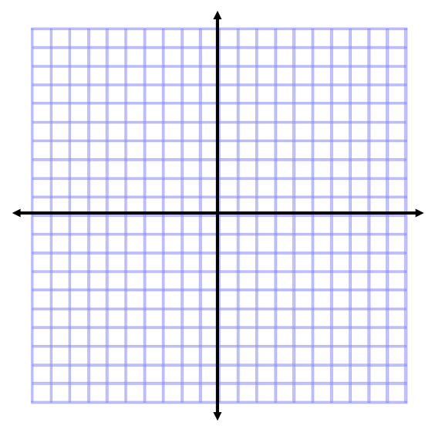
2. 
3. 
4. 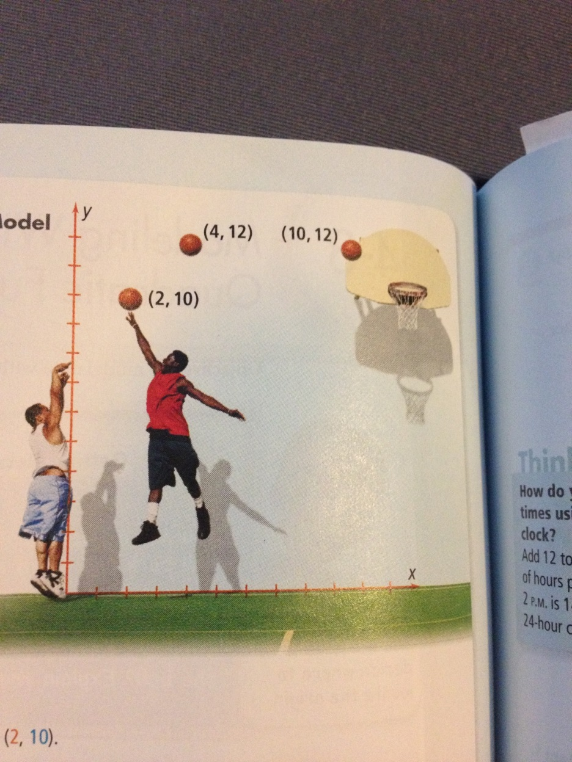A basketball player throws the basketball toward the hoop. The basketball follows a parabolic path through the points (2, 10), (4, 12), and (10, 12). What is the equation of this path? Will his shot pass through the hoop at the point (12,10)?
5. A parabola contains the points (0,0), (-1, -2) , and (1,6). What is the equation of this parabola in standard form?
6. A parabola contains the points (1, -2), (2, -2), and (3, -4). What is the equation of the parabola in standard form?

**2-7 Homework**

Open: up or down

Axis of symmetry: x =

Vertex:

( , )

Min or max?

Open: up or down

Axis of symmetry: x =

Vertex:

( , )

Min or max?

Open: up or down

Axis of symmetry: x =

Vertex:

( , )

Min or max?

1. $y={\left(x-2\right)}^{2}-3$ 3. $y={\left(x-6\right)}^{2}+6$ 4. $y=\frac{1}{2}{\left(x-2\right)}^{2}-1$

Write the following in vertex form and describe the transformations from x2.

5. 6.

7. 8.

9. 10.

**2-8 Homework**

Identify the vertex, focus, and directrix of a parabola with each equation. Then sketch a graph of the parabola with the given equation.





$x^{2}-25x=0$

$x^{2}=-4x$

$x^{2}-6x=18$

$y=x^{2}+4x+3$

Write an equation of a parabola with the given information:

|  |  |
| --- | --- |
| 1. Vertex: (0, 0), focus (0,6) | 1. Vertex (4, 1), focus (4, -2) |
| 1. Vertex (3, 2), directrix y = -2 | 1. Focus (0, 0), directrix y = 6 |