Honors Math 3 Name: ___________________________
Unit 3 Review Date: ___________________________

- a) What are the zeros and their multiplicities for $16x^{3}+40x^{2}+16x?$

b) What is the end behavior of the graph for this polynomial?

c) What kind of polynomial is $16x^{3}+40x^{2}+16x?$ according to the number of terms and degree? How many roots should it have? (Hint: look at its degree!)

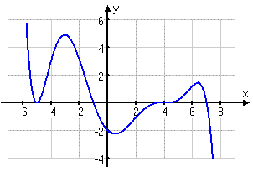
- a) Write the polynomial of the given graph $f(x)$, including the correct multiplicities and leading coefficient.

b) Suppose the graph represents a walker’s speed
over time. What is the practical domain and range?

- Write a 4th degree polynomial with roots at x = 2i and x = $\sqrt{3}$.

- Expand ${\left(3x-2\right)}^{4}$.

- Use the Rational Roots Theorem to find possible rational roots of $f\left(x\right)=2x^{4}-9x^{2}+7$. Then, use the Remainder Theorem to find which one actually is a root of the polynomial.

- Write $y=2x{\left(x+4\right)}^{2}$ in standard form. | - Which type of function best models the data in the chart below? A linear, quadratic, cubic, or quartic function?  x -2 -1 0 1  y -6 -2 1 4  How do you know?  What should y equal when x=5?
- A metal worker wants to make an open box from a 14 in x 18 in sheet of metal by cutting equal squares from each corner.

- Write a function for the volume of the box.

- What are the local maximum and local minimum?

- Find the maximum volume of the box and the side length of the cut out squares that generates that volume.

- Prove that the binomial $x+3$ is a factor of $2x^{3}+8x^{2}+6x$. Then, find all the other factors of the function.

- Divide.  Is $x+2$ a factor of $2x^{4}+6x^{3}+5x-6$? | - Divide.  $\frac{3x^{3}+26x^{2}+56x+35}{3x+5}$  Is 3x + 5 a factor of the polynomial?

