# Unit 4 EXTRA Test Review Name ____________________________________

**Math 3 Date ________________________ Period _______**

1. Simplify $\frac{x-2}{x-1}∙\frac{x^{2}+8x-9}{x^{2}+7x-18}$

Part II – Simplify. Circle answer

1. $\frac{5x-30}{x-6}$**5. $\frac{x^{2}-4x}{x^{2}+4x-12}∙\frac{x^{2}-36}{x^{2}-3x-4}$**

**6. $\frac{x-7}{4x^{3}y^{2}}÷\frac{x-7}{6x^{2}y}$**  7**. $\frac{x-5}{x^{2}-49}÷\frac{x^{2}-3x-10}{x^{2}-7x}$**

**Simplify. Addition/Subtraction.**

8. 9.

10.

Solve each equation and check your solution.

11. 12.

13.

Graph Rational Functions

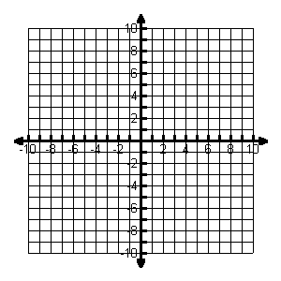17. Sketch the graph of: $y=\frac{5x-15}{x-6}$. Label any intercepts and asymptotes.

Vertical Asymptote:_______________

Horizontal Asymptote:_______________

X – intercepts: ____________

Y – intercepts: ________________

Domain: _________________