**Homework 5-1**

**Use Pythagorean Theorem to solve for the missing side in each triangle.**

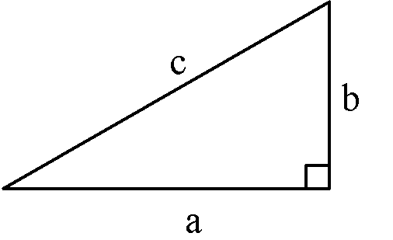

1.

2.

3.

4. .

1. The slide at the playground has a height of 6 feet. The base of the slide measured on the ground is 8 feet. What is the length of the sliding board?
2. The bottom of a 13-foot straight ladder is set into the ground 5 feet away from a wall. When the top of the ladder is leaned against the wall, what is the distance above the ground it will reach?
3. In shop class, you make a table.  The sides of the table measure 36" and 18".  If the diagonal of the table measures 43", is the table “square”?  (In construction, the term "square” just means the table has *right angles* at the corners.)
4. In the Old West, settlers made tents out of a piece of cloth thrown over a clothesline and then secured to the ground with stakes forming an isosceles triangle. How long would the cloth have to be so that the opening of the tent was 6 feet high and 8 feet wide?
5. A baseball “diamond” is actually a square with sides of 90 feet.  If a runner tries to steal second base, how far must the catcher, at home plate, throw to get the runner “out”? Given this information, explain why runners more often try to steal second base than third.

**Homework 5-2**

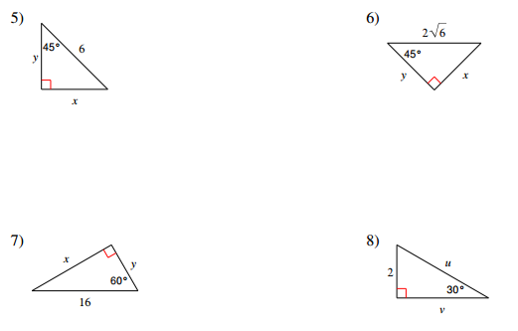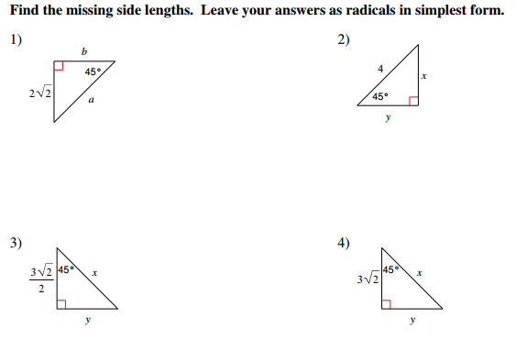

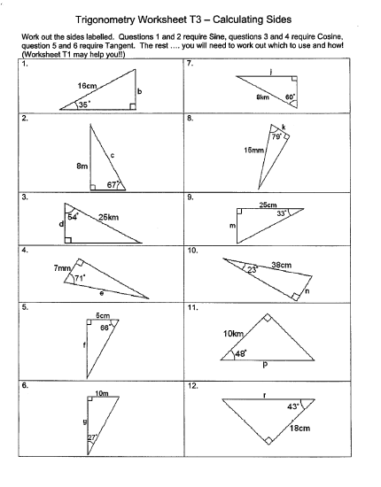

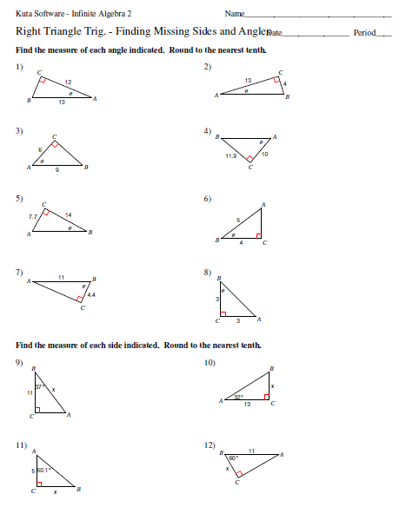

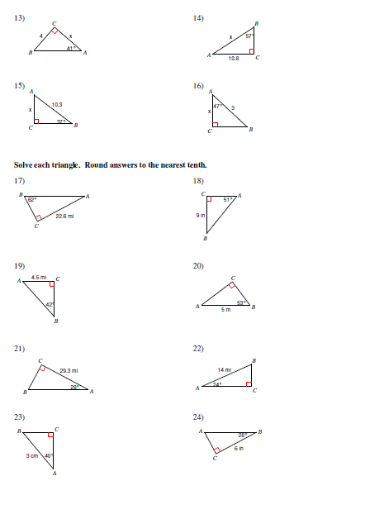

Angle of Elevation and Depression HW

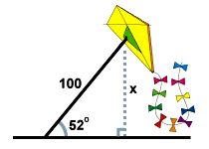**Find all values to the nearest tenth.*x* = 10 sec(20) latex_img1510.64 . The second boat must travel about 10.6 miles to get as far west as the first boat.**

[**Close**](http://www.sparknotes.com/math/trigonometry/solvingrighttriangles/problems_1.html#explanation1#explanation1)

1. A man flies a kite with a 100 foot string. The angle of elevation of the

string is 52 o . How high off the ground is the kite?

*x* = 100 sin(52) latex_img1578.8 . The kite is about 79 feet above the ground. [Close](http://www.sparknotes.com/math/trigonometry/solvingrighttriangles/problems_1.html#explanation2#explanation2)

2. From the top of a vertical cliff 40 m high, the angle of depression of an object that is level with the base of the cliff is 34º.  How far is the object from the base of the cliff?

3. An airplane takes off 200 yards in front of a 60 foot building. At what angle of elevation must the

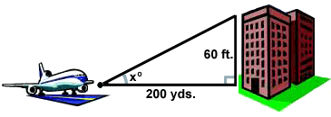 plane take off in order to avoid crashing into the building? Assume that the airplane flies in a

straight line and the angle of elevation remains constant until the airplane

flies over the building.

*x* = arctan(latex_img28) latex_img155.72 o . The plane must take off at an angle of elevation of about 5.72 o in order to avoid hitting the building.

[Close](http://www.sparknotes.com/math/trigonometry/solvingrighttriangles/problems_1.html#explanation3#explanation3)

4. A 14 foot ladder is used to scale a 13 foot wall. At what angle of elevation must the ladder be situated in

order to reach the top of the wall?

5. A person stands at the window of a building so that his eyes are 12.6 m above the level ground. An object is on the ground 58.5 m away from the building on a line directly beneath the person. Compute the angle of depression of the person’s line of sight to the object on the ground.

*x* = arcsin(latex_img31) latex_img1568.3 o . The ladder must be situated with about a 68.2 o angle of elevation in order to reach the top of the wall.

[Close](http://www.sparknotes.com/math/trigonometry/solvingrighttriangles/problems_1.html#explanation4#explanation4)

6. A ramp is needed to allow vehicles to climb a 2 foot wall. The angle of elevation in order for the vehicles to

safely go up must be 30 o or less, and the longest ramp available is 5 feet long. Can this ramp be used?

http://img.sparknotes.com/figures/C/c92e38c46d6be4610999d7936fd45ce2/prob235.gif

Trig Application Problems

Draw pictures! Make all answers accurate to the nearest tenth.

1. A damsel is in distress and is being held captive in a tower. Her knight in shining armor is on the ground below with a ladder. When the knight stands 15 feet from the base of the tower and looks up at his precious damsel, the angle of elevation to her window is 60 degrees. How long does the ladder have to be?
2. You are 200 yards from a river. Rather than walking directly to the river, you walk 400 yards along a straight path to the river’s edge. Find the acute angle between path and the river’s edge.
3. A 12 meter flagpole casts a 9 meter shadow. Find the angle of elevation of the sun.
4. Suppose Justin flying a kite, and it gets caught at the top of the tree. Justin lets out all 100 feet of string for the kite, and the angle that the string makes with the ground is 75 degrees. Instead of worrying about how to get his kite back, he wonders. “How tall is that tree?”
5. Suppose that Brandon and Kelsey are making measurements for the road-paving crew. They need to know how much the land slopes downward along a particular stretch of road. Kelsey walks 80 feet from Brandon and holds up a long pole, perpendicular to the ground, that has markings every inch along it. Brandon looks at the pole through a sighting instrument. Looking straight across, parallel to the horizon, Brandon sights a point on the pole 50 inches above the ground- call it point A. Then Brandon looks through the instrument at the bottom of the pole, creating an angle of depression. Which is the angle of depression or slope of the road, to where Brandon is standing?
6. A submersible traveling at a depth of 250 feet dives at an angle of 15º with respect to a line parallel to the water’s surface. It travels a horizontal distance of 1500 feet during the dive. What is the depth of the submersible after the dive?
7. A fire department’s longest ladder is 110 feet long, and the safety regulation states that they can use it for rescues up to 100 feet off the ground. What is the maximum safe angle of elevation for the rescue ladder?
8. Carter and Daniel buy a tent that has a center pole 6.25 feet high. If the sides of the tent are supposed to make a 50° angle with the ground, how wide is the tent?
9. Sydney decided to ride the Ferris wheel at the state fair. When is stops at the top she sees Rosalie at a 30o angle of depression and Staci on the other side of the Ferris wheel at a 45o angle of depression. If the Ferris wheel is 55 feet tall how far away are Rosalie and Staci?
10. Delmy is standing is the school parking lot and looks up to see Darius on the roof of the school. The angle of elevation to Darius’ feet is 45o and Delmy is 48 feet away from the building. If Darius is 5.8 feet tall, what is the angle of elevation Delmy must look up at to the top of Darius’ head?
11. An isosceles triangle has sides length 5, 5, 6. Find the measure, to the *nearest degree*, of each angle of the triangle. (Hint: Draw the altitude.)
12. Ethan is going water skiing. The length of a water ski jump is 720 cm and it is 415cm tall. At what angle will Ethan go uphill?
13. At 10:00am , Andrew observes a hot air balloon climbing vertically in the air from a point 300 meters away from the launch pad for the balloon. The angle of elevation to the top of the balloon at this time is 25o. At 10:02am, Andrew observes that the angle of elevation to the balloon is now 60o. What is the change in altitude, to the *nearest meter,* for the balloon over the 2 minutes between the first and second observations?
14. From the top of a lighthouse 160 feet high, the angle of depression of a boat out at sea is 24o. Find, to the *nearest foot*, the distance from the boat to the foot of the lighthouse. (The foot of the lighthouse is at sea level.)