Name: \_\_\_\_\_\_\_\_\_\_\_\_\_\_\_\_\_\_\_\_\_\_\_\_\_\_\_\_\_\_\_\_\_\_\_\_\_\_\_\_\_\_\_\_\_\_\_\_\_\_\_\_\_\_\_\_\_\_\_\_ Class: \_\_\_\_\_\_\_\_\_\_\_\_\_\_\_\_\_\_

**Math 2 – Unit 5 Notes and Homework Packet**

**Day 1: Pythagorean Theorem**

Pythagorean Theorem - \_\_\_\_\_\_\_\_\_\_\_\_\_\_\_\_\_\_\_\_\_\_\_\_\_\_\_\_\_\_\_\_\_\_\_\_\_\_\_\_\_\_\_\_\_\_\_\_\_\_\_\_\_\_\_\_\_\_\_\_\_\_\_\_\_\_\_\_\_\_

***a*** and ***b*** are \_\_\_\_\_\_\_\_\_\_\_\_\_\_\_ ***c*** is the \_\_\_\_\_\_\_\_\_\_\_\_\_\_\_\_\_\_\_\_\_\_\_

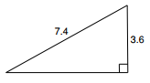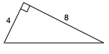Practice: Use the Pythagorean Theorem to solve for the missing side.

1. 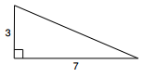 2. 3.

4. The slide at the playground has a height of 6 feet. The base of the slide measured on the ground is 8 feet. What is the length of the sliding board?

5. The bottom of a 13-foot straight ladder is set into the ground 5 feet away from a wall. When the top of the ladder is leaned against the wall, what is the distance above the ground it will reach?

**Converse of the Pythagorean Theorem**

You can use the Pythagorean Theorem to determine if a triangle is \_\_\_\_\_\_\_\_\_\_\_\_\_\_\_\_\_\_\_,

\_\_\_\_\_\_\_\_\_\_\_\_\_\_\_\_\_\_\_, or \_\_\_\_\_\_\_\_\_\_\_\_\_\_\_\_\_\_\_\_.

**RULES**

If $c^{2}__________$ $a^{2}+b^{2}$, then the triangle is \_\_\_\_\_\_\_\_\_\_\_\_\_\_\_\_\_\_\_\_\_

If $c^{2}__________$ $a^{2}+b^{2}$, then the triangle is \_\_\_\_\_\_\_\_\_\_\_\_\_\_\_\_\_\_\_\_\_

If $c^{2}__________$ $a^{2}+b^{2}$, then the triangle is \_\_\_\_\_\_\_\_\_\_\_\_\_\_\_\_\_\_\_\_\_

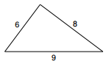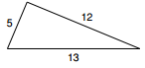Determine if the triangle is a right triangle. If not, determine if it is an acute or obtuse triangle.

1. 2.

3. Triangle sides: **51, 23, and 32** 4. Triangle sides: **9, 41, and 40**

\_\_\_\_\_\_\_\_\_\_\_\_\_\_\_\_\_\_\_\_\_\_\_\_\_\_\_\_\_\_\_\_\_\_\_\_\_\_\_\_\_\_\_\_\_\_\_\_\_\_\_\_\_\_\_\_\_\_\_\_\_\_\_\_\_\_\_\_\_\_\_\_\_\_\_\_\_\_\_\_\_\_\_\_\_\_\_\_\_\_

**Homework 5.1**

**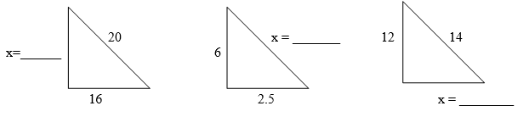Use the Pythagorean Theorem to find the missing side of the right triangle**

1. 2. 3.

4. A light pole 9 feet tall casts a shadow that is 18 feet long. Find the distance from the top of the light pole to the tip of the shadow.

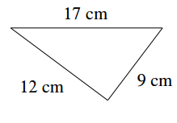**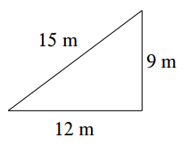Determine if the triangle is a right triangle, acute triangle, or obtuse triangle.**

5. 6. 7. Sides 37, 12, 35

**Day 2: Special Right Triangles**

There are 2 “Special Right Triangles” that allow you to find missing side lengths without using the Pythagorean Theorem.

$45°-45-90°$ $30°-60°-90°$

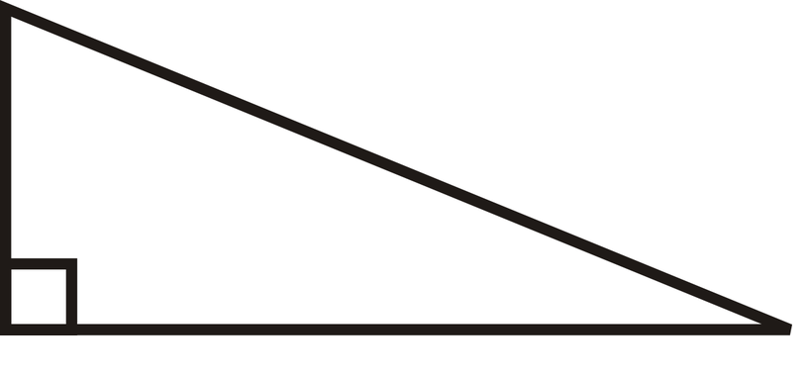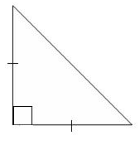

$$30°-60-90° Triangle$$

Side opposide $30°$

\_\_\_\_\_\_\_\_\_\_\_\_\_\_\_\_\_\_\_\_\_\_\_\_\_\_

Side opposide $60°$

\_\_\_\_\_\_\_\_\_\_\_\_\_\_\_\_\_\_\_\_\_\_\_\_\_\_

Hypotenuse

$$45°-45-90° Triangle$$

 \_\_\_\_\_\_\_\_\_\_\_\_\_\_\_\_\_\_\_\_\_\_\_\_\_\_

Side opposide $45°$

\_\_\_\_\_\_\_\_\_\_\_\_\_\_\_\_\_\_\_\_\_\_\_\_\_

Hypotenuse \_\_\_\_\_\_\_\_\_\_\_\_\_\_\_\_\_\_\_\_\_\_\_\_\_\_

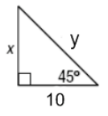

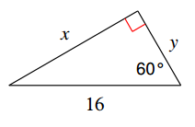Practice:

1. 2.

X = \_\_\_\_\_\_\_\_\_\_\_\_\_\_\_\_\_ X = \_\_\_\_\_\_\_\_\_\_\_\_\_\_\_\_\_\_

Y = \_\_\_\_\_\_\_\_\_\_\_\_\_\_\_\_\_ Y = \_\_\_\_\_\_\_\_\_\_\_\_\_\_\_\_\_\_

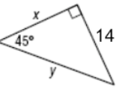

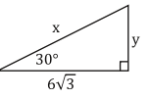3. 4.

X = \_\_\_\_\_\_\_\_\_\_\_\_\_\_\_\_\_ X = \_\_\_\_\_\_\_\_\_\_\_\_\_\_\_\_\_\_

Y = \_\_\_\_\_\_\_\_\_\_\_\_\_\_\_\_\_ Y = \_\_\_\_\_\_\_\_\_\_\_\_\_\_\_\_\_\_

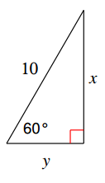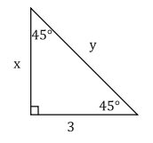5. 6.

X = \_\_\_\_\_\_\_\_\_\_\_\_\_\_\_\_\_ X = \_\_\_\_\_\_\_\_\_\_\_\_\_\_\_\_\_\_

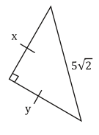Y = \_\_\_\_\_\_\_\_\_\_\_\_\_\_\_\_\_ Y = \_\_\_\_\_\_\_\_\_\_\_\_\_\_\_\_\_\_

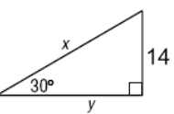

7. 8.

X = \_\_\_\_\_\_\_\_\_\_\_\_\_\_\_\_\_ X = \_\_\_\_\_\_\_\_\_\_\_\_\_\_\_\_\_\_

Y = \_\_\_\_\_\_\_\_\_\_\_\_\_\_\_\_\_ Y = \_\_\_\_\_\_\_\_\_\_\_\_\_\_\_\_\_\_

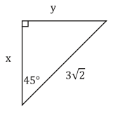\_\_\_\_\_\_\_\_\_\_\_\_\_\_\_\_\_\_\_\_\_\_\_\_\_\_\_\_\_\_\_\_\_\_\_\_\_\_\_\_\_\_\_\_\_\_\_\_\_\_\_\_\_\_\_\_\_\_\_\_\_\_\_\_\_\_\_\_\_\_\_\_\_\_\_\_\_

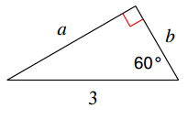**Homework 5.2**

1. 2.

A = \_\_\_\_\_\_\_\_\_\_\_\_\_\_\_\_\_ X = \_\_\_\_\_\_\_\_\_\_\_\_\_\_\_\_\_\_

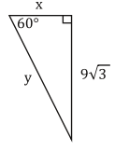B = \_\_\_\_\_\_\_\_\_\_\_\_\_\_\_\_\_ Y = \_\_\_\_\_\_\_\_\_\_\_\_\_\_\_\_\_\_

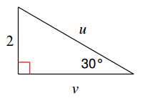

3. 4.

U = \_\_\_\_\_\_\_\_\_\_\_\_\_\_\_\_\_ X = \_\_\_\_\_\_\_\_\_\_\_\_\_\_\_\_\_\_

V = \_\_\_\_\_\_\_\_\_\_\_\_\_\_\_\_\_ Y = \_\_\_\_\_\_\_\_\_\_\_\_\_\_\_\_\_\_

**Day 3: Parts of a Right Triangle and Trigonometry**

Parts of a Right Triangle

\_\_\_\_\_\_\_\_\_\_\_\_\_\_\_\_\_\_\_\_\_\_\_\_\_\_\_\_\_\_\_\_\_\_

\_\_\_\_\_\_\_\_\_\_\_\_\_\_\_\_\_\_\_\_\_\_\_\_\_\_\_\_\_\_\_\_\_\_

\_\_\_\_\_\_\_\_\_\_\_\_\_\_\_\_\_\_\_\_\_\_\_\_\_\_\_\_\_\_\_\_\_\_

Trigonometry:

\_\_\_\_\_\_\_\_\_\_\_\_\_= \_\_\_\_\_\_\_\_\_\_\_\_\_\_\_\_\_\_\_\_\_ \_\_\_\_\_\_\_\_\_\_\_\_\_= \_\_\_\_\_\_\_\_\_\_\_\_\_\_\_\_\_\_\_\_\_

\_\_\_\_\_\_\_\_\_\_\_\_\_= \_\_\_\_\_\_\_\_\_\_\_\_\_\_\_\_\_\_\_\_\_

Practice:

Label the triangle’s sides as Opposite, Adjacent, and Hypotenuse.

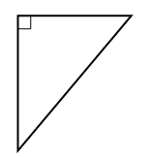1. 2.

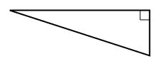

Ɵ

Ɵ

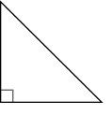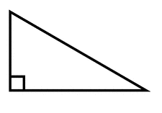3. 4.

Ɵ

Ɵ

Find the 3 trigonometric ratios for each triangle.

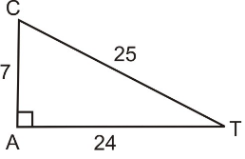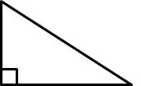5. 6.

Ɵ

41

9

Ɵ

40

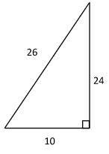

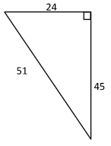

Ɵ

7. 8.

Ɵ

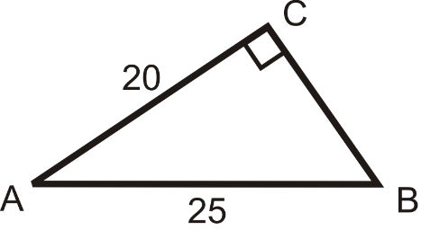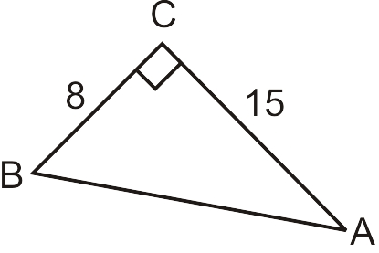

9. 10.

Ɵ

Ɵ

**Homework 5.3**

Label the triangle’s sides as Opposite, Adjacent, and Hypotenuse

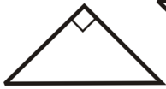

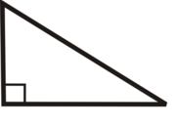1. 2. 3.

Ɵ

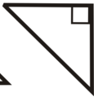

Ɵ

Ɵ

Find the 3 trigonometric ratios for each triangle

12

4.  5.

80



18

Ɵ

15

Ɵ

6. 7.

Ɵ

100

4

Ɵ

3

96

$sinƟ = ________________$ $sinƟ = ________________$

$cosƟ = ________________$ $cosƟ = ________________$

$tanƟ = ________________$ $tanƟ = ________________$

**Day 4: Solving for Missing Side Lengths and Angle Measures**

$sinθ= \frac{ }{ }$ $cosθ= \frac{ }{ }$ $tanθ= \frac{ }{ }$

|  |  |  |
| --- | --- | --- |
| 1.  Trig Ratio: \_\_\_\_\_\_\_\_\_\_\_\_\_\_\_\_\_\_  X = \_\_\_\_\_\_\_\_\_\_\_\_\_\_\_\_\_\_\_\_\_\_\_\_ | 2.  Trig Ratio: \_\_\_\_\_\_\_\_\_\_\_\_\_\_\_\_\_\_  X = \_\_\_\_\_\_\_\_\_\_\_\_\_\_\_\_\_\_\_\_\_\_\_\_ | 3.  Trig Ratio: \_\_\_\_\_\_\_\_\_\_\_\_\_\_\_\_\_\_  X = \_\_\_\_\_\_\_\_\_\_\_\_\_\_\_\_\_\_\_\_\_\_\_\_ |
| 4.  Trig Ratio: \_\_\_\_\_\_\_\_\_\_\_\_\_\_\_\_\_\_  X = \_\_\_\_\_\_\_\_\_\_\_\_\_\_\_\_\_\_\_\_\_\_\_\_ | 5.  Trig Ratio: \_\_\_\_\_\_\_\_\_\_\_\_\_\_\_\_\_\_  X = \_\_\_\_\_\_\_\_\_\_\_\_\_\_\_\_\_\_\_\_\_\_\_\_ | 6.  Trig Ratio: \_\_\_\_\_\_\_\_\_\_\_\_\_\_\_\_\_\_  X = \_\_\_\_\_\_\_\_\_\_\_\_\_\_\_\_\_\_\_\_\_\_\_\_ |

**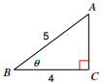Finding Missing Angles using Trigonometry**

Trig Ratio: \_\_\_\_\_\_\_\_\_\_\_\_\_\_\_\_\_\_\_\_

When solving for \_\_\_\_\_\_\_\_\_, you must use the \_\_\_\_\_\_\_\_\_\_\_\_\_\_\_\_\_\_\_\_\_\_\_\_ !!!!

Practice:

|  |  |  |
| --- | --- | --- |
| 7.  Trig Ratio: \_\_\_\_\_\_\_\_\_\_\_\_\_\_\_\_\_\_  X = \_\_\_\_\_\_\_\_\_\_\_\_\_\_\_\_\_\_\_\_\_\_\_\_ | 8.  Trig Ratio: \_\_\_\_\_\_\_\_\_\_\_\_\_\_\_\_\_\_  X = \_\_\_\_\_\_\_\_\_\_\_\_\_\_\_\_\_\_\_\_\_\_\_\_ | 9.  Trig Ratio: \_\_\_\_\_\_\_\_\_\_\_\_\_\_\_\_\_\_  X = \_\_\_\_\_\_\_\_\_\_\_\_\_\_\_\_\_\_\_\_\_\_\_\_ |
| 10.  Trig Ratio: \_\_\_\_\_\_\_\_\_\_\_\_\_\_\_\_\_\_  X = \_\_\_\_\_\_\_\_\_\_\_\_\_\_\_\_\_\_\_\_\_\_\_\_ | 11.  Trig Ratio: \_\_\_\_\_\_\_\_\_\_\_\_\_\_\_\_\_\_  X = \_\_\_\_\_\_\_\_\_\_\_\_\_\_\_\_\_\_\_\_\_\_\_\_ | 12.  Trig Ratio: \_\_\_\_\_\_\_\_\_\_\_\_\_\_\_\_\_\_  X = \_\_\_\_\_\_\_\_\_\_\_\_\_\_\_\_\_\_\_\_\_\_\_\_ |

**Homework 5.4 - Solve for the missing side or angle.**

|  |  |  |
| --- | --- | --- |
| 1.  Trig Ratio: \_\_\_\_\_\_\_\_\_\_\_\_\_\_\_\_\_\_  X = \_\_\_\_\_\_\_\_\_\_\_\_\_\_\_\_\_\_\_\_\_\_\_\_ | 2.  Trig Ratio: \_\_\_\_\_\_\_\_\_\_\_\_\_\_\_\_\_\_  X = \_\_\_\_\_\_\_\_\_\_\_\_\_\_\_\_\_\_\_\_\_\_\_\_ | 3.  Trig Ratio: \_\_\_\_\_\_\_\_\_\_\_\_\_\_\_\_\_\_  X = \_\_\_\_\_\_\_\_\_\_\_\_\_\_\_\_\_\_\_\_\_\_\_\_ |
| 4.  Trig Ratio: \_\_\_\_\_\_\_\_\_\_\_\_\_\_\_\_\_\_  X = \_\_\_\_\_\_\_\_\_\_\_\_\_\_\_\_\_\_\_\_\_\_\_\_ | 5.  Trig Ratio: \_\_\_\_\_\_\_\_\_\_\_\_\_\_\_\_\_\_  X = \_\_\_\_\_\_\_\_\_\_\_\_\_\_\_\_\_\_\_\_\_\_\_\_ | 6.  Trig Ratio: \_\_\_\_\_\_\_\_\_\_\_\_\_\_\_\_\_\_  X = \_\_\_\_\_\_\_\_\_\_\_\_\_\_\_\_\_\_\_\_\_\_\_\_ |
| 7.  Trig Ratio: \_\_\_\_\_\_\_\_\_\_\_\_\_\_\_\_\_\_  X = \_\_\_\_\_\_\_\_\_\_\_\_\_\_\_\_\_\_\_\_\_\_\_\_ | 8.  Trig Ratio: \_\_\_\_\_\_\_\_\_\_\_\_\_\_\_\_\_\_  X = \_\_\_\_\_\_\_\_\_\_\_\_\_\_\_\_\_\_\_\_\_\_\_\_ | 9.  Trig Ratio: \_\_\_\_\_\_\_\_\_\_\_\_\_\_\_\_\_\_  X = \_\_\_\_\_\_\_\_\_\_\_\_\_\_\_\_\_\_\_\_\_\_\_\_ |

**Day 5: Angle of Elevation and Depression**

**Angle of Elevation** **Angle of Depression**

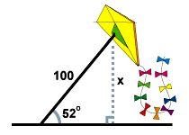**ANGLE OF ELEVATION** AND **ANGLE OF DEPRESSION** ARE ALWAYS \_\_\_\_\_\_\_\_\_\_\_\_\_\_\_\_\_\_

1. A man flies a kite with a 100 foot string. The angle of elevation of the

string is 52 o . How high off the ground is the kite?

*x* = 100 sin(52) latex_img1578.8 . The kite is about 79 feet above the ground. [Close](http://www.sparknotes.com/math/trigonometry/solvingrighttriangles/problems_1.html#explanation2#explanation2)

2. From the top of a vertical cliff 40 m high, the angle of depression of an object that is level with the base of the cliff is 34º.  How far is the object from the base of the cliff?

3. An airplane takes off 200 yards in front of a 60 foot building. At what angle of elevation must the

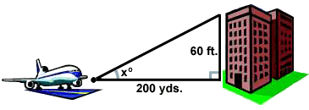 plane take off in order to avoid crashing into the building? Assume that the airplane flies in a

straight line and the angle of elevation remains constant until the airplane

flies over the building.

*x* = arctan(latex_img28) latex_img155.72 o . The plane must take off at an angle of elevation of about 5.72 o in order to avoid hitting the building.

[Close](http://www.sparknotes.com/math/trigonometry/solvingrighttriangles/problems_1.html#explanation3#explanation3)

4. A 14 foot ladder is used to scale a 13 foot wall. At what angle of elevation must the ladder be situated in

order to reach the top of the wall?

**Homework 5.5**

1. A ladder against a wall. It makes an angle of 30° angle of elevation. The foot of the ladder is 41 ft from the base of the wall. Find the height of the point where the ladder touches the wall.
2. A man on the deck of a ship observes that the angle of elevation of the top of a cliff is 70°. If the ship is 3,2 miles from the base of the cliff, find the height of the cliff.
3. The angle of elevation of the top of a tree is 30o from a point 28 ft away from the foot of the tree. Find the height of the tree.
4. From the top of a lighthouse 160 feet high, the angle of depression to a boat out at sea is 24°. Find, to the nearest foot, the distance from the boat to the foot of the lighthouse.
5. Spencer is going snowboarding. He rode the ski lift to the top of the mountain, which is at an altitude of 1500 feet. The angle of elevation from the bottom to the top of the mountain is 25o. What is the length of the Spencer’s run (his trip down the hill)?