Math 3 Geometry Part 1 Study Guide Unit 6

**Directions:** Find the value of each variable. Then find the measure of each labeled angle.

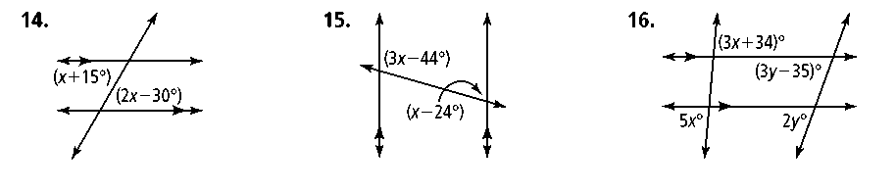1. 2. 3. 

**Directions:** Name two triangles that are congruent by ASA.

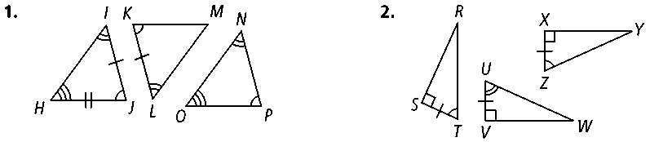4. 5.

**Directions:** Would you use SSS or SAS to prove these triangles congruent? If there is not enough information to prove the triangles congruent by SSS or SAS, write *not enough information.* Explain your answer.

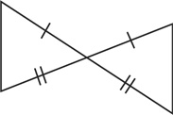

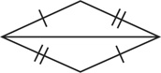6. 7.

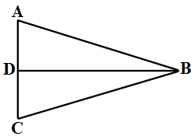 8. Given:  is the perpendicular bisector of   Prove: ∆*BAD* ≅ ∆*BCD*

|  |  |
| --- | --- |
| **Statements** | **Reasons** |
| 1) is the perpendicular bisector of *.* | 1) Given |
| 2) | 2) Definition of segment bisector |
| 3) ∠*ADB* and ∠*CDB* are right . | 3) Definition of perpendicular |
| 4) | 4) |
| 5) | 5) |
| 6) | 6) |

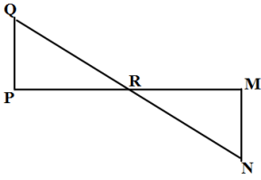

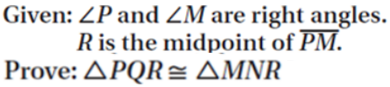9

**Directions:** Find the values of the variables in each parallelogram (14 is a trapezoid)..

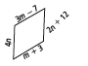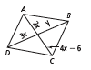

10. 11.

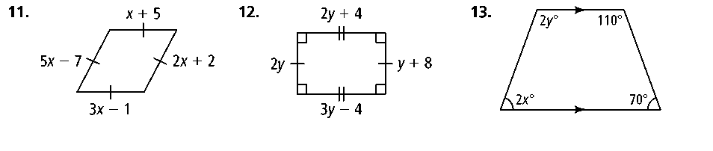12. 13. 14.

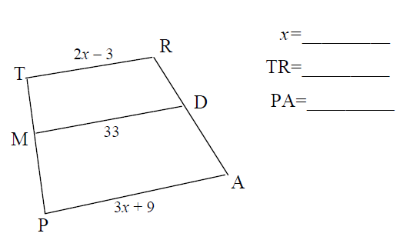

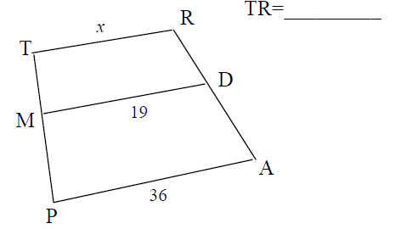15. 16.

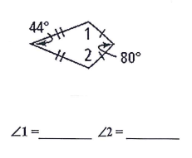

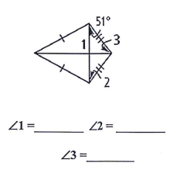

17. 18.

Are the following parallelograms? Explain why or why not. (For example, draw or state a counterexample if not.)

|  |  |  |
| --- | --- | --- |
| 19. | 20. | 21. |

