Angle | Measure
a
b
c
d
e
f
g
h
i
j
k

HW 6-1

1. a. Find the measure of each angle in the diagram.

e
b
c
d
a
f
g
h
i
j
k
55°
110°

b. What geometric relationship did you use to find angles c, g, and k?

Explanation for ∠c: Explanation for ∠g: Explanation for ∠k:

3. Set up and solve an equation to solve for x in each diagram.
3x – 20
2x + 20
- b)
3x – 20
2x + 20

3x + 2
7x – 10
- d)
98°
x
48°

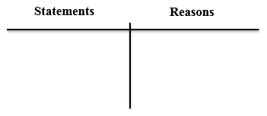
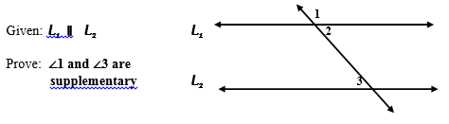
4.

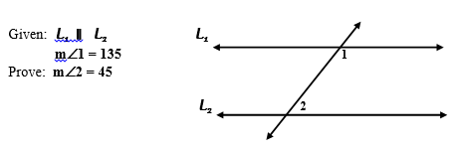
5.

