Angle | Measure
a
b
c
d
e
f
g
h
i
j
k

HW 6-1

1. a. Find the measure of each angle in the diagram.

e
b
c
d
a
f
g
h
i
j
k
55°
110°

b. What geometric relationship did you use to find angles c, g, and k?

Explanation for ∠c:
Explanation for ∠g:
1
2
3
4
5
7
8
6
Explanation for ∠k:

2. Use the diagram to answer the questions below.
a. If angle 1 and angle 7 are congruent, what
property proves the lines are parallel?

b. If angle 5 and angle 8 are congruent, what can be concluded about the lines?

c. If the lines are parallel, what must be true about angle 2 and angle 6? What is the name of the property used to determine this?

d. If the lines are parallel, what must be true about angle 7 and angle 3? What is the name of the property used to determine this?

3. Set up and solve an equation to solve for x in each diagram.
3x – 20
2x + 20
- b)
3x – 20
2x + 20

3x + 2
7x – 10
- d)
98°
x
48°

HW 6-2
For each question determine whether the given figure is a parallelogram.

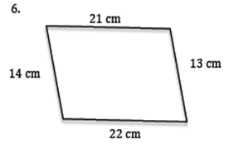
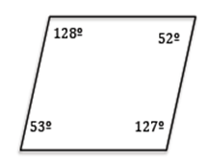
1.
2.
37ft
27ft
29ft
32ft
45°
137°
43°
135°

Solve for the given variables using properties of parallelograms.
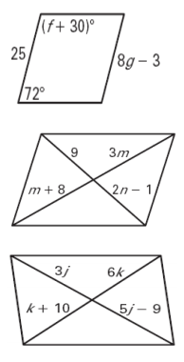
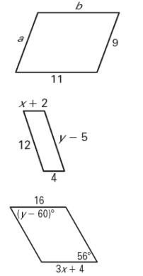
4.
3.

5.
6.

8.
7.

9.
10.
3x - y
1
2x+3y
7
3x - 2y
1
5x+4y
2

