Name: __________________________________________________________ Class: ___________________
Math 2: Unit 6 Review Sheet
Part 1: Transformations
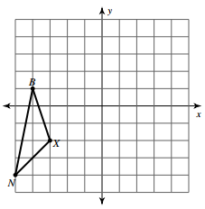
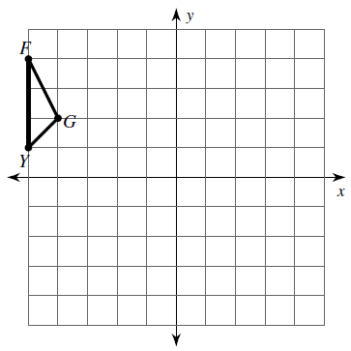
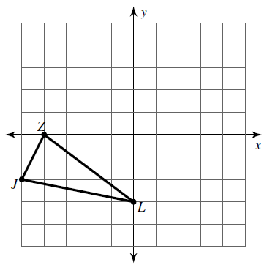
1. Reflect over the y axis 2. Rotate 180° 3. Translate (x, y) (x + 6, y – 5)

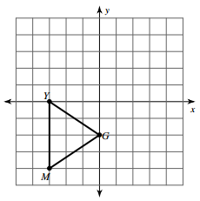
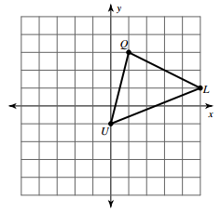
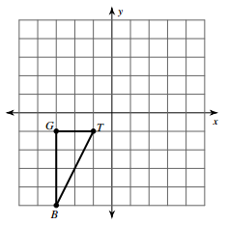
4. Rotate 90° clockwise 5. Reflect over the x axis 6. Rotate 270° clockwise

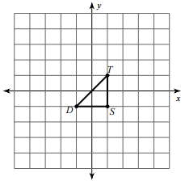
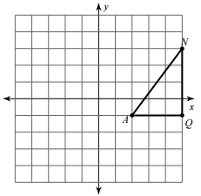
7. Reflect over y = x 8. Dilate k = 2

Part 2: Compositions of Transformations. Continue the transformation for each. Do not start over.
9. a. Start at (0, 0)…translate (x, y) (x – 3, y + 9) _____________
b. Continue…reflect over the x axis _____________ f. Rotate 270° clockwise _____________
c. Rotate 90° clockwise _____________ g. Reflect over the y axis _____________
d. Dilate k = 3 _____________ h. Translate (x, y) (x – 1, y) __________
e. Reflect over y = x _____________ i. Rotate 180° _____________
Complete the composition of transformations. Be sure to label ALL points.
10. Reflect over the y axis 11. Rotate 90° clockwise
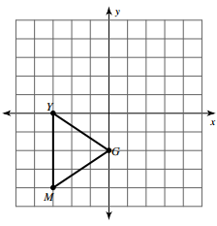
Rotate 180° Translate (x, y) (x – 4, y + 5)

‘_______________________________________ ‘_______________________________________
‘‘_______________________________________ ‘‘_______________________________________

Part 3: Use the rules to find the new image points, using the 3 preimage points below. Do not continue the transformations.
U(8, 2) G(-6, -1) A(7, -3)

12. Rotate 270° clockwise 13. Reflect over y = x
_____________________________________ _____________________________________

14. Reflect over the x axis 15. Rotate 180°
_____________________________________ _____________________________________

16. Translate (x, y) (x – 5, y + 10) 17. Dilate k = 3
_____________________________________ _____________________________________

Part 4: Backwards!
18. A’(5, 3) was translated using (x, y) (x + 1, y – 2). Find A. ________________
19. B’(0, 3) was reflected over the x axis. Find B. ________________
20. C’(-10, 4) was rotated 180 degrees. Find C. ________________
21. D’(8, 7) was dilated using k = ½ . Find D. ________________
22. E’(-5, -1) was translated using (x, y) (x, y – 5). Find E. ________________
23. F’(-2, 8) was reflected over y = x. Find F. ________________

